







SENIOR ONE

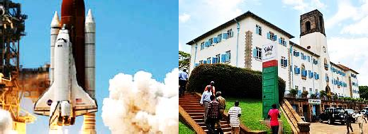

LOWER SECONDARY NEW CURRICULUM 1ST EDITION

8/24/2022

**NEXT GENERATION LEARNER**

***Mr. Onderi Kenneth*** [kennethonderi@gmail.com](mailto:kennethonderi@gmail.com) 0705476300/0771940855

TABLE OF CONTENTS

Preface I

Acknowledgement II

Chapter 1 1

Introduction to physics 2

Chapter 2 9

Measurements in physics 10

Chapter 3 42

States of matter 43

Chapter 4 56

Effect of forces 57

Chapter 5 75

Temperature measurement 76

Chapter 6 88

Heat transfer 89

Chapter 7 108

Expansion of solids, liquids and gases 109

Chapter 8 121

Nature of light: reflection at plane surfaces 122

# Preface

##### This Learner’s workbook has been written in line with the revised Physics syllabus for the new lower secondary curriculum. The revision questions, worksheets and activities of integration have been incorporated into this workbook. Through those activities of integration provided at the end of each chapter the learner is able to produce new knowledge, values and skills are required in the 21st century.

This has been done by providing a range of activities of integration which will enable the learner to research more through the internet in order to understand the applicability of knowledge learned at his or her respective school.

##### The learner is expected to be able to work as an individual, in pairs and groups according to the nature of the activities in order to be able to share learning experiences with their colleagues.

This Learner’s workbook is one of the materials which are to be used to support the teaching and learning process of the new lower secondary curriculum.

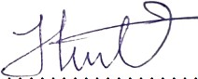

### Mr. Onderi Kenneth

##### Physics Teacher, Kakungulu Memorial School Kibuli.

i

Acknowledgements

##### I would like to express a sincere appreciation to all those who worked

tirelessly towards the production of this Learner’s workbook.

##### First and foremost, I would like to thank my family and friends for the supporting all my initiatives both financially and spiritually. my parents Mr. Omwandi Philemon, and Mrs. Akoth Rose Mary, my siblings Atosa Jonathan and Omwandi Philemon Junior, Adikini Esther lucy and Akoth Georgina. My friends Ashraf, Ntambi and Genza.

My gratitude also goes to the various institutions which provided staff who natured and supported me to become the physics teacher I am today. My thanks go to Kakungulu memorial school Kibuli which provided the best environment to work from, best reference books and best experienced colleagues like Mr. Hassan, Mr. Mukiibi, Mr. Abiib, Tr Gilbert, Mr. Kintu.

##### Last but not least, I would like to acknowledge Greenhill Academy Kibuli for the good environment that enabled me to get used to the next generation teachers like Mr. Bemba, Mr. Amayo, Mr. Guma, Tr. Moses.

I welcome any suggestions for improvement to continue making my service delivery better. Please get to me through [kennethonderi@gmail.com](mailto:kennethonderi@gmail.com) or contact **0705476300** or **0771940855**

ii

i

## Chapter 1

Introduction to physics

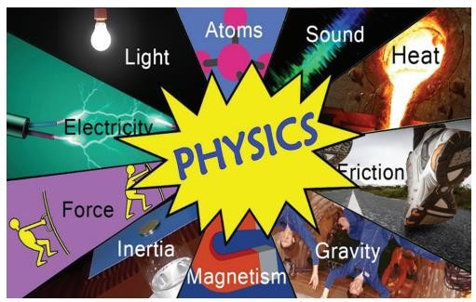

#### Key learning outcomes

*By the end of this chapter, the learner should be able to:*

* understand the meaning of physics.
* understand why it is important to follow the laboratory rules and regulations.

#### Summary

This is the 1st topic in physics and is also the most important to a learner since it briefly introduces learners to what physics is all about from mechanics to heat, waves, light, electricity, magnetism, earth and space, modern physics. The above eight are the branches of physics.

Since the beginning of time scientists all over the world have made discoveries for example Sir Isaac Newton was seated under an apple tree and when an apple fell down from the tree, he discovered laws of gravitation.

This informs us that physics is all around us and discoveries can be made anywhere anytime but the best place to carry out scientific research in the world today is the LABORATORY. So that is why learners should know about the laboratory, it’s rules, care and maintenance.

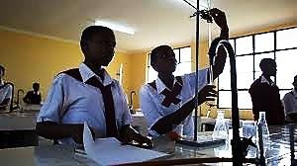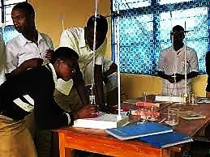

#### WORKSHEET (SHORT ANSWER REVISION QUESTIONS)

1. Define physics

………………………………………………………………………………………………..

1. Write down all the branches of physics you know

…………………………………………………………………………………………….…….

…………………………………………………………………………………………………..

…………………………………………………………………………………………………..

………………………………………………………………………………………………….

1. List down any four benefits of studying physics.

…………………………………………………………………………………………….……

…………………………………………………………………………….……………………

……………………………………………………………….…………………………………

………………………………………………….………………………………………………

1. Write down any five careers (occupation undertaken) in Physics

………….………………………………………………………………………………………

…………………………………………………………………………….……………………

……………………………………………………………………….…………………………

………………………………………………………………….………………………………

…………………………………………………………………………………………………

1. State any four ways we can always commonly apply knowledge of physics while at home

…………………………………………………………………………………………….……

…………………………………………………………………………….……………………

……………………………………………………………….…………………………………

………………………………………………….………………………………………………

1. What is meant by the term a laboratory?

…………………………………………………………………………………………….……

…………………………………………………………………………….……………………

1. Write down any four-laboratory apparatus you know in physics

…………………………………………………………………………………………….……

…………………………………………………………………………….……………………

……………………………………………………………….…………………………………

………………………………………………….………………………………………………

1. What other name can you use to replace the word APPARATUS without changing its meaning……………………………………………………………………………………....

24. What is the laboratory apparatus?............................................................................................

……………………………………………………………………………………………….

1. List down any four safety precautions/measures taken while in the laboratory

…………………………………………………………………………………………….……

…………………………………………………………………………….……………………

……………………………………………………………….…………………………………

………………………………………………….………………………………………………

1. As you moved around your school you must have noticed some other safety precautions / measures taken by the school to ensure safety of the students. Write down any four safety precautions you have noticed in your school.

…………………………………………………………………………………………….……

…………………………………………………………………………….……………………

……………………………………………………………….…………………………………

………………………………………………….………………………………………………

1. Write down any four laboratory rules and regulations that must be followed while in the laboratory

…………………………………………………………………………………………….……

…………………………………………………………………………….……………………

……………………………………………………………….…………………………………

………………………………………………….………………………………………………

1. State two reasons why you should follow the laboratory rules and regulations

…………………………………………………………………………………………….……

…………………………………………………………………………….……………………

……………………………………………………………….…………………………………

………………………………………………….………………………………………………

1. The mobile phones are some of the real-life applications of waves since it transfers information or DATA inform of electromagnetic waves from one place (source) to another ( receiver). Name any other two machine or device that use knowledge of physics to operate and in each case note down the topic applied by the device mentioned

Device 1…………………………………. Uses knowledge of…………………………………...

…………………………………. from topic called………………………………………………

Device 2………………………………… Uses knowledge of ……………………….…………

……………………………………………..from topic called……………………………………

**SCENARIO**

#### ACTIVITY OF INTEGRATION

The importance of physics in our lives is highlighted by the many applications that physics has made possible in people's lives, and which have become one of the indispensable necessities of life however most people are not aware of this significance especially our old grandparents.

**SUPPORT/RESOURCES**

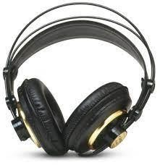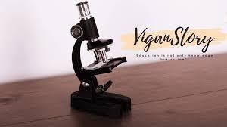

**(A)**

**(D)**

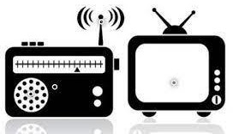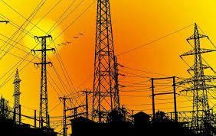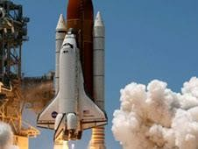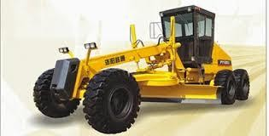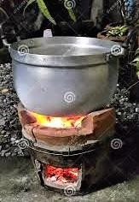

**(B)**

**(C)**

**(E)**

**(H)**

**(F)**

**(G)**

**TASK**

1. From the above highlighted images identify the activity in figures above and explain how physics helps in our daily life. In each case **identify** the figure, how it is **applicable**, and the **branch** of physics where the above figure falls under.
2. From pictures in A, B, C, D, E, F, G and H above write down the possible career opportunities (occupation undertaken) at the end of your education.

**SCENARIO**

#### ACTIVITY OF INTEGRATION

During the visitation at your school parents and guardians flooded the school compound and as part of school way of promoting their school to the outside community you are one of the few students selected to show the parents around the school laboratory. Whereas in the laboratory many apparatuses were organized to be displayed to the parents and guardians who were eagerly waiting to see how well their learners have attained knowledge and skills while at school.

**SUPPORT MATERIALS / RESOURCES**

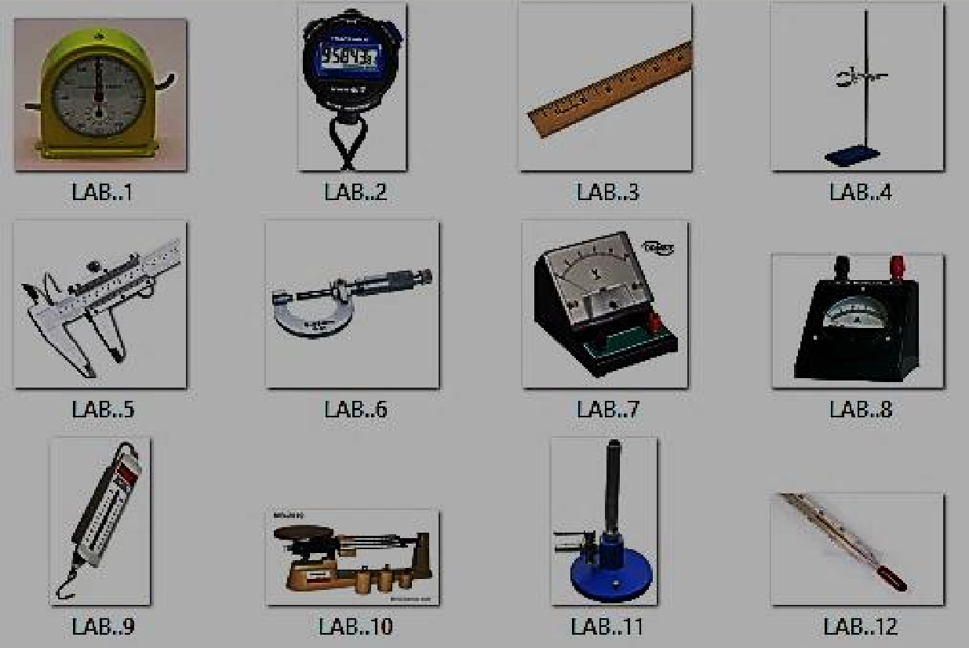

#### TASK

1. You have been selected as one of the few students to guide parents and guardians through **Laboratory Tour**. Organize the speech you are going to present to the presents about the **Physics Laboratory** and don’t forget to inform them of the rules and regulations they must abide by as they enter the laboratory for the tour.
2. As the second part of your presentation, you are required to organize each apparatus labelled above write down its name and briefly explain its real-life applications.

#### ACTIVITY OF INTEGRATION

.

**SCENARIO**

It is always best, to follow all safety rules while in the laboratory because unforeseen accidents could happen in a blink of an eye. People could get hurt. Maybe even die, if safety rules are ignored. No one needs to get hurt. No one needs to die, because of stupid mistakes.

This evening we received bad news from our neighbouring school about Fire outbreak that started from the physics laboratory and many school properties were destroyed in the process.

**SUPPORT MATERIAL**

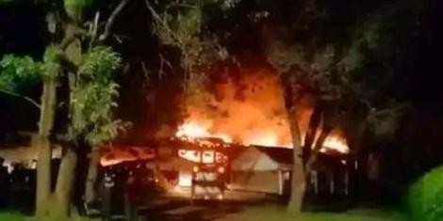

Figure showing Moi Girls’ school Kenya gutted by fire

**TASK**

From the above speech and figure what do you think could have been the cause of fire outbreak in the Laboratory. What improvements and safety precautions can we make to avoid such dangers from repeating itself in our school environment?

#### ACTIVITY OF INTEGRATION

**SCENARIO**

Your elder brother has just received his **S.6** results and he scored AAA (perfect triple A) he is soon going to apply for a course on Bachelors’ degree level at Uganda’s greatest University, Makerere University. Your brother is however not sure of which career path he should apply for. He needs some one to guide him through the right career opportunities he can pursue in the future.

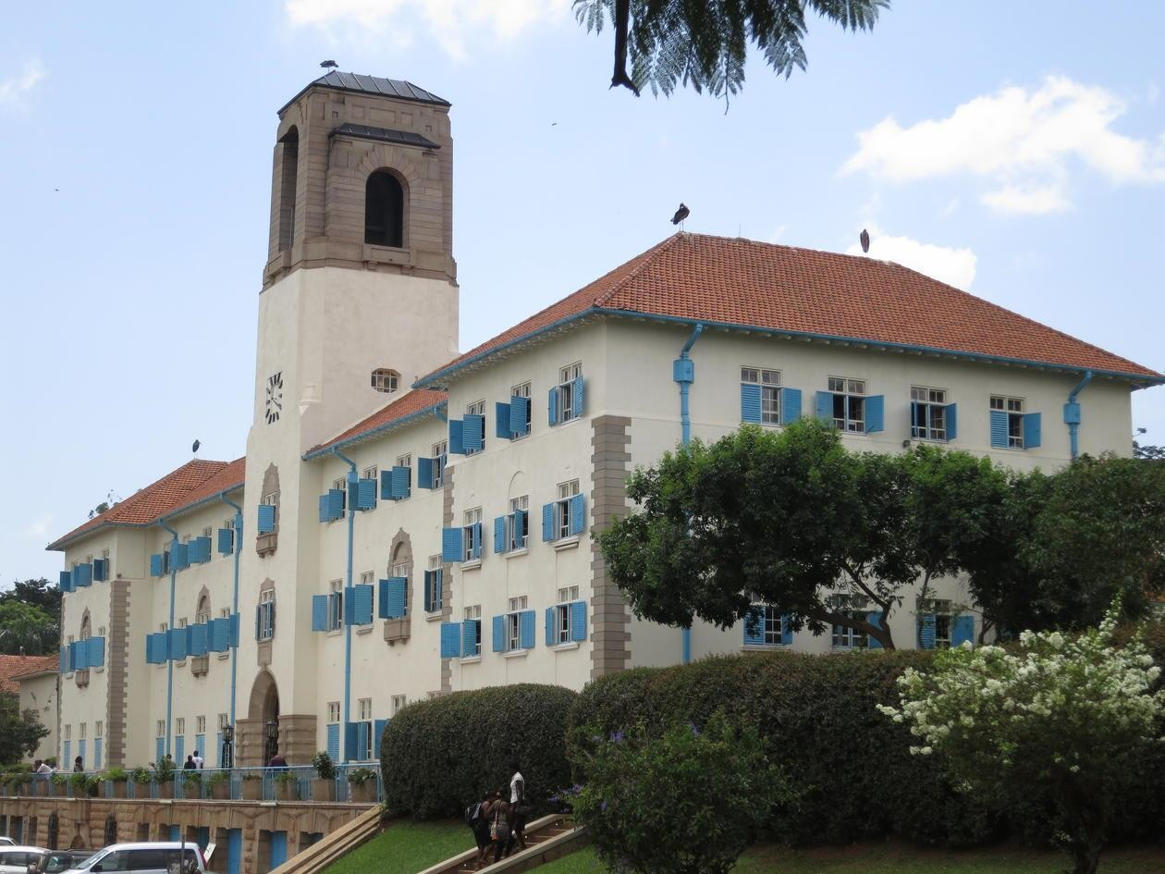**SUPPORT MATERIAL**

**TASK**

Write down how you can help your brother in **identifying** all possible suitable physics careers he can pursue at the university (try to be convincing by telling him also some challenges and benefits in some of the careers available)

## Chapter 2

Measurements In Physics

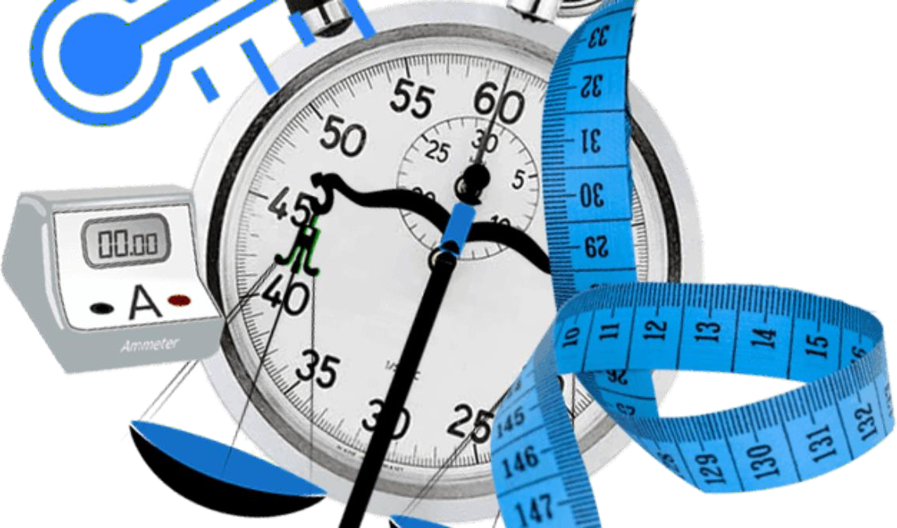

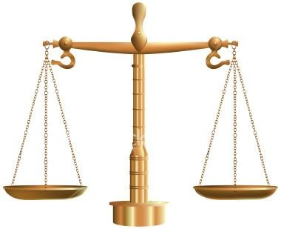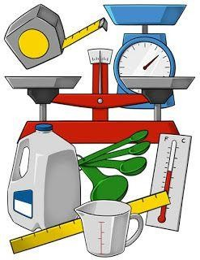

#### Key learning outcomes

*By the end of this chapter, the learner should be able to:*

* 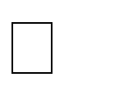estimate and measure physical quantities using appropriate equipment and units.
*  explain how to choose and use the right measuring instruments and the right units, ensuring accuracy.
*  identify the potential sources of errors in measurements and devise strategies to minimise them.
* understand the various methods of presenting data.
* use scientific notation and significant figures in measurements and calculations.
* understand the scientific method of investigation.
* understand the meaning of density and its application to floating and sinking.
* determine densities of different materials and relate them to purity.
*  understand the global nature of ocean currents and how they are driven by changes in water density and temperature.

***The Introduction***

Measurement is defined as **the act of measuring or the size of something**. An example of measurement is the use of a ruler to determine the length of a piece of paper.

Measurement can also be defined as **the comparison of the specified physical quantity**. **with the known standard quality of the equivalent nature**. For example- distance is measured in meter whereas time is measured in seconds and kilogram or gram is used for measuring mass of an object.

The quantity of matter is determined by measurements. In this chapter, you will learn how to estimate and measure physical quantities in standard units, and the importance of making accurate measurements. *Time, size, distance, speed, direction, weight, volume, temperature, pressure, force, sound, light, energy*—these are among the physical

properties for which humans have developed accurate measures, without which we could not live our normal daily lives. Measurement spreads throughout every aspect of human life.

In our daily life, we buy sugar, fuel, rice, cooking oil and many others which are purchased in measurable quantities. When you go to the hospital, the doctor will determine your weight, height, age and mass for proper dosage of medication.

How do you find out your height and weight?...............................................................................

How much water can fill your cup?...............................................................................................

How long do you take to run 100 metres?.....................................................................................

You can be able to answer such questions using knowledge of measurements. In this chapter you will be able to estimate and measure length, area, volume, mass, weight, density and time.

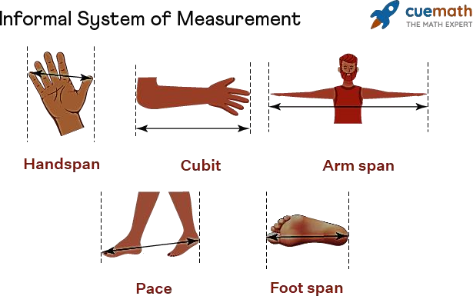

#### WORKSHEET (SHORT ANSWER REVISION QUESTIONS)

1. What do you understand by the term Measurement.

…………………………………………………………………………………………………

…………………………………………………………………………………………………

1. What do you understand by the term Estimation.

…………………………………………………………………………………………………

…………………………………………………………………………………………………

1. In today’s global world, the word international is used frequently for example companies like COCACOLA, AMAZON are international because they are widely spread worldwide, and so many more. In measurement what system is used worldwide.

………………………………………………………………………………………………….

1. Akram said that he is 2 meters tall, his younger Abdallah doubted him and they began arguing over it, so to stop the endless argument Abdallah got the tape measure and measured Akram’s height, he found out that he is 1.7 meters instead.
   1. Which physics term can be used to represent 2 meters tall?

……………………………………………………………………………………………..

* 1. Which physics term can be used to represent 1.7 meters tall?

………………………………………………………………………………………………

* 1. What is the difference between the above two physics terms?

………………………………………………………………………………………………

………………………………………………………………………………………………

………………………………………………………………………………………………

1. On visitation day you your younger brother visited you at school and after a warm, delicious meal you took him to show him the school laboratory, briefly explain to him the name, use and units of the following instruments

|  |  |  |
| --- | --- | --- |
| **INSTRUMENT** | **NAME** | **IT’S USE AND UNITS** |
|  |  |  |
|  |  |  |

|  |  |  |
| --- | --- | --- |
| INSTRUMENT | NAME | IT’S USE AND UNITS |
|  |  |  |
|  |  |  |
|  |  |  |
|  |  |  |
|  |  |  |
|  |  |  |
|  |  |  |
|  |  |  |

1. During class activity, the students were tasked to find the length of their classroom. Osman used his foot span and found out that the classroom length is **50-foot spans** meanwhile John went to the laboratory and got a tape measure to which he used and obtained **12 meters.**
   1. Why do you think there are differences between the values obtained by the two students……………………………………………………………………..........................

……………………………………………………………………………………………..

* 1. Which of the two values obtained is an estimated value?………………………………….
  2. Which of the two values obtained is the actual value ?……………………………………

d) Who obtained the actual value of the length of classroom?.................................................

e) How can we improve the reliability of an estimate?............................................................

……………………………………………………………………………………………..

1. “Length of a football pitch is a **fundamental** physical quantity whereas Area of the same football pitch is a **derived** quantity”. Said the teacher
   1. Briefly explain what this statement means.

………………………………………………………………………………………………

………………………………………………………………………………………………

………………………………………………………………………………………………

* 1. Name any other four fundamental quantities you know.

………………………………………………………………………………………………

………………………………………………………………………………………………

* 1. Name any other four derived quantities you know.

………………………………………………………………………………………………

………………………………………………………………………………………………

* 1. What is the main difference between these two quantities?

………………………………………………………………………………………………

………………………………………………………………………………………………

………………………………………………………………………………………………

1. The table below contains some physical quantities commonly used in real life situations, complete the table using the right symbol, unit, and quantity.

|  |  |  |  |
| --- | --- | --- | --- |
| **QUANTITY** | **SYMBOL** | **UNIT** | **SYMBOL** |
| Mass | m | kilogram | kg |
| length | 𝑙 |  | m |
|  | t | second |  |
| Electric current | I |  |  |
|  |  | Kelvin | K |
| Area |  |  | m2 |
|  |  | Cubic meters | m3 |
| density |  | Kilogram per cubic  meters |  |
|  |  | Newton |  |
| pressure |  |  | Pa |
| Energy or work |  |  |  |
|  |  | Watt |  |

1. Given the following measuring instruments in the table below, you are required to identify the right instrument for measuring or estimating the physical quantities (tasks) in the table. In each case allocate the right **standard unit** of measurement used.

|  |  |
| --- | --- |
| **INSTRUMENT** | **TASK** |
| Tape measure | The thickness of a laptop |
| Metre rule | The time it takes to run a race |
| Vernier calliper | The width of the classroom |
| Stop clock | The length of a football pitch |
| Micrometer screw gauge | The area of the classroom |
| Stop watch | Diameter of a very small tube |

Tape measure……………………………………………………………………………………...

Metre rule…………………………………………………………………………………………...

Vernier calliper……………………………………………………………………………………...

Stop clock…………………………………………………………………………………………...

Micrometer screw gauge…………………………………………………………………………...

Stop watch…………………………………………………………………………………………

1. Six different groups of students were given research work on school project about finding the length and width of a standard football pitch. Since each group worked independently, they ended up presenting their research findings in different units as shown in the table below

|  |  |  |  |  |  |  |
| --- | --- | --- | --- | --- | --- | --- |
| **GROUP** | **A** | **B** | **C** | **D** | **E** | **F** |
| **LENGTH** | 11Dm | 11,000cm | 120,000mm | 0.1km | 0.9Hm | 1000dm |
| **WIDTH** | 7Dm | 7,000cm | 80,000mm | 0.06km | 0.45Hm | 550dm |

1. As the student coordinator in the school help your friends from different groups to work together by using standard unit of measurement of length for all groups.

…………………………………………………………………………………………………

…………………………………………………………………………………………………

…………………………………………………………………………………………………

…………………………………………………………………………………………………

…………………………………………………………………………………………………

…………………………………………………………………………………………………

…………………………………………………………………………………………………

…………………………………………………………………………………………………

…………………………………………………………………………………………………

…………………………………………………………………………………………………

…………………………………………………………………………………………………

…………………………………………………………………………………………………

…………………………………………………………………………………………………

…………………………………………………………………………………………………

…………………………………………………………………………………………………

1. Show how you can obtain the most accurate measurement of the football pitch from the results obtained from all the above groups.

…………………………………………………………………………………………………

…………………………………………………………………………………………………

…………………………………………………………………………………………………

…………………………………………………………………………………………………

…………………………………………………………………………………………………

1. What physics term do we use to mean the difference between the actual value and the apparent value…………………………………………………………………………………………….
2. Briefly explain two reasons why you think different groups obtained different values after the measurement

…………………………………………………………………………………………………

…………………………………………………………………………………………………

…………………………………………………………………………………………………

…………………………………………………………………………………………………

1. What do you understand by the terms area and volume of a body?

…………………………………………………………………………………………………

…………………………………………………………………………………………………

…………………………………………………………………………………………………

1. What is the S.I unit of area and volume respectively?

…………………………………………………………………………………………………

1. What do scientists mean when they say surface area? How about cross-sectional area? (You may use illustrations)

…………………………………………………………………………………………………

…………………………………………………………………………………………………

…………………………………………………………………………………………………

…………………………………………………………………………………………………

14

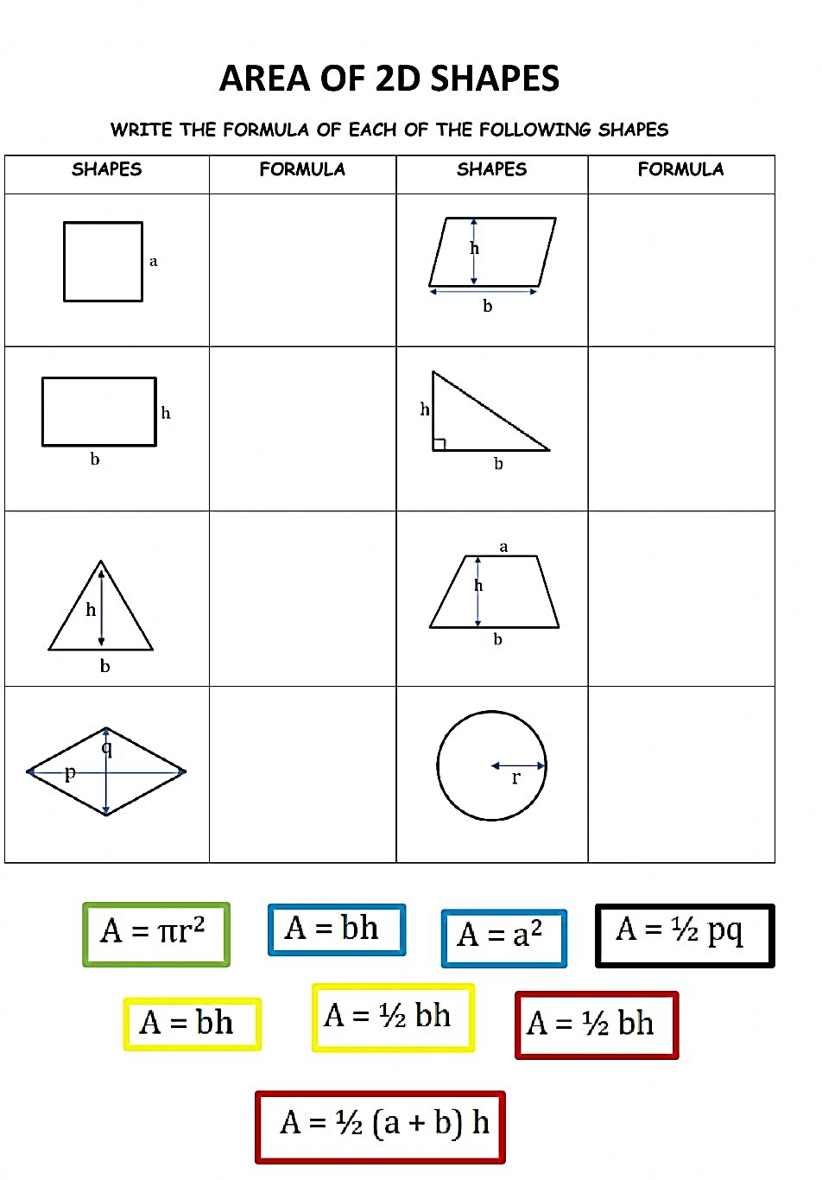

15

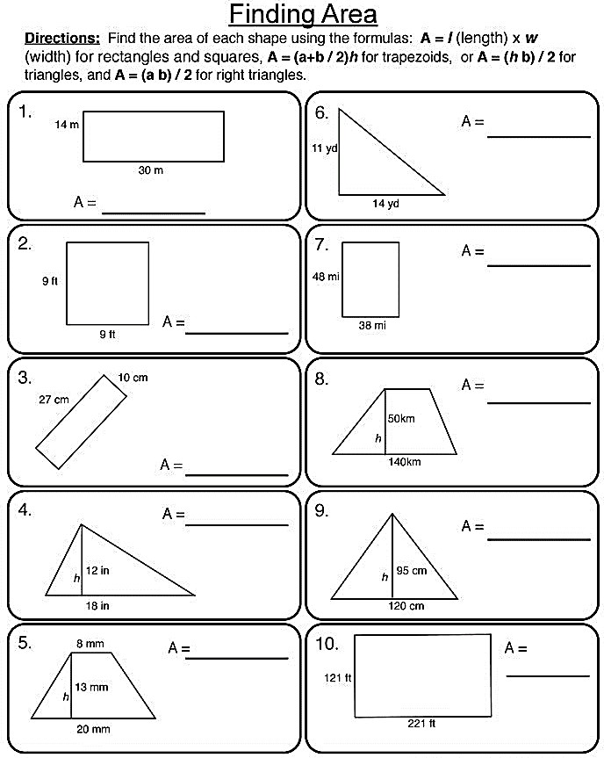

1. 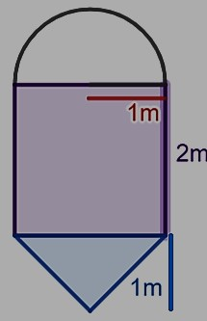Peter's dad wants to remove some of the grass in the garden to make a flowerbed. He drew a diagram of what he would like the flowerbed to look like:
   1. **What will the area of the flowerbed be?**

………………………………………………………………

………………………………………………………………

………………………………………………………………

………………………………………………………………

………………………………………………………………

………………………………………………………………

………………………………………………………………

………………………………………………………………

1. The diagram shows the shape and dimensions of Teresa’s rose garden.
2. 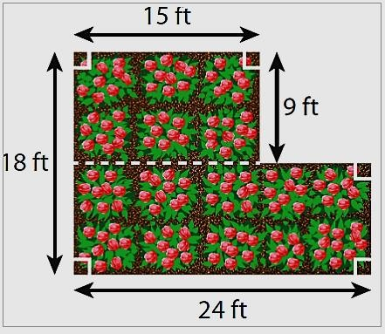Find the area of the garden

…………………………………………………

…………………………………………………

…………………………………………………

…………………………………………………

…………………………………………………

…………………………………………………

…………………………………………………

………………………………………………….

.

1. Teresa wants to buy mulch for her garden. One bag of mulch covers 12 square feet. How many bags will she need?

…………………………………………………

…………………………………………………

…………………………………………………

…………………………………………………

…………………………………………………

…………………………………………………

1. The cost of fencing a circle shaped garden is **$20** per foot. If the radius of the garden is **14** feet, find the total cost of fencing the garden. (𝝅 = 𝟐𝟐⁄𝟕).

…………………………………………………………………………………………………

…………………………………………………………………………………………………

…………………………………………………………………………………………………

…………………………………………………………………………………………………

1. Jess is painting a giant arrow on a playground. Find the area of the giant arrow. If one can of paint covers 100 square feet.

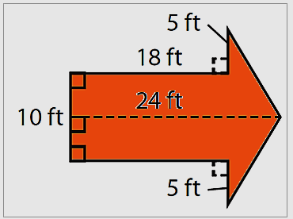how many cans should Jess buy?

………………………………………………………………………………………

………………………………………………………………………………………

………………………………………………………………………………………

………………………………………………………………………………………

………………………………………………………………………………………

………………………………………………………………………………………

………………………………………………………………………………………

………………………………………………………………………………………

………………………………………………………………………………………

………………………………………………………………………………………

1. John went to buy a carpet for his bedroom that measures 10m by 60m. what size of the carpet should he buy in:
2. m2
3. cm2
4. km2

………………………………………………………………………………………………

………………………………………………………………………………………………

………………………………………………………………………………………………

………………………………………………………………………………………………

………………………………………………………………………………………………

………………………………………………………………………………………………

………………………………………………………………………………………………

………………………………………………………………………………………………

………………………………………………………………………………………………

1. your father wants to buy an irregular shaped plot of land but he fears that he may spend a lot of money than usual because he doesn’t know how to obtain the actual value of the land without knowing it’s actual size. Briefly explain the steps you would follow to help him determine the area of the plot of land so that he doesn’t get cheated. (Include illustrations).

…………………………………………………………………………………………………

…………………………………………………………………………………………………

…………………………………………………………………………………………………

…………………………………………………………………………………………………

…………………………………………………………………………………………………

…………………………………………………………………………………………………

1. Ismael poured sells water in a 𝟐𝟎 𝒍𝒊𝒕𝒓𝒆 jerrycan at **UgShs.200** per jerrycan. One day he was paid **Ug. Shs. 15,000** by one of his customers who wanted to buy water.
2. What physics term can be used to replace the sentence, “the space occupied by water in a jerrycan?.................................................................................................................................
3. How much water should Ismael sell to his customer?

………………………………………………………………………………………………

………………………………………………………………………………………………

1. Name any other two common units used in measuring the amount of space occupied by an object.

………………………………………………………………………………………………

1. What is the relationship between those units in (c) and the unit used by Ismael?

………………………………………………………………………………………………

………………………………………………………………………………………………

1. Calculate the volume of a cylinder with a length of 20cm, and whose circular end has a radius of 2.5cm.

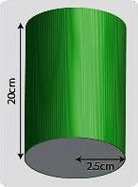

…………………………………………………………………………………………………………………

…………………………………………………………………………………………………………………

…………………………………………………………………………………………………………………

…………………………………………………………………………………………………………………

…………………………………………………………………………………………………………………

…………………………………………………………………………………………………………………

…………………………………………………………………………………………………………………

…………………………………………………………………………………………………………………

…………………………………………………………………………………………………………………

…………………………………………………………………………………………………………………

…………………………………………………………………………………………………………………

1. 24.

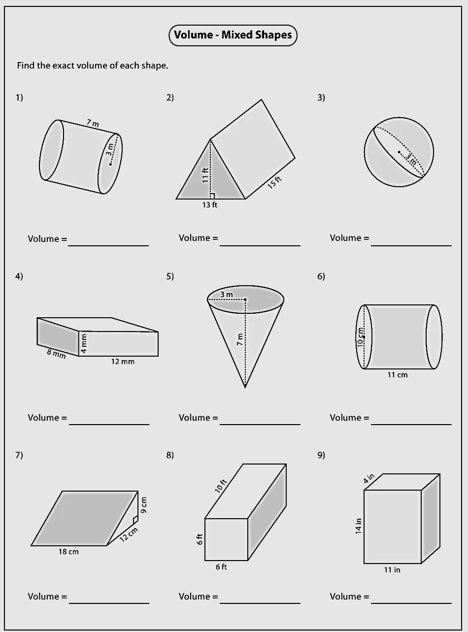

1. Which is bigger by volume, a sphere with radius 2cm or a pyramid with base 2.5cm square and height of 10cm?

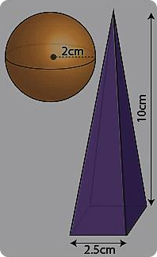………………………………………………………………………………………………………………

………………………………………………………………………………………………………………

………………………………………………………………………………………………………………

………………………………………………………………………………………………………………

………………………………………………………………………………………………………………

………………………………………………………………………………………………………………

………………………………………………………………………………………………………………

………………………………………………………………………………………………………………

………………………………………………………………………………………………………………

………………………………………………………………………………………………………………

………………………………………………………………………………………………………………

1. Calculate the volume of a water cylinder with total height 1m, diameter of 40cm, and whose top section is hemispherical (half of a sphere).

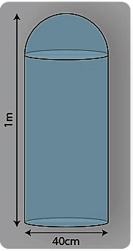………………………………………………………………………………………………………………………

………………………………………………………………………………………………………………………

………………………………………………………………………………………………………………………

………………………………………………………………………………………………………………………

………………………………………………………………………………………………………………………

………………………………………………………………………………………………………………………

…………………………………………………………………………………………………………..…………

………………………………………………………………………………………………………………………

………………………………………………………………………………………………………………………

1. Jane has a model of the Moon in the shape of a sphere. If the model has a radius of 10 centimeters, what is the volume of the model in cubic meters?

…………………………………………………………………………………………………

…………………………………………………………………………………………………

…………………………………………………………………………………………………

…………………………………………………………………………………………………

1. A puzzle box is shaped like a rectangular prism and has a volume of **240** cubic centimetres. If the puzzle box has a length of **10** centimetre and a width of **8** centimetres, what is the height of the puzzle box in metres?

…………………………………………………………………………………………………

…………………………………………………………………………………………………

…………………………………………………………………………………………………

…………………………………………………………………………………………………

…………………………………………………………………………………………………

…………………………………………………………………………………………………

1. A medicine bottle is in the shape of a right circular cylinder. If the volume of the bottle is 144*π* cubic centimetres, its height is 9 centimetres. what is the diameter of the base of the bottle, in centimeters?

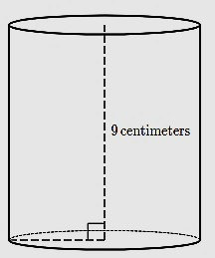…………………………………………………………………………………………………………

…………………………………………………………………………………………………………

…………………………………………………………………………………………………………

…………………………………………………………………………………………………………

…………………………………………………………………………………………………………

…………………………………………………………………………………………………………

…………………………………………………………………………………………………………

1. The figure below shows various measuring tools for volume. You are required to **identify** and

**name** each of them and **places** where they are commonly used in real life.

E

F

H

G

F

P

G

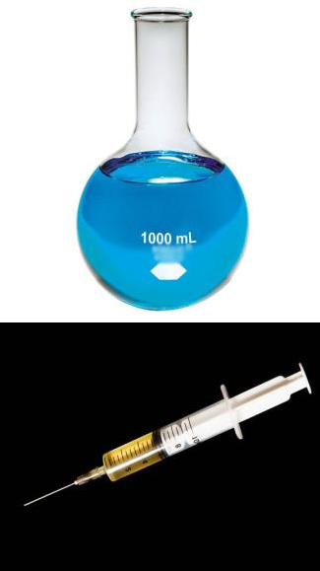

**F**

**G**

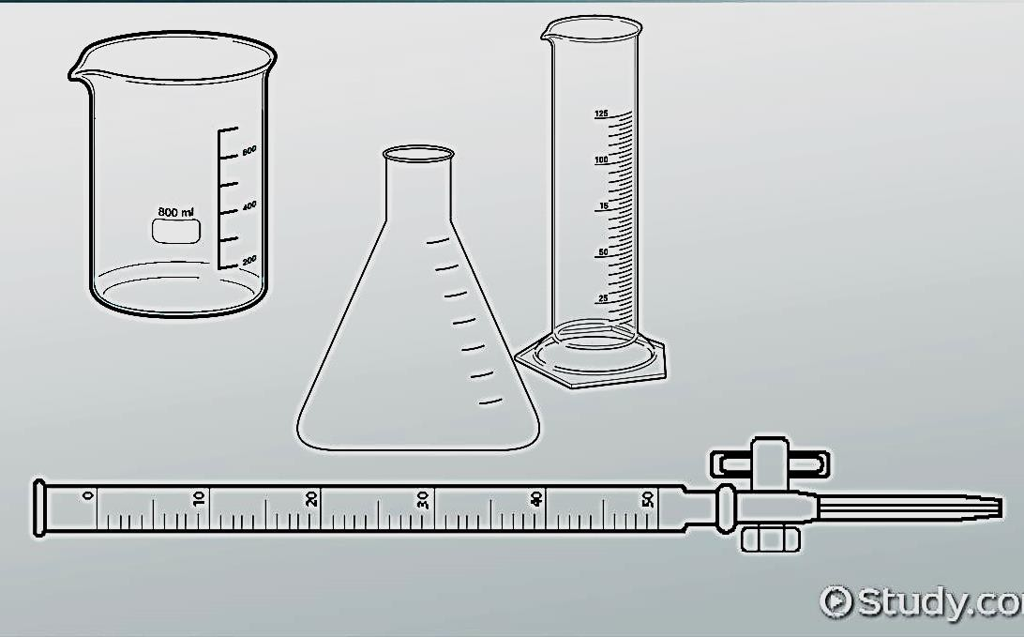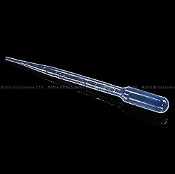

**C**

**A**

**E**

**B**

**D**

A……………………………………………………………………………………………………

B……………………………………………………………………………………………………

C……………………………………………………………………………………………………

D……………………………………………………………………………………………………

E……………………………………………………………………………………………………

F……………………………………………………………………………………………………

G……………………………………………………………………………………………………

1. You found your brother using a ruler to find the volume of a stone. Do you think he is on the right track or not? if no then what are the right procedures to follow in order to obtain the actual results? (Use illustrations where necessary).

…………………………………………………………………………………………………

……..……………………………………………………………………………………………

…………………………………………………………………………………………………

…………………………………………………………………………………………………

…………………………………………………………………………………………………

…………………………………………………………………………………………………

1. The figure below shows an illustration of measurement taking place. You are required to identify the method of measurement and describe how it’s carried out.

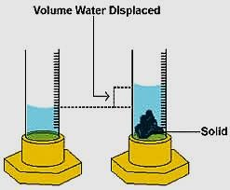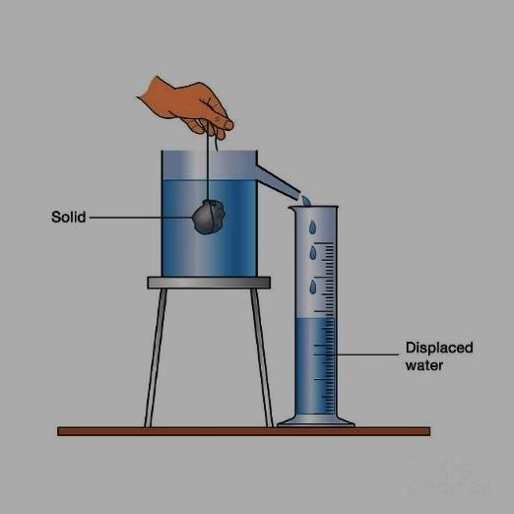

A

B

…………………………………………………………………………………………………

…………………………………………………………………………………………………

…………………………………………………………………………………………………

…………………………………………………………………………………………………

…………………………………………………………………………………………………

…………………………………………………………………………………………………

…………………………………………………………………………………………………

…………………………………………………………………………………………………

…………………………………………………………………………………………………

…………………………………………………………………………………………………

…………………………………………………………………………………………………

…………………………………………………………………………………………………

…………………………………………………………………………………………………

…………………………………………………………………………………………………

………………………………………………………………………………………………….

1. The volume of water in a measuring jar is **37 ml**. When an object is immersed in the water, the water level rises to **45 ml**. What is the volume of the object (in cubic cm)?

…………………………………………………………………………………………………

…………………………………………………………………………………………………

…………………………………………………………………………………………………

1. To measure the volume of a coin, water is taken in a measuring cylinder to a level **15.0 ml**. On immersing the coin in it, the water level in measuring cylinder rises to **16.7 ml**. What is the volume of coin? Express your result in **S.I**. units.

…………………………………………………………………………………………………

…………………………………………………………………………………………………

…………………………………………………………………………………………………

…………………………………………………………………………………………………

………………………………………………………………………………………………..

1. Ibrahim has a mass of 50kg on earth whereas his weight is 500N on earth.
2. What is the mathematical relationship between mass and weight?

……………………………………………………………………………………………..

1. What does the term mass mean? what is its SI unit?

………………………………………………………………………………………………

………………………………………………………………………………………………

1. What does the term weight mean? what is its SI unit?

………………………………………………………………………………………………

………………………………………………………………………………………………

1. When Ibrahim went to the moon, his weight changed from 500N to 81N but to his surprise his mass did not change at all. Briefly explain that scenario.

………………………………………………………………………………………………

………………………………………………………………………………………………

1. Write down any three key differences between mass and weight of a body?

|  |  |
| --- | --- |
| **MASS** | **WEIGHT** |
|  |  |
|  |  |
|  |  |

1. A car has a weight of 10,000 N. What is the mass of the car on Earth (g = 10 N/kg)?

…………………………………………………………………………………………………

…………………………………………………………………………………………………

1. A girl has a weight of 88 N on the moon, where g = 1.6 N/kg. What is her mass?

…………………………………………………………………………………………………

…………………………………………………………………………………………………

1. 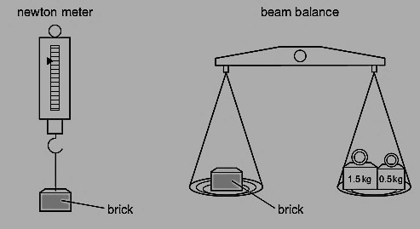A brick is placed on a newton meter and then on a beam balance.
2. What does each instrument measure?

………………………………………………………………………

………………………………………………………………………

………………………………………………………………………

1. Are the readings the same or different when the instruments are on the moon?

………………………………………………………………………

………………………………………………………………………

………………………………………………………………………

##### The table shows the weights and masses of four objects on different planets.

* 1. On which planet is the gravitational field strength the largest?...........................................................
  2. On which planet is the gravitational field strength the smallest?.........................................................
  3. In each case find the gravitational field strength of each planet on the table

………………………………………………………

………………………………………………………

………………………………………………………

……………………………………………………….

##### The mass and volume of four different objects are plotted as shown.

1. Which object has the smallest density? Show working………………………………………......

…………………………………………………...

…………………………………………………...

…………………………………………………...

1. Which object has the largest density? Show working………………………………………….

………………………………………………………

………………………………………………………

………………………………………………………

1. Four objects are situated in places with different gravitational field strengths as shown below.
   1. 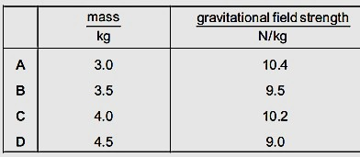Which object has the greatest weight and why?

………………………………………………

………………………………………………

* 1. Which object has the least weight and why?

………………………………………………

………………………………………………

##### Two identical beakers contain the same mass of liquid. There is a different liquid in each beaker.

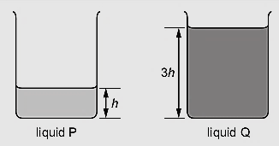Liquid Q has density 𝝆**.** what is the density of

liquid **P?**

**................................................................................**

**................................................................................**

**................................................................................**

**................................................................................**

1. A spacecraft travels from the Earth to the Moon. At a certain point in the journey, it has zero weight. Why is the weight zero at this point?

…………………………………………………………………………………………………

…………………………………………………………………………………………………

…………………………………………………………………………………………………

1. A solid ball has a mass of 100 grams and a radius of 2 cm. What is the density? (Answer: 2.98 g/cm3)

…………………………………………………………………………………………………

…………………………………………………………………………………………………

…………………………………………………………………………………………………

…………………………………………………………………………………………………

1. A solid cylinder has a radius of 2 cm and a length of 7 cm. It has a density of 3.1 g/cm3. What is the mass of the cylinder? (Answer: 272.69 grams)

…………………………………………………………………………………………………

…………………………………………………………………………………………………

…………………………………………………………………………………………………

………………………………………………………………………………………………….

1. Rocks are sometimes used along coasts to prevent erosion. If a rock needs to weigh 2,000 kilograms (about 2 tons) in order not to be shifted by waves, how big (what volume) does it need to be? You are using basalt, which has a typical density of 3200 kg/m3

…………………………………………………………………………………………………

…………………………………………………………………………………………………

…………………………………………………………………………………………………

…………………………………………………………………………………………………

1. A golden-colored cube is handed to you. The person wants you to buy it for **$100**, saying that is a gold nugget. You pull out your old geology text and look up gold in the mineral table, and read that its density is **19.3 g/cm3**. You measure the cube and find that it is **2 cm** on each side, and weighs 40 g. What is its density? Is it gold? Should you buy it?

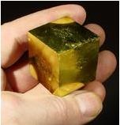………………………………………………………………

………………………………………………………………

………………………………………………………………

…………………………………………………..……………

………………………………………………………………

………………………………………………………………

………………………………………………………………

………………………………………………………………

……………………………………………………………….

1. Solids normally have higher density as compared to liquids however to my surprise ice floats on water. Explain why.

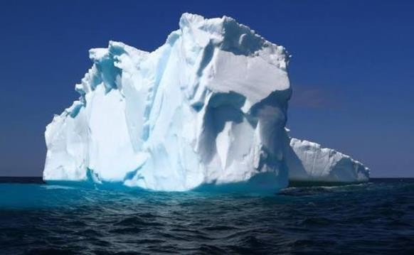………………………………………………

………………………………………………

………………………………………………

………………………………………………

………………………………………………

………………………………………………

………………………………………………

………………………………………………

………………………………………………

1. Why among the three states of matter, gases have the least density?

…………………………………………………………………………………………………

…………………………………………………………………………………………………

…………………………………………………………………………………………………

1. What is the relationship between mass, volume and density?

…………………………………………………………………………………………………

…………………………………………………………………………………………………

1. What does the word density mean? And state it’s SI unit.

…………………………………………………………………………………………………

…………………………………………………………………………………………………

1. What activity can you carry out to find the density of irregular solid which is heavier than water and insoluble in it. (Include illustrations)

……………………………………….…………………………………………………………

…………………………………………………………………………………………………

…………………………………………………………………………………………………

…………………………………………………..………………………………………………

…………………………………………………………………………………………………

…………………………………………………………………………………………………

………………………………………………………………………………………………..

1. Calculate the relative density of the liquid from the following information.

Mass of empty relative density bottle M1 = 24.5 Bottle with water mass M2 = 56.2g

Bottle with liquid M3 = 51.2g

……………………………………….………..

…………………………………………………

…………………………………………………

…………………………………………………

…………………………………………………

1. If mass of solid is **84.2 g**. Initial volume of water in a measuring cylinder is **36 ml**. Final volume of water in measuring cylinder is **60 ml**. Find the density of substance.

……………………………………….…………………………………………………………

…………………………………………………………………………………………………

…………………………………………………………………………………………………

…………………………………………………..………………………………………………

1. In an oil spill in the ocean, the oil rises to the top creating an oil slick on the surface of the ocean. State the reason why.

…………………………………………………………………………………………………

…………………………………………………………………………………………………

1. Helium balloons rise in air. Over time, the helium escapes the balloon and is replaced by air, causing it to sink. Explain the above scenario.

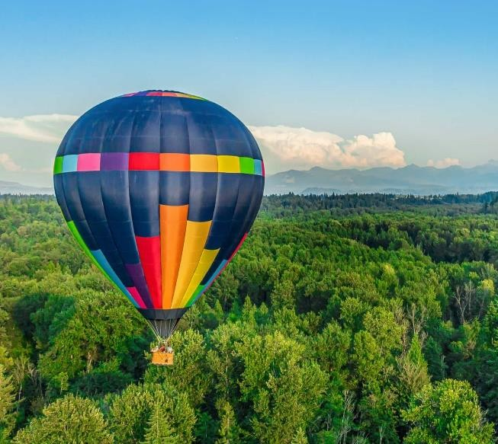……………………………………….……

…..…………………………………………

………………………………………………

………………………………………………

………………………………………………

………………………………………………

………………………………………………

…………………..…………………………

………………………………………………

………………………………………………

………………………………………………

………………………………………………

1. It is given that the density of mercury is 13600 kgm3. The density of water is1000 kgm3.
2. What is the relative density of mercury in SI unit?

……………………………………….…………………………………………………………

…………………………………………………………………………………………………

…………………………………………………………………………………………………

…………………………………………………………………………………………………

1. It is given that density of iron is **7800 kgm-3**. The density of water is**1000 kgm-3**. What is the relative density of iron in SI unit? Is it greater than relative density of mercury which is **13.6**? Will an iron rod sink in it or float?

……………………………………….……………………………………………………

………………………………………………………………………………………………

………………………………………………………………………………………………

…………………………………………………………….………………………………...

1. The figure below shows an application of density in real life. Identify and name the object in the picture and explain how it uses knowledge of density to travel both under the water and on surface of water.

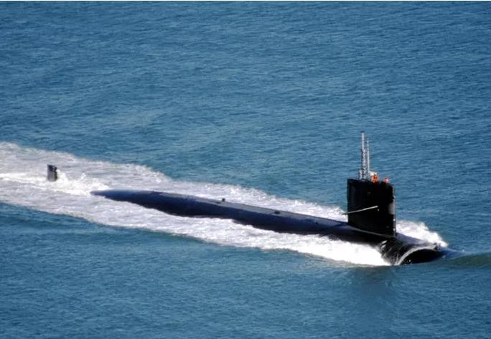……………………………………….…

……………………………………………

……………………………………………

……………………………………………

……………………………………………

……………………………………………

……………………………………………

……………………………………………

……………………………………………

……………………………………………

1. A cube measures **3.0cm** on each side and has a mass of **25g**. What is the density of the cube? Will the cube float in water? Will it float in benzene? (Density of benzene = **0.88 g/ml** and that of water is **1 g/cm3**)

……………………………………….…………………………………………………………

…………………………………………………………………………………………………

…………………………………………………………………………………………………

…………………………………………………………………………………………………

…………………………………………………………………………………………………

1. The density of gold is **19,300** 𝐤𝐠𝐦−𝟑. You are given a block of metal with a mass of **62.73 kg**. The object has a length of **10** centimeters, a width of **50** centimeters, and a height of **25** centimeters. Could the metal object be made from gold? That would be a lot of gold!

……………………………………….…………………………………………………………

…………………………………………………………………………………………………

…………………………………………………………………………………………………

…………………………………………………………………………………………………

…………………………………………………………………………………………………

…………………………………………………………………………………………………

1. Below is a model of a pyramid found at an archeological dig made of an unknown substance. It is too large to find the volume by submerging it in water. Also, the scientists refuse to remove a piece to test because this pyramid is a part of history. Its height is **150**.**0m**. The length of its base is **75**.**0m** and the width is **50**.**0m**. The mass of this pyramid is **5**.**50x105kg**. What is the density?

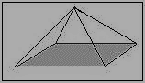

……………………………………….…………………………………………………………

…………………………………………………………………………………………………

…………………………………………………………………………………………………

…………………………………………………………………………………………………

**150m**

…………………………………………………………………………………………………

X

150m

…………………………………………………………….……………………………………

**50m**

…………………………………………………………………………………………………

**75m**

…………………………………………………………………………………………………

…………………………………………………………………………………………………

1. A ring has a mass of **5**.**00g** and a volume of **0**.**476** 𝒎𝒍. Is it pure silver? (Density of pure silver

**10.5 g/cm3**)

……………………………………….…………………………………………………………

…………………………………………………………………………………………………

…………………………………………………………………………………………………

…………………………………………………………………………………………………

1. Use the table below to answer the following questions about density.

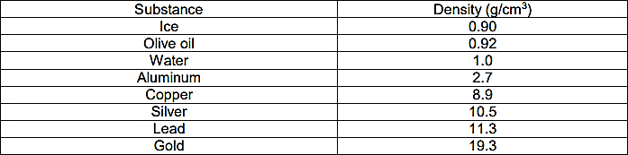

1. The mass of a silver ring is **21 g**. Its volume is **2 cm3**. Is the ring made of pure silver?

…………………………………………………………………………………………………

1. The mass of a chunk of metal is **50 g**. Its volume is **4**.**42 cm3**. What type of metal is it?

…………………………………………………………………………………………………..

1. A shiny substance was found that takes up **23**.**6 cm3** of space. Its mass is **63**.**72** g. What is the substance? )……………………………………………………………………………………..
2. A metal sample has a mass of **52**.**0 g** and a volume of **17**.**1** cubic centimeters. Could this sample be one of the metals in the table above? If so, which one?

………………………………………………………………………………………………….

1. The figure below shows effects of density differences on large water bodies like seas and oceans. Briefly explain the processes that lead to such occurrences of water disturbances.

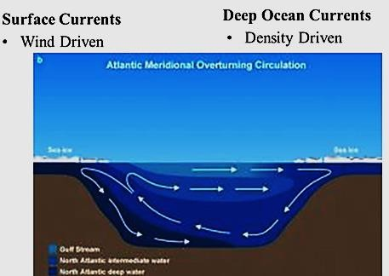……………………………………….…………………………………

…………………………………………………………………………

…………………………………………………………………………

…………………………………………………………………………

…………………………………………………………………………

…………………………………………………………………………

…………………………………………………………………………

……………………………….…………………………………………

…………………………………………………………………………

…………………………………………………………………………

…………………………………………………………………………

1. **200 cm3** of liquid **A** of density **0.7 gcm-3** is mixed with **100 cm-3** of liquid **B** of density

**0.9 gcm-3**. Assuming there was no loss of liquid during mixing and there was uniform mixing, find the density of the mixture.

……………………………………….…………………………………………………………………………………………………………………

……….…………………………………………………………………………………………………………………………………………………

……………………………………………………………………………………………………………………………………………………………

……………………………………………………………………………………….…………………………………………………………………

………………………………………………………………………………………………………………………………………………………….

1. Musa Put a fresh egg in a beaker of fresh water. He then Added salt and stirred as shown in the figure below. state and explain your observation.

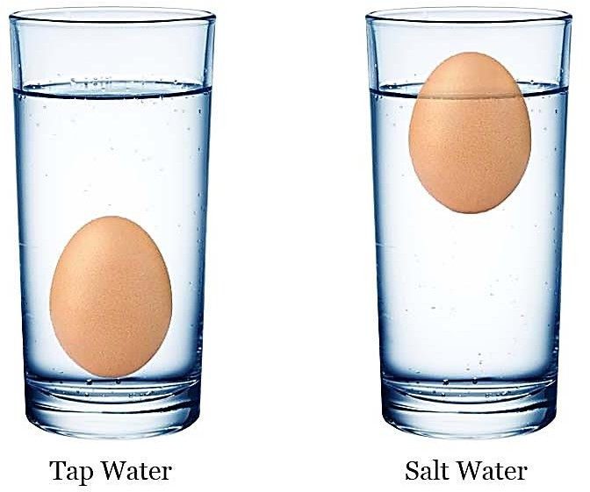……………………………………….………………………………

…………………………………………………………………………

……………….………………………………………………………

…………………………………………………………………………

…………………………………………………………………………

…………………………………………………………………………

…………………………………………………………………………

…………………………………….…………………………………

…………………………………………………………………………

…………………………………………………………………………

…………………………………………………………………………

…………………………………………………………………………

………………………………………………………………………..

1. 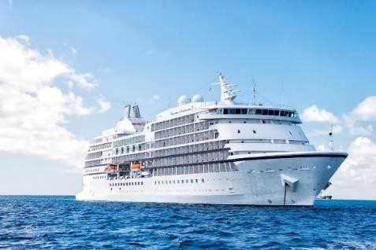What a surprise! A ship in the figure below is made of steel ( 𝜌 = 7.85 𝑔/𝑐𝑚3) which is denser than water ( 𝜌 = 1 𝑔/𝑐𝑚3 )and weighs 105, 000 tonnes, but it can still float on water.

……………………………………….………………………………………

…………………………………………………………………………………

.………………………………………………………………………………

…………………………………………………………………………………

…………………………………………………………………………………

…………………………………………………………………………………

……………………………………………………………….………………

…………………………………………………………………………………

…………………………………………………………………………………

##### Give the number of significant figures in each measurement.

(a) 4308 ………………………………………………………………………………………..

(b) 40.05 ……………………………………………………………………………………….

(c) 470,000 …………………………………………………………………………………….

(d) 4.00 …………………………………………………………………………………………

(e) 0.00500 …………………………………………………………………………………….

1. Express the final answer to the proper number of significant figures.

a) 101.2 + 18.702 =?..................................................................................................................

b) 202.88 − 1.013 =?..................................................................................................................

c) 1.02 + 8.2 + 3.33 + 9.781=?...................................................................................................

1. Calculate the correct number of significant figures for the final solution:

a) 76.4 × 180.4 =?......................................................................................................................

b) 934.9 ÷ 0.00455 =?................................................................................................................

1. A rectangular block of wood has a length of **5.24 cm**, a height of **3.645 cm** and a width of

**0.63 cm**. Calculate the volume of the block of wood. Give the answer to the appropriate number of significant figures and decimal places.

......................................................................................................................................................

......................................................................................................................................................

1. Jupiter is the largest planet in our solar system and its mass in scientific notation is about

**1.9 × 1027**. Write the mass in standard notation. What challenge have you faced using standard notation?

......................................................................................................................................................

......................................................................................................................................................

1. It is predicted that the world population in 2025 may reach eight billion. Write eight billion in scientific notation.

…………………………………………………………………………………………………..

1. The following masses which are parts of an atom are measured in grams. Order the parts of an atom from greatest to least mass.

electron: 9.1096 × 10-28, neutron: 1.6749 × 10-24, proton: 1.6726 × 10-24

…………………………………………………………………………………………………..

1. The weight of an adult male elephant is about 5600 kg. What is the weight in scientific notation?...................................................................................................................................
2. A computer can perform about 5 × 108 instructions per second. How many instructions is that per hour? Express the answer in scientific notation.

…………………………………………………………………………………………………

…………………………………………………………………………………………………

1. You want to know if water freezes faster on its own or with sugar added to it. Show all the steps you would follow using scientific method of solving a problem.

…………………………………………………………………………………………………

…………………………………………………………………………………………………

…………………………………………………………………………………………………

…………………………………………………………………………………………………

…………………………………………………………………………………………………

…………………………………………………………………………………………………

…………………………………………………………………………………………………

1. You went to the market to buy some goods with your friend Kaggwa. When you reached home you noticed that your wallet was gone. How could you use the scientific method to solve this problem?

…………………………………………………………………………………………………

…………………………………………………………………………………………………

…………………………………………………………………………………………………

…………………………………………………………………………………………………

…………………………………………………………………………………………………

…………………………………………………………………………………………………

…………………………………………………………………………………………………

1. You turn a light switch, and the bulb does not light. How could you use the scientific method to solve this problem? (Show step by step)

…………………………………………………………………………………………………

…………………………………………………………………………………………………

…………………………………………………………………………………………………

…………………………………………………………………………………………………

…………………………………………………………………………………………………..

......................................................................................................................................................

.....................................................................................................................................................

#### ACTIVITY OF INTEGRATION

**SCENARIO**

Some bottles of colorless liquids were being labeled when the technicians accidentally mixed them up and lost track of their contents. 𝟏𝟓. 𝟎 𝒎𝒍 sample withdrawn from one bottle weighed

**22.3 g**. The technicians knew that the liquid was either acetone, benzene, chloroform, or carbon tetrachloride. He however has challenges identifying the right chemical to label.

**SUPPORT MATERIAL**

|  |  |  |  |  |  |
| --- | --- | --- | --- | --- | --- |
| **LIQUID** | Acetone | Benzene | Chloroform | water | Carbon tetrachloride |
| **DENSITY**  (𝒈/𝒄𝒎𝟑**)** | 0.792 | 0.899 | 1.489 | 1.000 | 1.595 |

**TASK**

1. What was the identity of the liquid? (Clearly show each step of your work out)
2. Name those liquids which can float on water and explain why they float on water
3. Name those liquids on which water floats on top and explain why water floats on those liquids named.

#### QUESTION 2

**SCENARIO**

Your teacher of physics happens to be on sick leave but before leaving the school he had already told the class of what they were going to study next which happens to be about measurements. He had left you with many measurements equipment to be used during the lesson.

**SUPPORT MATERIAL**

|  |  |  |
| --- | --- | --- |
|  |  |  |
|  |  |  |

**TASK**

As the class captain during the teacher’s absence, briefly explain to the senior ones the **name**, **use**

and **S.I units** of the following instruments that the teacher left with you.

**SCENARIO**

**ACTIVITY OF INTEGRATION**

You are working in the office of a precious metals’ buyer. A miner brings you a nugget of metal that he claims is gold. The person wants you to buy it for $1000, You suspect that the metal is a form of "fool's gold," called marcasite, which is composed of iron and sulfur. In the back of your office, you have a chunk of pure gold.

**SUPPORT MATERIAL**

Density of gold is 19.3 grams per cubic centimetre

**TASK**

What simple experiments could you perform to determine whether the miner's nugget is pure gold? Is it gold? Should you buy it?

**SCENARIO**

**QUESTION 2**

You are discussing for a class of senior one PHYSICS, and they are confused about an object's MASS versus its WEIGHT. Keeping in mind that most senior ones don't understand easily, how will you help simplify to them the discussion of mass and weight.

**SUPPORT MATERIAL**

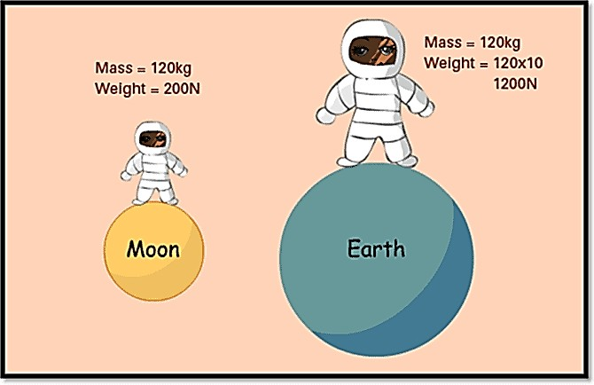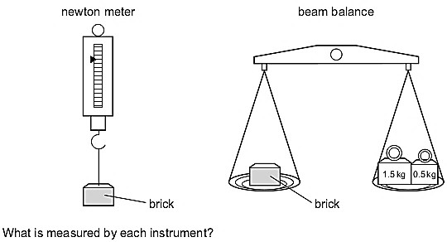

**TASK**

(a) How would you explain these two ideas and illustrate how they differ? What examples would you use as a part of your explanation?

**SCENARIO**

**ACTIVITY OF INTEGRATION**

your father wants to buy an irregular shaped plot of land but he fears that he may spend a lot of money than usual because he doesn’t know how to obtain the actual value of the land without knowing it’s actual size.

**SUPPORT MATERIAL**

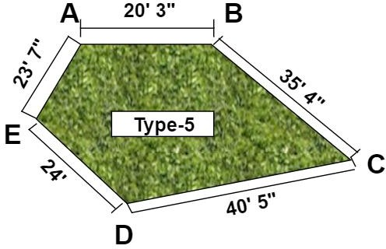

**TASK**

Briefly explain the steps you would follow to help him determine the ACTUAL area of the plot of land so that he doesn’t get cheated. (Include illustrations).

**QUESTION 2**

**SCENARIO**

Alvin has a prism-like water tank whose base area is 0.90 square meters and height is 0.60 meters. He wants to buy guppy fish, and the pet store owner tells him to make sure their density in the tank isn't more than 5 fish per cubic meter. He is confused on what to do about this.

**SUPPORT MATERIAL**

**0.60m**

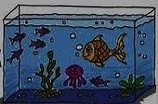

**TASK**

Assuming you are a friend of Alvin. Write down how you will help him to find the maximum number of fish suitable for the tank?

**SCENARIO**

### ACTIVITY OF INTEGRATION

A student wants to calculate the density of the two objects shown below: He however has some challenges in doing so help him write him all the procedures to be followed for accurate results. **SUPPORT MATERIAL**

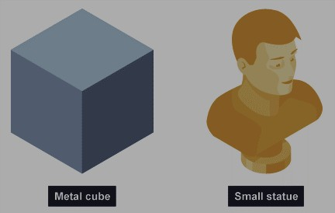

**TASK**

Describe the methods that the student should use to calculate the densities of the two objects

## Chapter 3 States of matter

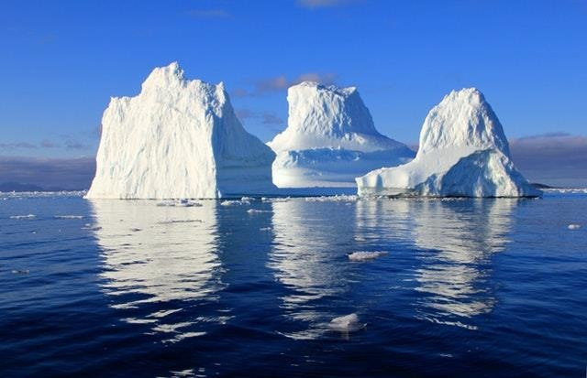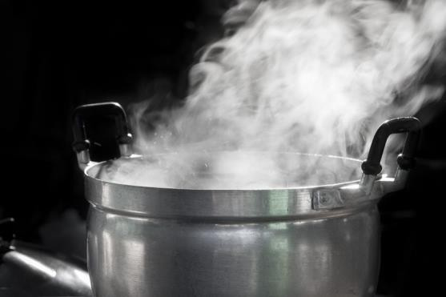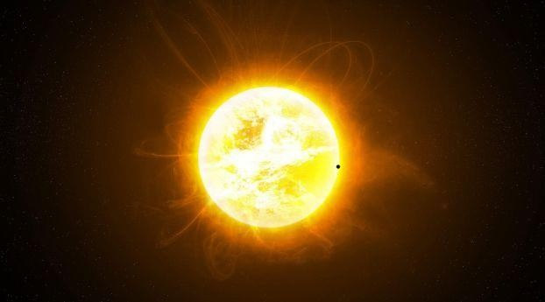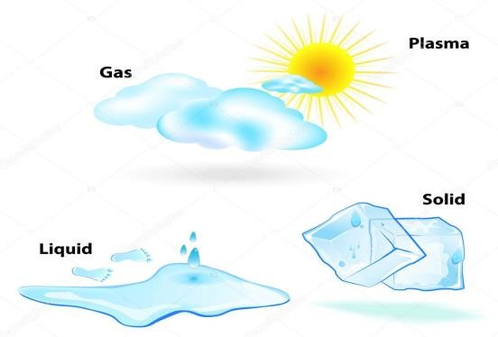

**KEY LEARNING OUTCOMES**.

*By the end of this chapter, you should be able to:*

* understand the meaning of matter.
* understand that atoms are the building blocks from which all matter is made.



* appreciate that the states of matter have different properties.
* apply the particle theory of matter to explain Brownian motion and diffusion and their applications.
*  understand how the particle theory of matter explains the properties of solids, liquids and gases; change of state.
* understand that a change from one state to another involves either heat gain or loss.



* understand the meaning of plasma in physics.

**INTRODUCTION**

Matter is all around you. All atoms and compounds are made up of very small pieces of matter. Such atoms continue to build the everyday things you see and touch. Matter is defined as anything that has mass (it has volume) and takes up space.

The four types of matter are solids, liquids, and gases, plasma. Particles that makeup matter are called atoms and molecules. Matter is also composed of small particles. Atoms are the particles that makeup matter. Because they are so small you can’t see atoms. Most atoms come together to make up the substance you can see.

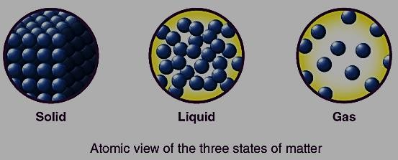*When water turns into snow, is it still water? The answer is yes! Our world is filled with* ***solids****,* ***liquids****,* ***gases*** *and even other matter that can go from one state of matter to another without changing its chemical substance.*

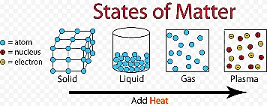

### WORKSHEET (SHORT ANSWER QUESTIONS)

1.

1. Complete the diagram below

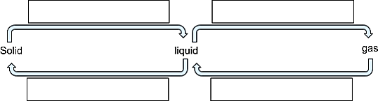

1. Tick or Cross to show which states have which properties

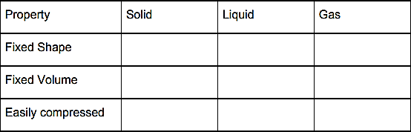

1. Wet clothes are put on a washing line to dry. The water in the clothes turns into water vapour in the air as the clothes dry.
   1. Name the change as water turns into water vapour …………………………………………
   2. Rain forms from water vapour in the air. Name this change ……………………………….
   3. The clothes dry much faster on a sunny day, explain why in terms of particles.

…………………………………………………………………………………………………

…………………………………………………………………………………………………

…………………………………………………………………………………………………

1. Some substances can change directly from a solid to a gas, research the name of this process. Can you find an example of a substance that behaves like this?

…………………………………………………………………………………………………

1. The diagram below shows particles in a gas, a solid and a liquid. Each arrow, A, B, C and D, represents a change of state.

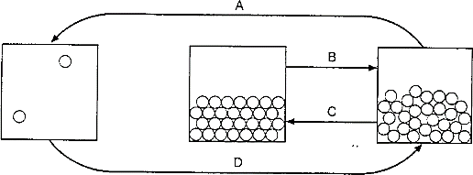

Choose from the following words to complete the sentences below:

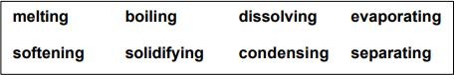

1. Change of state A is called
2. Change of state B is called
3. Change of state C is called
4. Change of state D is called
5. The box below contains some statements about the particle model of a solid. All the statements are correct.

|  |  |
| --- | --- |
| **A** | The particles are very closely packed together. |
| **B** | The particles are tightly bound to their neighbours. |
| **C** | The particles vibrate in their positions but cannot move around. |
| **D** | The particles are arranged in a regular pattern. |
| **E** | If you heat a solid, the average speed with which the particles vibrate gets bigger. |

Which of the statements above help to explain each of the following? Write a letter (or letters) on the line to show your answer

(a) Solids do not flow or pour…………………………………………………………….

* 1. Solids cannot easily be compressed………………………………………………….
  2. Above a certain temperature, many solids melt and turn into liquid…………………
  3. Some solids form crystals…………………………………………………………….

1. The box below contains some statements about the particle model of a liquid. All the statements are correct.

|  |  |
| --- | --- |
| **A** | The particles are very closely packed together. |
| **B** | The particles are not tightly bound to their neighbours. |
| **C** | The particles vibrate and jostle around. |
| **D** | The particles are not arranged in a regular pattern. |
| **E** | If you heat a liquid, the average speed with which the particles vibrate gets bigger. |

Which of the statements above help to explain each of the following? Write a letter (or letters) on the line to show your answer.

1. Liquids flow easily and can be poured.
2. Liquids are difficult to compress.
3. Above a certain temperature, a liquid boil and turns into a gas
4. The box below contains some statements about the particle model of a gas. All the statements are correct.

|  |  |
| --- | --- |
| **A** | The particles are far from each other. |
| **B** | The particles collide with the walls of the container they are in. |
| **C** | The particles move around rapidly in all directions. |
| **D** | The particles are too far apart to exert any force on each other |
| **E** | If you heat a gas, the average speed with which the particles get bigger. |

Which of the statements above help to explain each of the following? Write a letter (or letters) on the line to show your answer.

1. Gases are fairly easy to compress.
2. Gases spread out to fill the whole space they are in.
3. Gases don’t settle to the bottom of a container, but fill the whole space.
4. Gases are less dense than solids and liquids
5. It is impossible to represent the particles in solids, liquids and gases accurately in a diagram. So, all drawings show some aspects of the particle model well, and others not so well.

This diagram from a textbook illustrates the particle model of a solid dissolving in a liquid:

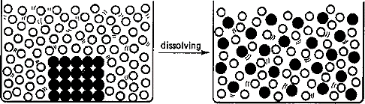

State three ways in which you think the diagram is a good representation of a solid dissolving in a liquid:

1

2

3

1. There is solid ice on a car’s rear window. The glass window contains an electrical heating element.

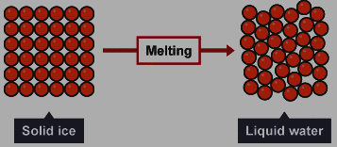

*Use the particle model above to describe how the heating element causes the arrangement of the ice particles to change as the ice melts.*

*You should include a description of how the particles are arranged in the solid ice and in the water.*

1. Central heating boilers burn gas and use the energy released to heat water. Modern condensing central heating boilers take advantage of the energy that is released when water condenses. Waste water vapour produced when the water is heated in the boiler is used to preheat the cold water entering the boiler.

Give some of the arguments in favour of condensing boilers compared to older non-condensing boilers. **[4 marks]**

1. If someone is cooking in the kitchen, the smell travels around the house to other rooms. This is because of_
2. The particles of smelly gas are free to move quickly in all directions as shown below

Describe and explain the movement of particles

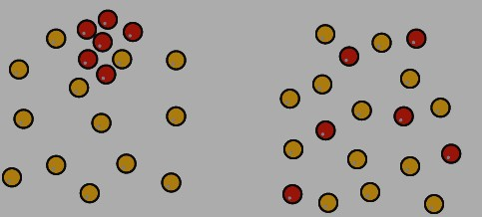

1. Potassium permanganate was put in the beaker having water as shown below.

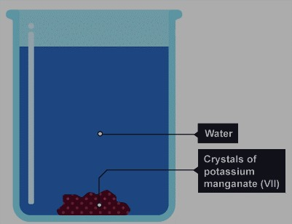

a) Describe and explain what happens after some time.

1. Suggest what would happen if the setup above was heated.
2. The figure below shows one of the factors affecting diffusion. Study it carefully and answer the questions that follow.

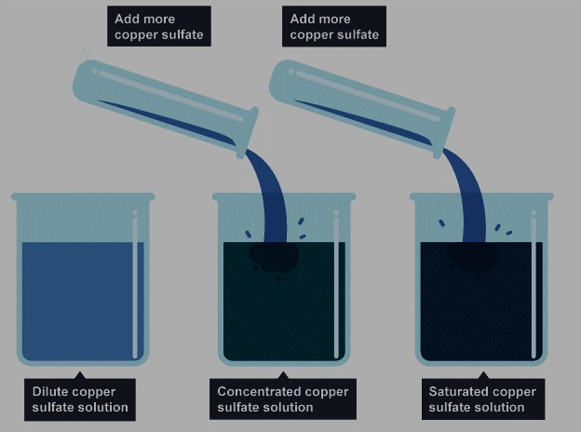

1. Name the factor affecting the rate of diffusion shown in the figure…………………………

….

1. Explain how it affects the rate of diffusion using particle theory of matter………………………

…………………………………………

…………………………………………

…………………………………………

…………………………………………

…………………………………………

* 1. Name any other three factors that affect the rate of diffusion and state how.

………………………………………………………………………………………………

………………………………………………………………………………………………

………………………………………………………………………………………………

1. The figure below is why balloons and tyres burst if you blow them up too much. It is also why deodorant spray cans carry warning signs to tell you not to leave them in the sunshine. If they get too hot, they may explode.

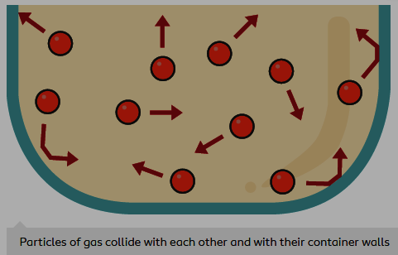Briefly explain the effect of heat on gas molecules in the tyres using particle theory of matter.

…………………………………………

…………………………………………

…………………………………………

…………………………………………

…………………………………………

…………………………………………

…………………………………………

1. The figure below shows a demonstration of a certain experiment in physics.
   1. 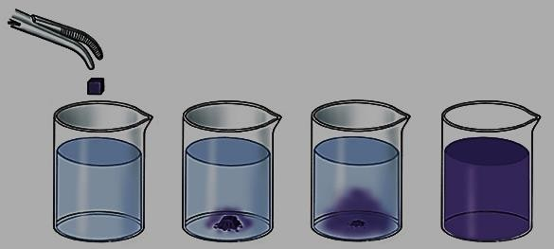Which experiment is being demonstrated in the figure?...........................................

…………………………………..

* 1. Briefly describe the processes taking place in the experiment shown.

……………………………………

……………………………………

……………………………………

……………………………………

1. Small particles (such as pollen or smoke particles) suspended in a liquid or gas are observed to move around in a random, erratic fashion as shown in the figure below.
   1. 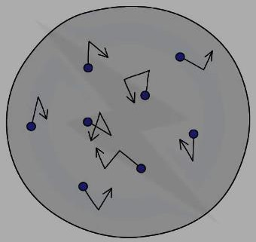Name the process taking place in the figure……………………...
   2. Briefly describe and explain the process taking place

………………………………………………………………………

………………………………………………………………………

………………………………………………………………………

………………………………………………………………………

* 1. Name any other three real life examples of such motions shown in the figure above.

…………………………………………………………………………………………………

…………………………………………………………………………………………………

…………………………………………………………………………………………………

1. Joseph First filled one bowl with cold water, and another with boiled hot water. Then he just left them to settle for 5-10 minutes.

Then he added just a little food colouring in each bowl in a nice controlled way. Perhaps by dipping a handle of a teaspoon into the food colouring and then just touch the surface of each bowl of water with it.

1. State what was observed in the above experiment.

………………………………………………………………………………………………

………………………………………………………………………………………………

………………………………………………………………………………………………

1. Explain your observation

………………………………………………………………………………………………

………………………………………………………………………………………………

………………………………………………………………………………………………

1. Name any two adjustments you can make so that the experiment takes place faster.

………………………………………………………………………………………………

………………………………………………………………………………………………

1. Brownian motion of smoke particles can be studied by using the apparatus shown below. To observe the motion, some smoke is enclosed in the smoke cell and then observed through the microscope as shown below,
   1. 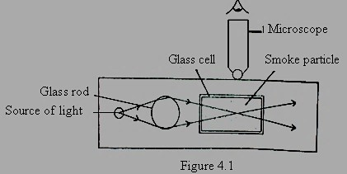Explain the role of the smoke particles, glass rod and microscope in the experiment

…………………………………………………………………………

…………………………………………………………………………

…………………………………………………………………………

…………………………………………………………………………

* 1. State and explain the nature of the observed motion of the smoke particles

……………………………………………………………………………………………………………………………………………………

……………………………………………………………………………………………………………………………………………………

…………………………………………………..…………………………………………………………………………………………………

…………………………………………………………………………………………………………………………………………………….

* 1. State what will be observed about the motion of the smoke particles if the temperature surrounding the smoke cell is raised slightly

…………………………………………………………………………………………………………………………………………………….

* 1. Explain your observation in c) above

……………………………………………………………………………………………………………………………………………………

…………………………………………………..…………………………………………………………………………………………………

……………………………………………………………………………………………………………………………………………………

……………………………………………………………………………………………………………………………………………………

#### ACTIVITY OF INTEGRATION

**SCENARIO**

One rainy day one of your community members was struck by lightning and his body was having third degree skin burns and deep wounds. Most community members claimed it was witchcraft, maybe they are right or there maybe another better explanation to this scenario using knowledge of states of matter

**SUPPORT MATERIAL**

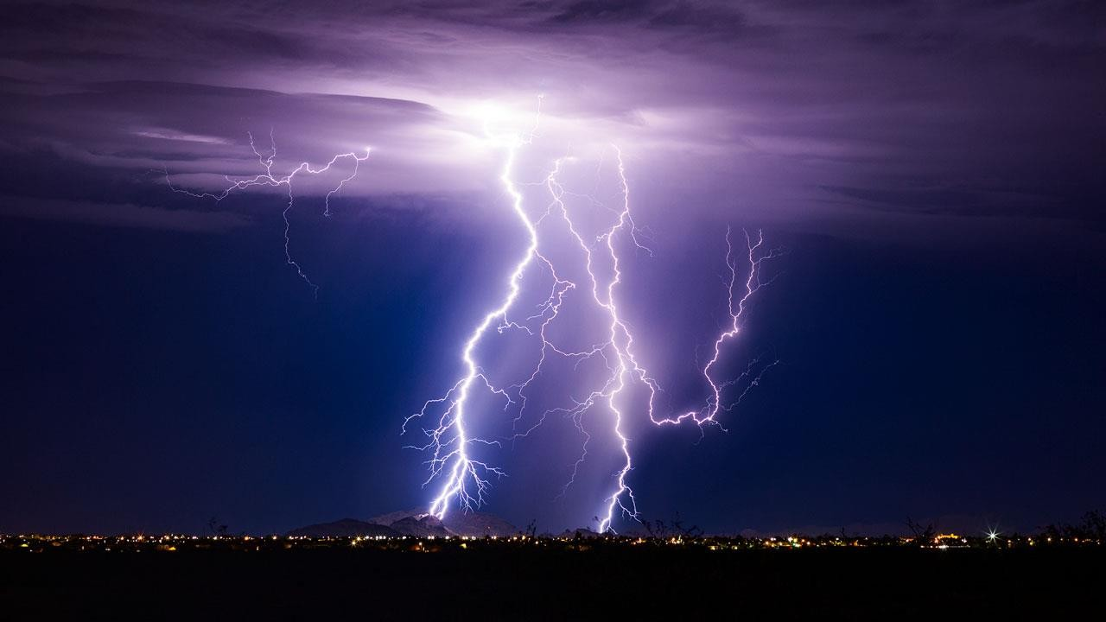

**TASK**

1. briefly explain to them what lightening really is and how lightening occurs?
2. What possible advices would you give to the community members to avoid lightning strikes in the future?
3. Name any other three examples of the above state of matter shown in the figure above
4. Of what importance is studying the above states of matter (where is it useful in real life)

**SCENARIO**

#### ACTIVITY OF INTEGRATION

One of your friends works at the parking yard in a certain hotel which is in a very hot part of northern Uganda in kitgum district. You visited him one day and discovered that the parking yard is an open place with no shelter from the extreme harsh hot weather conditions. He then informed you that the main problem he faces at his work place is that most customers who visit the hotel always quarrel with him over flat tyres (tire blowouts) at the time of their departure.

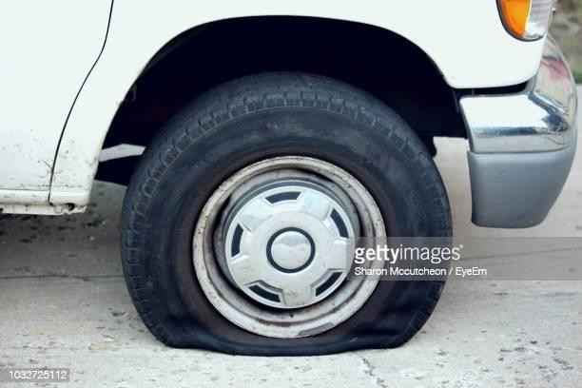**SUPPORT MATERIAL**

**TASK**

1. Help your friend understand the cause of such a phenomenon. Explain to your friend why the tyres are flat (blowout)?
2. What recommendations or advice would you offer to your friend to ensure such scenarios don’t repeat itself again?
3. What conclusions can you draw from such a scenario (what is the relationship between heat and matter)?

**SCENARIO**

### ACTIVITY OF INTEGRATION

You left your room clean as were heading back to school. All tables were wiped very clean, all windows had their curtains lowered and both the windows and doors were all locked perfectly. At the end of the term (after about three months) you returned back home but to your surprise you found your room dusty which was not the case when you left for school, the tables which was clean is now dusty, the cupboard is dusty and the room needs to be cleaned again for you to sleep peacefully.

**SUPPORT MATERIAL**

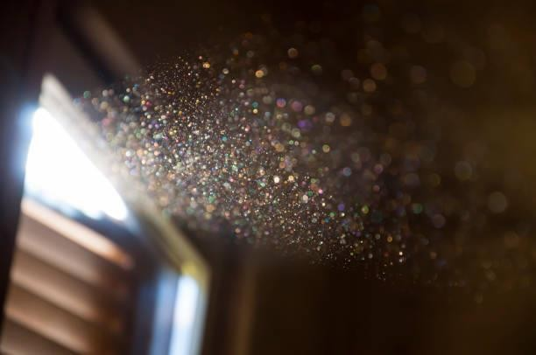

**TASK**

1. Explain why you think dust particles settled on the tables, cupboards and other parts of the room despite the fact that the room was perfectly closed. (Include illustrations of dust movement). Is it possible to overcome this inconvenience caused by dust particles? If yes how?
2. What are the factors that can affect the rate of movement of dust particles in the room and how does it affect the rate of movement of dust particles?

**SCENARIO**

### ACTIVITY OF INTEGRATION

Several people in the past and present have tried various methods to create rain but was it luck or a true scientific discovery? The question of some humans wielding the power to control the rain has been on for years, littered across history are stories of legendary rainmakers and their acts, one notable act is the story of **Irene Mutoto** a resident of Karubuga village in Ibaare Sub County in **Bushenyi** district. The people in her community identify her as the **rainmaker**.

Mutoto, aged 50 as she estimates says she has been “artificially inducing rain” for the last 28 years the powers she received after her father made special cuts on her shoulders and rubbed in charms, an act locally known as **Okushandaga**. Irene is not the only rainmaker in her village. Six other people in her **Karubuga** village, including her family members claim to be having powers to do exactly what she does.

On several occasions, they are hired to stop rain from disrupting burial ceremonies; wedding parties; musical, among others. They are also paid to induce rain especially during planting seasons. In return for their services, the ‘rainmakers’ are usually given meat particularly lungs and duodenum; local beer; chicken and all kinds of food stuffs.

Communities such as the Banyankole, the Karamojong and Iteso among others believe that it is possible for rainmakers to alter weather patterns. This is the reason why communities attribute some effects of climate change such as droughts, floods and destructive hailstorms to them.

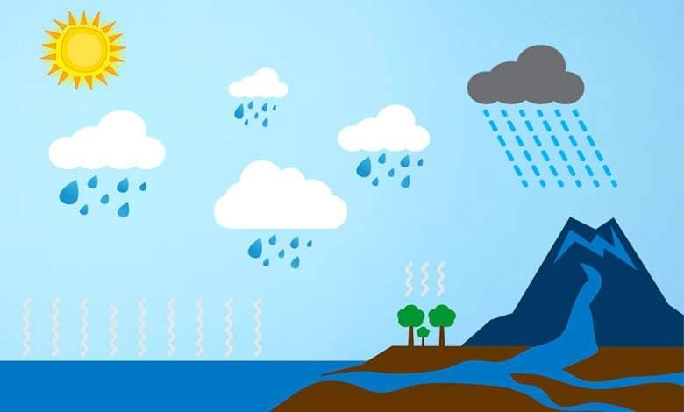**SUPPORT MATERIAL**

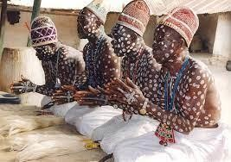

**TASK**

1. Do you believe in this ancient power, will you be employing the services of one during your events? The question that remains unanswered however is “why do we have droughts? Why wouldn’t these guys during drought bring rain?”.
2. “What I know is that there are areas which you need scientific explanations instead of depending on these wizards.” Explain the actual processes involved in the actual rain formation (You may include illustrations).

## Chapter 4

Effects Of Forces

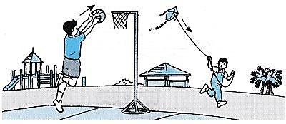

**KEY LEARNING OUTCOMES**

*By the end of this chapter, you will be able to:*

* + appreciate that a force is a push or a pull, and that the unit of force is the Newton.



* + appreciate the effects of balanced and unbalanced forces on objects.
  + understand the importance of friction in everyday contexts.
  + understand the existence of the force of gravity and distinguish between mass and weight.
  +  appreciate that the weight of a body depends on the size of the force of gravity acting upon it.
  + understand the meaning of cohesion and adhesion.



* + explain surface tension and capillarity in terms of adhesion and cohesion.

**INTRODUCTION**

You all have experienced a force in some way. Forces play a role in everything that we do. It may be kicking a ball, turning a tap, or even taking a bite! What shows that there is a force? In this chapter, you will learn different kinds of forces and how they affect objects.

**SHORT ANSWER QUESTIONS (WORKSHEET)**

1. The following statements are true according to effect of forces:
   1. A force can move a stationary object
   2. A force can change the speed of a moving object.
   3. A force can stop a moving object.
   4. A force can change the direction of a moving object.
   5. A force can change the shape of an object.

Give a real-life experience (an example) of each of the above-mentioned effect of forces in A, B, C, D, and E above.

A. ………………………………………………………………………………………………

B. ………………………………………………………………………………………………

C. ………………………………………………………………………………………………

D. ………………………………………………………………………………………………

E. ………………………………………………………………………………………………

1. Give two examples each of situations in which you **push** or **pull** to change the state of motion of objects.

…………………………………………………………………………………………………

…………………………………………………………………………………………………

…………………………………………………………………………………………………

…………………………………………………………………………………………………

1. What brings a change in the state of the motion of an object?

………………………………………………………………………………………………..

1. State what happens to the spring when masses are attached to it.

………………………………………………………………………………………………..

1. Name any three objects that can change both its shape and size due to application of force on it.

…………………………………………………………………………………………………

…………………………………………………………………………………………………

1. A pull or push that changes the position or state of an object is called ……………

7. The S.I unit of force is called ……………………………………………………………..

1. is the instrument used for measuring force.
2. What is the sum of all forces exerted on an object called?

…………………………………………………………………………………………………

1. What type of forces are applied when the objects involved are in direct contact?

………………………………………………………………………………………………….

1. The following are different types of forces.

Frictional Force, Tension Force, Electrical Force, Normal Force, Magnetic Force, Air Resistance Force, Applied Force, Spring Force, Gravitational Force.

* 1. Classify the above forces into the two main categories of contact and non- contact forces.

1. 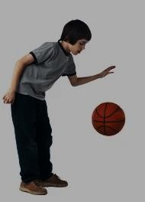What makes a ball bounce?

………………………………………………………………………………………………………………

………………………………………………………………………………………………………………

………………………………………………………………………………………………………………

………………………………………………………………………………………………………………

………………………………………………………………………………………………………………

………………………………………………………………………………………………………………

………………………………………………………………………………………………………………

………………………………………………………………………………………………………………

………………………………………………………………………………………………………………

1. Why does something drop when I throw it up?

…………………………………………………………………………………………………

………………………………………………………………………………………………….

1. How does a magnet work?

…………………………………………………………………………………………………

………………………………………………………………………………………………….

1. Are all metals affected by magnets?

…………………………………………………………………………………………………

………………………………………………………………………………………………….

1. Why do some planets have more gravity than others?

…………………………………………………………………………………………………

………………………………………………………………………………………………….

1. Why doesn't anything on a table just fall through the table?

…………………………………………………………………………………………………

………………………………………………………………………………………………….

1. How do you measure force?

…………………………………………………………………………………………………

………………………………………………………………………………………………….

1. Is there gravity in space?

…………………………………………………………………………………………………

………………………………………………………………………………………………….

1. Does the sun have gravity?

…………………………………………………………………………………………………

…………………………………………………………………………………………………

1. What do we call a force from water that pushes things up……………………………………
2. What do we call a force that tries to slow things down when two things rub together.

……………………………………………………………………………………………….

1. State what happens two forces working in opposite directions are not the same strength.

……………………………………………………………………………………………….

1. 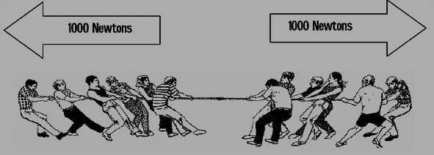Study the figure below about effect of forces and answer the following questions.
   1. Name the force taking place in the figure above…………………………………….

b) What is the resultant force?.........................................................................................

1. 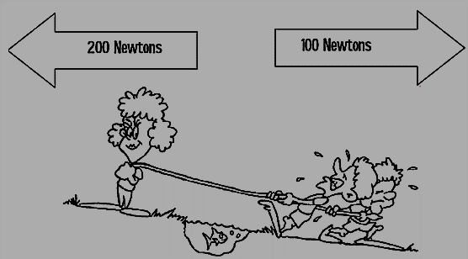Study the figure below carefully and answer the questions that follow.
   1. What is the resultant force from the figure shown.

……………………………………………………

……………………………………………………

……………………………………………………

……………………………………………………

1. What do you think will happen to a body when the forces acting on it are all **balanced**?

…………………………………………………………………………………………………..

1. What do you think will happen to a body when the forces acting on it are all **unbalanced**?

…………………………………………………………………………………………………..

1. Jack is going skiing. Does he need high or low friction between his skis and the snow?

Explain your answer.

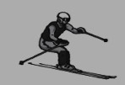………………………………………………………………………………………………………………………

………………………………………………………………………………………………………………………

………………………………………………………………………………………………………………………

………………………………………………………………………………………………………………………

………………………………………………………………………………………………………………………

1. 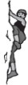Jill is climbing. Where does she need high friction? Explain your answer.

………………………………………………………………………………………..

……………………………………………………………………………………….

1. The drawing shows Samir riding his mountain bike.

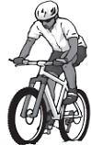

i)

ii)

Draw a circle around the places on the drawing where there should be a lot of friction.

Explain why there should be a lot of friction in these places.

………………………………………………………………………

………………………………………………………………………

………………………………………………………………………

………………………………………………………………………

1. What two things should Samir do in order to reduce the friction on the parts of the mountain bike?

…………………………………………………………………………………………………

…………………………………………………………………………………………………

1. Draw a square around a place where friction should be low on the mountain bike.
2. Explain why there should be low friction in these places.

…………………………………………………………………………………………………

…………………………………………………………………………………………………

…………………………………………………………………………………………………

1. What two things should Samir do in order to increase the friction on the parts of the mountain bike?

…………………………………………………………………………………………………

…………………………………………………………………………………………………

1. Label the forces.
   1. 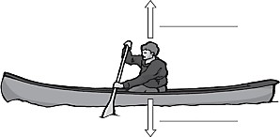What two forces affect you when you float?

…………………………………………………

* 1. What is the relationship between the two forces When an object floats,

………………………………………………….

1. 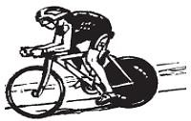The force that stops the cyclist from skidding is called

………………………………………………………..

1. Two forces are trying to make the cyclist slow down. They are

…………………………….and………………………………

1. 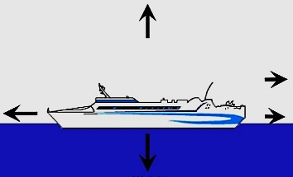Label the forces on this ship.

Use the letters next to each phrase

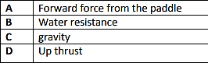

1. What can friction do to moving objects?

………………………………………………………………………………………………….. 36. What is a force that pulls things down to Earth?.........................................................................

1. The amount of force with which gravity is pulling down on something is called?.....................
2. Decide whether each picture/statement below indicates **more** friction or **less** friction.

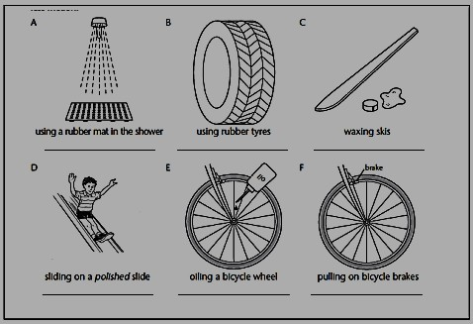

1. Name the forces:
   1. A force which pulls you down………………………………………………………
   2. This force helps to hold things on fridge doors……………………………………..
   3. This force rubs things away…………………………………………………………
   4. This force helps a ship float…………………………………………………………
   5. This type of force needs to touch something to affect it……………………………
   6. A force that slows down things moving through air………………………………..
2. Write the forces below to show whether they are Contact or Non-Contact forces:

Air resistance, gravity, friction, magnetic force, static electricity, water resistance

|  |  |
| --- | --- |
| Contact force | Non-Contact force |
|  |  |
|  |  |
|  |  |
|  |  |

1. 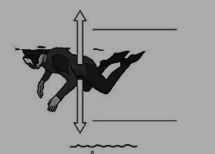Josh is learning to dive.

He is seen floating in the water. Label the two forces.

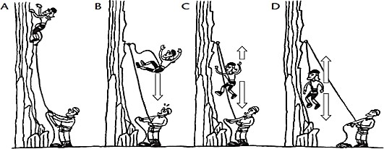

1. i) What force or forces are acting on the falling climber in picture B?

………………………………………………………………………………………………… ii) What forces are acting on the climber in C?.........................................................................

1. Are the forces balanced or unbalanced? ………………………………………………….
2. What will happen to the falling speed of the climber? ……………………………………
3. Are the forces balanced or unbalanced in D? …………………………………………….
4. If two forces are the same size and are in the opposite directions, they are

…………………………………………………………………………………………………

1. Matilda and Ravi carried out an experiment with springs. They put different masses on the spring and measured the length of the spring each time. The table shows some of their results

|  |  |  |
| --- | --- | --- |
| **Mass (g)** | **Weight (N)** | **Length (cm)** |
| 0 | 0 | 10 |
| 200 | 2 | 14 |
| 400 | 4 | 18 |
| 600 |  | 22 |
| 800 |  | 26 |
| 1000 |  | 30 |

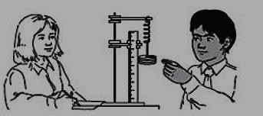

1. Fill in the missing weights in the table.
2. Draw a graph to show the results.
3. write the best conclusion for this experiment from the graph drawn.
4. 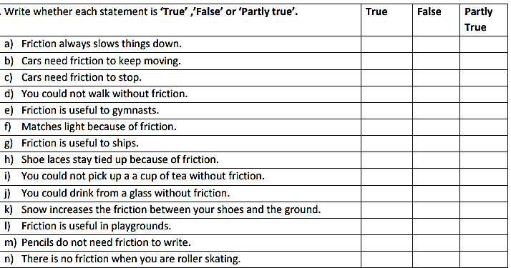45.
5. A boy pulls a wagon with a force of 6 N east as another boy pushes it with a force of 4 N east. What is the net force?..........................................................................................................

………………………………………………………………………………………………….

1. Mr. Smith and his wife were trying to move their new chair. Mr. Smith pulls with a force of 30 N while Mrs. Smith pushes with a force of 25 N in the same direction. What is the net force?.......................................................................................................................................

……………………………………………………………………………………………….

1. The classes are playing tug of war. **Mrs**. **Larson’s** homeroom pulls with a force of **50 N**. Ms. **Mitko’s** homeroom pulls with a force of **45 N** in the opposite direction. What is the net force? And who won?...............................................................................................................

…………………………………………………………………………………………………

…………………………………………………………………………………………………

1. Draw a picture below that shows an example of a balanced force (examples: a bird’s nest in a tree, a hat on a person’s head, or a light hanging from a ceiling). Show the forces acting on the object. In a separate picture show what would happen to the object if the forces became unbalanced.

…………………………………………………………………………………………………

…………………………………………………………………………………………………

…………………………………………………………………………………………………

…………………………………………………………………………………………………

…………………………………………………………………………………………………

…………………………………………………………………………………………………

…………………………………………………………………………………………………

1. The force that results from all the combined forces acting on the object is called the **net force.** Calculate the net force acting on the following problems.

Be sure to include the direction of the net force (left or right).

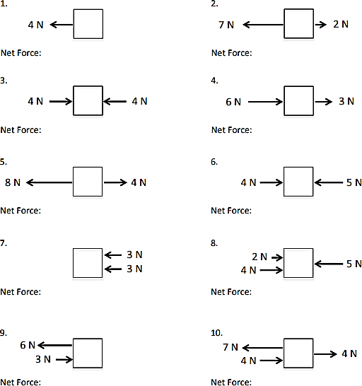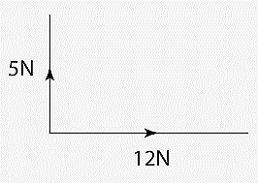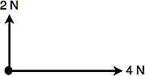

1. If a scale says 80 kg after you step on it, is that a measure of your weight?..............................
2. Jason purchased 7 kg 200 g of sugar, 9 kg 395 g of rice. What is the total weight which Jason carried?

…………………………………………………………………………………………………

…………………………………………………………………………………………………

…………………………………………………………………………………………………

1. A rickshaw-puller is carrying two persons weighting 52 kg 250 g and 37 kg 700 g. What is the total weight of the two persons carried by the rickshaw-puller?

…………………………………………………………………………………………………

…………………………………………………………………………………………………

…………………………………………………………………………………………………

1. The total weight of Tania’s bag is 45 kg 750 g and Diana’s bag is 43 kg 950 g. Whose bag is heavier and by how much?

…………………………………………………………………………………………………

…………………………………………………………………………………………………

…………………………………………………………………………………………………

1. A truck was loaded with 352 kg 100 g of pumpkins and 207 kg 432 g of watermelons. Find the total weight carried by the truck.

…………………………………………………………………………………………………

…………………………………………………………………………………………………

…………………………………………………………………………………………………

1. The force of gravity acting on an object is called………………………………………………
2. The measure of the amount of matter in an object is called…………………………………...
3. A girl has a weight of 88 N on the moon, where g = 1.6 N/kg. What is her mass?

…………………………………………………………………………………………………

…………………………………………………………………………………………………

1. If Earth's mass was cut in half, EXPLAIN what would happen to your weight?

…………………………………………………………………………………………………

………………………………………………………………………………………………….

1. On which celestial object (stars and planets and outer space) would your mass be the greatest?.......................................................................................................................................

61. If mass = 60 kg, weight on Earth = …………………………………………………………….

62. If weight on Earth = 54 N, mass = …………………………………………………………….

63. If weight on Earth = 4.80 N, mass = …………………………………………………………..

1. Do I weigh less on the equator than at the North Pole? Why?

…………………………………………………………………………………………………

…………………………………………………………………………………………………

1. The acceleration of gravity on the moon is significantly less than the acceleration of gravity on earth. What will happen to an astronaut's weight and mass on the moon, compared to her weight and mass on Earth?

……………………………………………………………………………………………….

1. An astronaut lands on a new planet and discovers her weight on this planet is half of her weight on Earth. What is the acceleration due to gravity on this planet in terms of the acceleration due to gravity on Earth (𝑔 = 10 𝑚/𝑠2 on earth)

………………………………………………………………………………………………

1. A ball that weighs 4N on Earth weighs 19Non a recently discovered planet. What is the force of gravity on this new planet? Give your answer with the correct number of significant figures.

…………………………………………………………………………………………………

…………………………………………………………………………………………………

1. The figure below is a man on earth and same man on the moon.

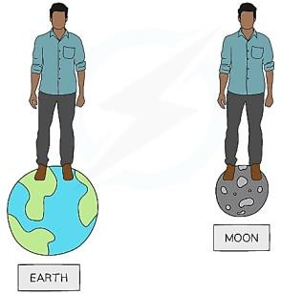Where does the man weigh more why?

...............................................................................................................

...............................................................................................................

...............................................................................................................

...............................................................................................................

...............................................................................................................

......................................................................

1. The figure below shows different gravitational strength of different bodies in our solar system. Study and answer the questions that follow.

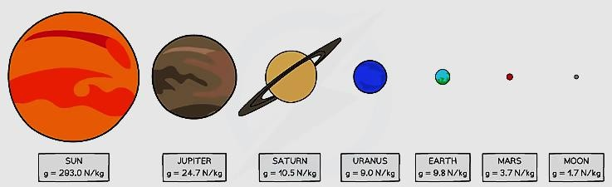

* 1. Which body has the body has the greatest strength of gravity?.............................................

b) Why do you think so?............................................................................................................

c) Which body has the least strength of gravity?.......................................................................

d) Why do you think so?............................................................................................................

e) On which body will a human weigh heaviest?......................................................................

f) On which body will a human weigh least?...........................................................................

g) What conclusion can you draw from the above picture on variation of gravitational strength of different bodies on our solar system

………………………………………………………………………………………………

………………………………………………………………………………………………

1. A student estimates she would have a weight of 190 N on Mars. Calculate the weight of the student on Earth. (The gravitational field strength on Earth is 9.8 N/kg. The gravitational field strength on Mars is 3.8 N/kg).

…………………………………………………………………………………………………

…………………………………………………………………………………………………

…………………………………………………………………………………………………

1. The tendency of two or more different molecules to interact with each other is known as

whereas the force of attraction between the same molecules is known as

1. When a glass surface is poured with water, both adhesive and cohesive forces act on the

surface of the water. A strong force tends the liquid to spread over

the surface whereas a strong water droplets on the water surface.

force is responsible for the formation of

1. Study the pictures below and answer the questions that follow.

|  |  |  |
| --- | --- | --- |
|  |  |  |
|  |  |  |

1. Explain the intermolecular forces acting on each of the above pictures
   1. A man painting on the wall

………………………………………………………………………………………………

………………………………………………………………………………………………

* 1. Spherical Water droplets remained on leaves after it rained

………………………………………………………………………………………………

………………………………………………………………………………………………

* 1. Bubbles of soap in air

………………………………………………………………………………………………

………………………………………………………………………………………………

………………………………………………………………………………………………

* 1. Drop of water from the tap is spherical in shape

………………………………………………………………………………………………

………………………………………………………………………………………………

* 1. Oil or mercury has spherical shape on a glass plate

………………………………………………………………………………………………

………………………………………………………………………………………………

* 1. Water flattens out when poured on glass

………………………………………………………………………………………………

………………………………………………………………………………………………

* 1. Water in a small tube has a concave meniscus

………………………………………………………………………………………………

………………………………………………………………………………………………

* 1. Mercury in a small tube has a convex meniscus

………………………………………………………………………………………………

………………………………………………………………………………………………

1. The force on a liquid surface that makes the liquid surface behave as if it is covered with thin elastic membrane/skin is called
2. Small insects such as water striders can walk on water even though they are denser than water. Explain why.

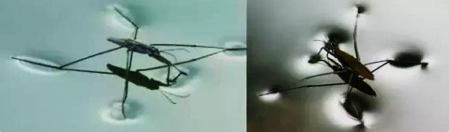

…………………………………………………………………………………………………

…………………………………………………………………………………………………

…………………………………………………………………………………………………

1. Is there any other material that can float on water yet it is denser than water? ……………….

If yes then name it…………………………………………………………………………….

1. Paper clip was placed carefully and it floated on water surface. detergent was then carefully added to water. State what happened and explain the observation

…………………………………………………………………………………………………

…………………………………………………………………………………………………

1. State any two ways you can increase surface tension

…………………………………………………………………………………………………

…………………………………………………………………………………………………

1. The tendency of a liquid in a capillary tube (small tube) or absorbent material to rise or fall without any external assistance is called
2. Why does paraffin rise up the wick of a lamp? (Use molecular explanation)

…………………………………………………………………………………………………

………………………………………………………………………………………………….

1. 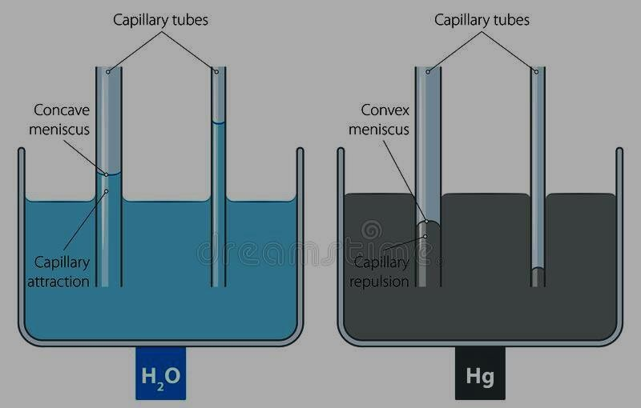The figure below shows effect of capillarity on liquids in small tubes.

##### Where:

**H2O** is water

**Hg** is mercury

* 1. Explain why water exhibits capillary rise while mercury exhibits capillary fall

………………………………………………………………………………………………

………………………………………………………………………………………………

* 1. Why is the water meniscus concave whereas the mercury meniscus is convex?

………………………………………………………………………………………………

………………………………………………………………………………………………

* 1. Name any four applications of capillary action in real life

………………………………………………………………………………………………

………………………………………………………………………………………………

………………………………………………………………………………………………

………………………………………………………………………………………………

* 1. What conclusion can you draw from the diameter of the tube and capillary rise in water and capillary fall in mercury regarding intermolecular forces between the liquid molecules.

………………………………………………………………………………………………

………………………………………………………………………………………………

………………………………………………………………………………………………

………………………………………………………………………………………………

………………………………………………………………………………………………

**ACTIVITY OF INTEGRATION**

**SCENARIO**

During the community football tournament **Wakiso** team went to play against a village team in **Jinja** district, Wakiso team wore ***new sports shoes*** having *spikes underneath* while the Jinja team played ***bear footed***. the game started and jinja team was the first to score a goal and few minutes again they scored a second goal. then suddenly it started ***raining*** and everything suddenly changed jinja team players began to ***fall*** every time they tried to run with the ball, while Wakiso players were just ***fine***. Wakiso scored **5** goals and the game ended. Wakiso players celebrated their victory while jinja players were busy claiming Wakiso used rain as witchcraft to win the game.

**SUPPORT MATERIAL**

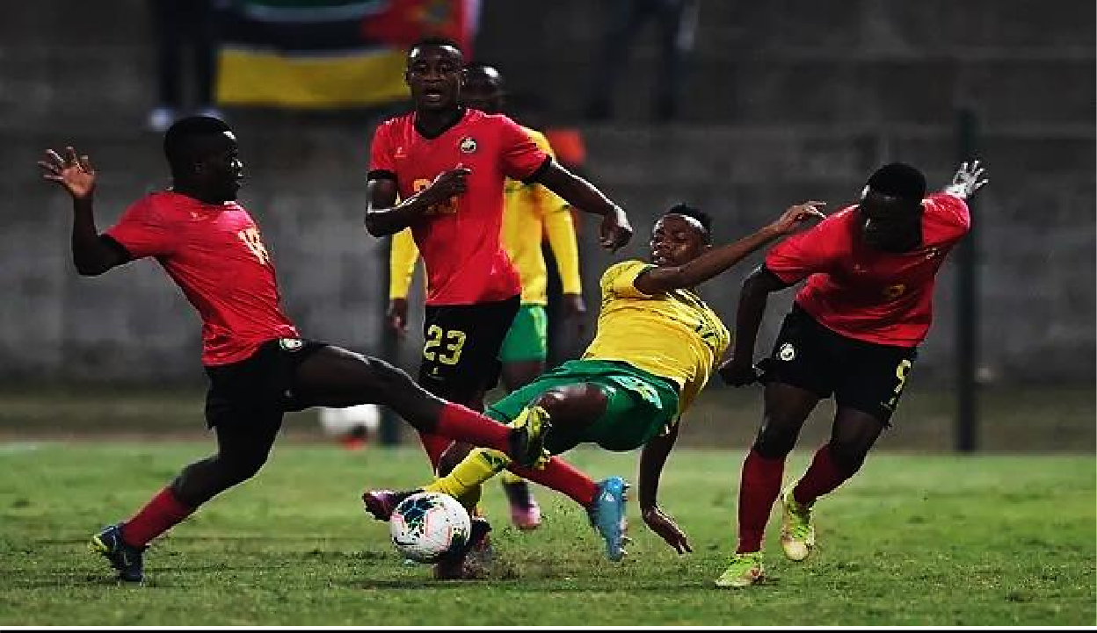

**TASK**

You want to be voted as a youth leader in **jinja** district use this opportunity to explain to this community members ***why jinja lost the game***. Conclude your speech by informing them of ***what you will do*** so that they don’t loose again in the next competition.

#### SCENARIO

**ACTIVITY OF INTEGRATION**

*On one weekend it rained heavily and as a result lightning struck and destroyed one of the transformers supplying power in your community. Due to the blackout created in your community in absence of electricity in the surrounding area you were left with no light at home however inside your home you found an empty tin, paraffin, a cotton cloth and a razorblade for cutting the cloth and a box of matchsticks.*

#### SUPPORT MATERIALS

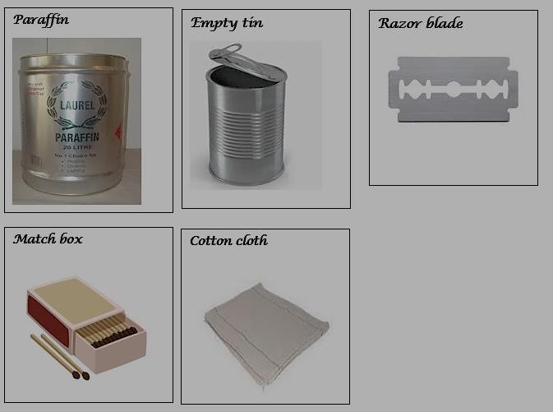

**TASK**

1. *Develop the guidelines you should follow to use the available materials to solve the problem of darkness in your home. (Include the illustration)*
2. *Explain the process through which your light source works*

**SCENARIO**

### ACTIVITY OF INTEGRATION

Uganda is one of the countries in the world with the highest death rate due to road accidents. About 3500 Ugandans die in road accidents per year. One of the most common causes of accidents in Uganda today is related to motor vehicles bad mechanical condition such as old parts for example ***worn out tyres*** being used in vehicles and motor bikes, vehicles ***not well lubricated*** or oiled, vehicles overloaded with ***heavy luggage on the roof***, Faulty Headlights and Taillight among others.

**SUPPORT MATERIAL**

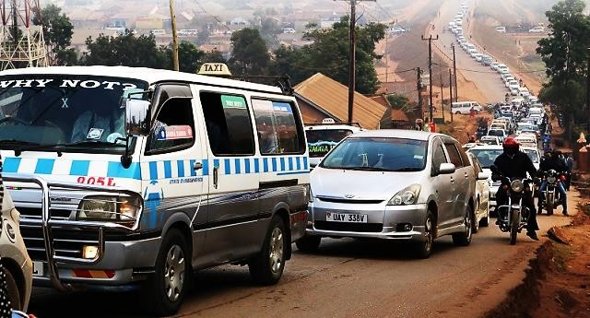

**TASK**

1. You have been appointed as the traffic officer along Kampala jinja highway and you have a situation at hand to deal with. Briefly write guidelines of your operation in order to curb down on nasty road accident deaths.
2. Explain why you would recommend such guidelines in TASK a) above (your feedback should be in relation to effect of forces)

**SCENARIO**

### ACTIVITY OF INTEGRATION

Many people are under the impression that homes made of stone or brick are made to last. While they do last many years, stone and brick are weak to a very prevalent element of life: water. There are a lot of complicated things that happen with stone buildings. The average person knows that brick houses sometimes get cracks or complications, but most don’t know about WHAT exactly affects their buildings and what action to take.

You may be asking, “How does this affect my home if it’s only 40 years old?” No matter where you live, there will be groundwater and moisture in the soil that longs to make its way into your walls. If you have a stone or brick home, or if your basement walls are made of cement that is no longer keeping moisture out, it’s time to get help.

**SUPPORT MATERIAL**

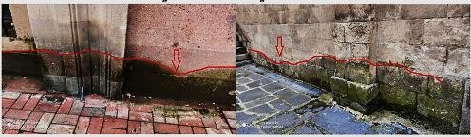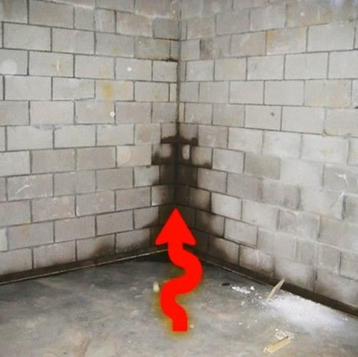

**TASK**.

1. You are one of the well-known engineers in your community, you have been selected to make a speech about ***why*** many buildings are in bad conditions in your estate? ***what*** is affecting your buildings ***how*** it may be affecting your home?
2. “My two-year-old house develops patches on the oil distemper painted walls and gets damp after rain though the exterior is okay. Foul smell also develops inside the house if locked for a few weeks. Can you suggest any remedy?” asked one of the estate residents.

## Chapter 5

Temperature Measurement

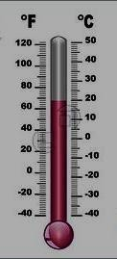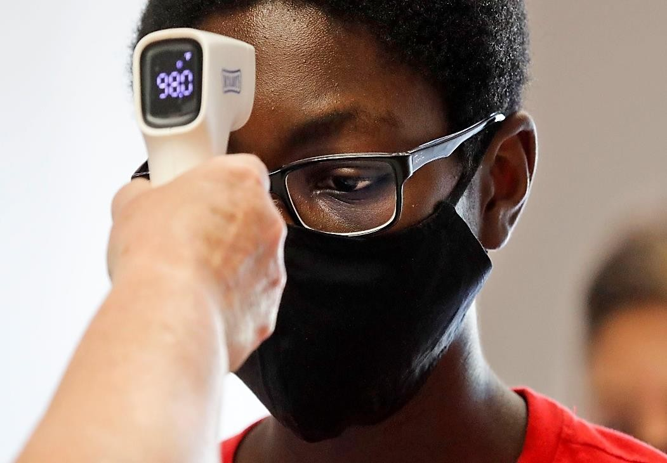

**KEY LEARNING OUTCOMES**

*By the end of this chapter, you should be able to:*

* + understand the difference between heat and temperature.
  + understand how temperature scales are established.

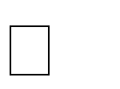

* + calibrate a thermometer and use it to measure temperature.
  + compare the qualities of thermometric liquids.
  + describe causes and effects of the daily variations in atmospheric temperature.

**INTRODUCTION**

**Temperature** is the **measure** of heat in the body. **Temperature** characterizes the body as hot or cold. The SI unit used to **measure** the **temperature** in Kelvin(K).

Temperature can be measured via a diverse array of sensors. All of them infer temperature by sensing some change in a physical characteristic. Six types with which the engineer is likely to come into contact are: thermocouples, resistive temperature devices (RTDs and thermistors), infrared radiators, bimetallic devices, liquid expansion devices, and change-of-state devices

**WORKSHEET (SHORT ANSWER QUESTIONS)**

1. The instrument used to measure the hotness or coldness of an object is called

…………………………………………………………………………………………………

1. The standard unit for measuring hotness or coldness of a place is

………………………………………………………………………………………………….

1. During the covid 19 outbreak in 2019 the use of thermometers defined each and every place on earth from malls, arcades, supermarkets, airports, schools, offices. Industries among others. Explain four other reasons why temperature measurement is really that essential to healthy living.

…………………………………………………………………………………………………

…………………………………………………………………………………………………

…………………………………………………………………………………………………

…………………………………………………………………………………………………

1. The thermometer makes use of a physical property of a substance which changes continuously and uniformly with temperature. The physical property is referred to as

………………………………………………………………………………………………..

1. State any four examples of the above physical property of a substance which changes continuously and uniformly with temperature

…………………………………………………………………………………………………

…………………………………………………………………………………………………

…………………………………………………………………………………………………

…………………………………………………………………………………………………

1. The figure below is an instrument that can help measure the temperature of a body

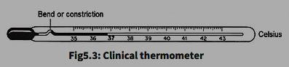

* 1. Label all the parts of the above instrument
  2. Explain the operation of each of the parts of the above instrument

………………………………………………………………………………………………

………………………………………………………………………………………………

………………………………………………………………………………………………

………………………………………………………………………………………………

………………………………………………………………………………………………

* 1. Which physical property of a substance which changes continuously and uniformly with temperature in a clinical thermometer shown above?

………………………………………………………………………………………………

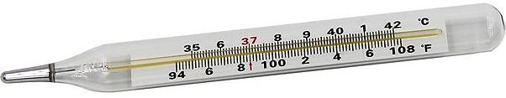

d)

Why are liquid in glass thermometers not used for accurate work?

…………………………………………………………………………………………………

…………………………………………………………………………………………………

1. Explain the working of the above thermometer

…………………………………………………………………………………………………

…………………………………………………………………………………………………

…………………………………………………………………………………………………

…………………………………………………….…………………………………………..

1. What is the temperature range of the above clinical thermometer?

…………………………………………………………………………………………………

1. Convert the above range to kelvin scale

…………………………………………………………………………………………………

…………………………………………………………………………………………………

…………………………………………………………………………………………………

1. What will happen if a thermometer is placed in a liquid which has a higher temperature than its range?

…………………………………………………………………………………………………

…………………………………………………………………………………………………

…………………………………………………………………………………………………

1. Why does the level of liquid in a thermometer rise as the temperature increases?

…………………………………………………………………………………………………

……………………………………………………………………………………….……….. j) What dangerous liquid is used in thermometers?......................................................................

…………………………………………………………………………………………………

k) Why are gas thermometers more sensitive than liquid thermometers?

…………………………………………………………………………………………………

…………………………………………………………………………………………………

…………………………………………………………………………………………………

##### 7.

|  |  |
| --- | --- |
|  |  |
|  |  |

1. Name each of the above type of thermometer shown above
2. Which of the above thermometers is the most preferred to give accurate results and why?.............................................................................................................................................

…………………………………………………………………………………………………..

1. Which of the above thermometers is the most commonly used in hospitals and why?

…………………………………………………………………………………………………

………………………………………………………………………………………………….

1. Write the thermometric property of each of the above shown thermometers.

…………………………………………………………………………………………………

…………………………………………………………………………………………………

…………………………………………………………………………………………………

…………………………………………………………………………………………………

…………………………………………………………………………………………………

1. During the covid 19 pandemic, which of the above thermometers were widely used to check people’s temperature and why?

…………………………………………………………………………………………………

…………………………………………………………………………………………………

1. Water is the one of the most abundant substances on earth and the most common however it is not used in thermometers. Why is alcohol or mercury used in a thermometer and not water?

…………………………………………………………………………………………………

…………………………………………………………………………………………………

…………………………………………………………………………………………………

…………………………………………………………………………………………………

1. What are some reasons why we use mercury over alcohol when building a thermometer?

…………………………………………………………………………………………………

…………………………………………………………………………………………………

…………………………………………………………………………………………………

…………………………………………………………………………………………………

1. Why is boiling temperature of water cannot be measured by alcohol thermometer?

…………………………………………………………………………………………………

…………………………………………………………………………………………………

1. Scientists studying a very hot substance use Mercury thermometer to measure temperature of hot objects like boiling water whereas a mountaineer prefers an alcohol thermometer. Explain the above scenario?

…………………………………………………………………………………………………

…………………………………………………………………………………………………

…………………………………………………………………………………………………

…………………………………………………………………………………………………

1. During the external MOCK examinations, you were one of the students who was called to help your teacher to organize the laboratory for the physics practical examinations. Each table was supposed to be allocated a liquid in glass thermometer unfortunately you found out that most of the thermometers defected. They were either broken or not working properly.

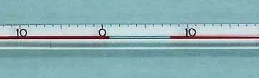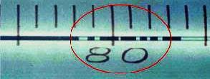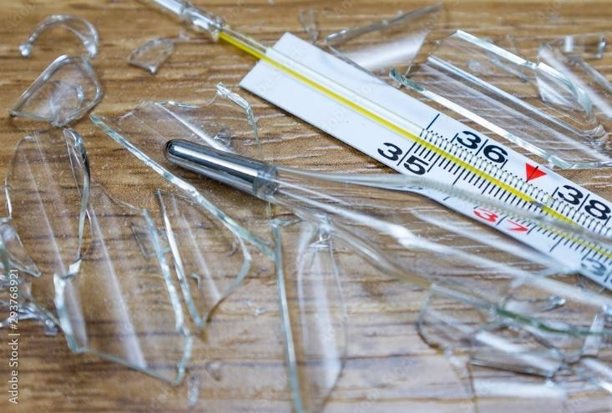

1. From the above pictures shown, some parts of the glass have gas trapped between mercury ink as shown by the circle drawn on the picture. Name and explain how the above defect affects results obtained.

…………………………………………………………………………………………………

…………………………………………………………………………………………………

…………………………………………………………………………………………………

…………………………………………………………………………………………………

1. Based on the features of the clinical thermometer, suggest best practices of the proper use, handling and storage of a clinical thermometer.

…………………………………………………………………………………………………

…………………………………………………………………………………………………

…………………………………………………………………………………………………

…………………………………………………………………………………………………

…………………………………………………………………………………………………

1. For general use at home, forehead thermometers will give an idea of whether or not an individual has a fever. However, according to a 2020 study, forehead thermometers are less accurate than other methods of reading temperature, such as oral, rectal, or tympanic (ear) temperature readings.

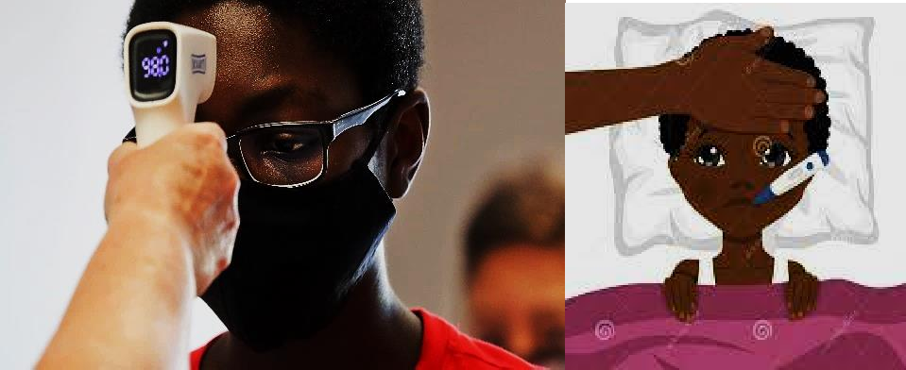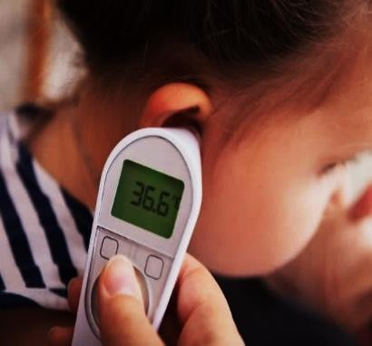

Briefly explain which is the best way to measure the temperature of a human being and why some methods have large errors.

…………………………………………………………………………………………………

…………………………………………………………………………………………………

…………………………………………………………………………………………………

…………………………………………………………………………………………………

…………………………………………………………………………………………………

…………………………………………………………………………………………………

…………………………………………………………………………………………………

………………………………………………………………………………………………..

1. Our investigation into personal thermometers has found you can't always trust the number on the screen. Being able to identify when you or your child is running a fever is important. It can help you decide whether or not to see a doctor, and inform how you manage an illness. A fever is usually defined as an elevated body temperature of 38°C or higher. ***(Normal body temperature is generally 36–37°C).*** Since there can be as little as **1°C** difference between a healthy temperature and a fever, getting an accurate reading is important. But how do you know that your thermometer is giving you an accurate temperature reading?

…………………………………………………………………………………………………

…………………………………………………………………………………………………

…………………………………………………………………………………………………

…………………………………………………………………………………………………

…………………………………………………………………………………………………

…………………………………………………………………………………………………

………………………………………………………………………………………………..

1. The upper and lower fixed point of a thermometer are separated by 160 mm. The length of mercury thread just above the lower temperature is 40 mm. What is the temperature at this point?

…………………………………………………………………………………………………

…………………………………………………………………………………………………

…………………………………………………………………………………………………

1. The ice and Steam points of a Mercury in-glass thermometer centigrade scale and of uniform bore corresponds reactively to **3 cm** and **19 cm** length of the Mercury thread. When the length is **12 cm**, what is the temperature in Celsius scale?

………………………………………………………………………………………………………

………………………………………………………………………………………………………

………………………………………………………………………………………………………

………………………………………………………………………………………………………

1. The length of Mercury thread in a mercury thermometer is **2 mm** at the ice point and **26 mm** at the boiling point of water. What will be the length of mercury thread in this thermometer if it is used to measure a temperature of **75** degree Celsius?

………………………………………………………………………………………………………

………………………………………………………………………………………………………

………………………………………………………………………………………………………

………………………………………………………………………………………………………

1. A faulty thermometer measures the temperature of an object as **28.2 o C**. The upper and lower fixed points of the thermometer is **98.4 o C** and **-12 o C** respectively. What is the correct temperature of the object?

………………………………………………………………………………………………………

………………………………………………………………………………………………………

………………………………………………………………………………………………………

1. A thermometer reads 111.1 K. What is the temperature in °C?

………………………………………………………………………………………………………

………………………………………………………………………………………………………

1. A thermometer reads **25** degrees Celsius. If the temperature of the room is then increased by

**16 K**, what temperature will the thermometer read, in degrees Celsius?

………………………………………………………………………………………………………

………………………………………………………………………………………………………

……………………………………………………………………………………………………..

1. A faulty thermometer reads **2** degrees Celcius when dipped in ice at **zero** degrees celcius and **95** degrees celcius when dipped in steam at **100** degrees celcius. What would this thermometer read if it was placed in water at room temperature at **18** degrees celcius?

………………………………………………………………………………………………………

………………………………………………………………………………………………………

………………………………………………………………………………………………………

………………………………………………………………………………………………………

………………………………………………………………………………………………………

##### The pictures below reasons behind the variation in temperature of different places on earth.

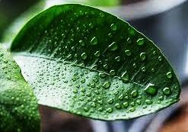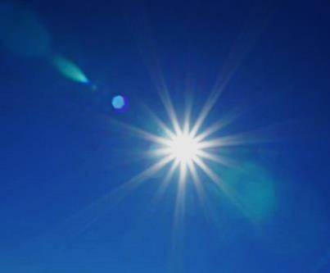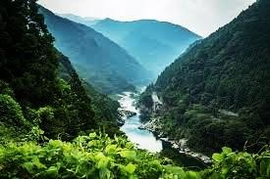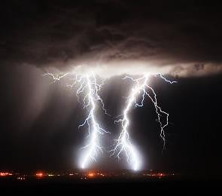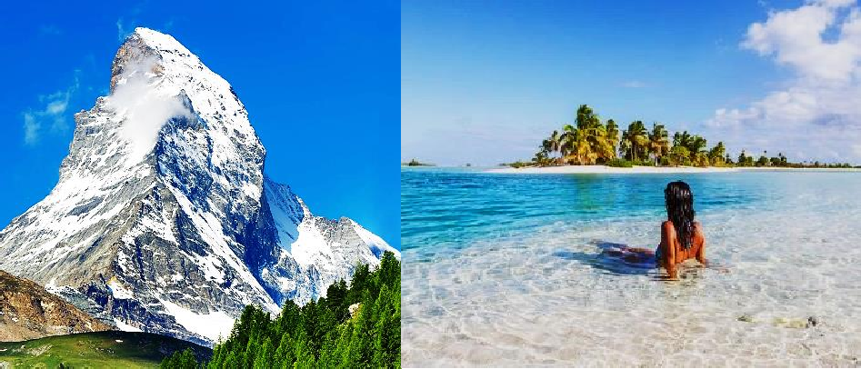

Explain the factors that is responsible for the variation in temperature of places on earth as shown in the pictures above

Explain the factors that is responsible for the variation in temperature of places on earth as shown in the pictures above

………………………………………………………………………………………………………

………………………………………………………………………………………………………

………………………………………………………………………………………………………

………………..……………………………………………………………………………………

………………………………………………………………………………………………………

………………………………………………………………………………………………………

…………………………………..…………………………………………………………………

………………………………………………………………………………………………………

………………………………………………………………………………………………………

……………………………………………………..………………………………………………

………………………………………………………………………………………………………

………………………………………………………………………………………………………

………………………………………………………………………..……………………………

………………………………………………………………………………………………………

………………………………………………………………………………………………………

…………………………………………………………………………………………..…………

………………………………………………………………………………………………………

………………………………………………………………………………………………………

………………………………………………………………………………………………………

……..………………………………………………………………………………………………

………………………………………………………………………………………………………

………………………………………………………………………………………………………

………………………..……………………………………………………………………………

………………………………………………………………………………………………………

………………………………………………………………………………………………………

…………………………………………..…………………………………………………………

………………………………………………………………………………………………………

………………………………………………………………………………………………………

……………………………………………………………..………………………………………

………………………………………………………………………………………………………

………………………………………………………………………………………………………

………………………………………………………………………………..……………………

………………………………………………………………………………………………………

………………………………………………………………………………………………………

…………………………………………………………………………………………………..…

………………………………………………………………………………………………………

……………………………………………………………………………………………………..

**SCENARIO**

**ACTIVITY OF INTEGRATION**

In your home you rear local poultry using the free-range system where the chicken and other birds look for their own food each day, however recently during the rainy and cold season you have realized that most chicks die rampantly due to unknown causes. more than half of the chicks have died during this rainy season. The eggs have also taken longer than the expected days without hatching. You are worried that the main source of your income at home is at the brink of collapse

**SUPPORT MATERIAL**

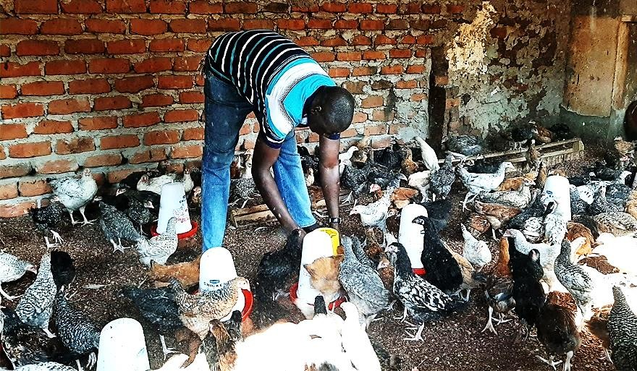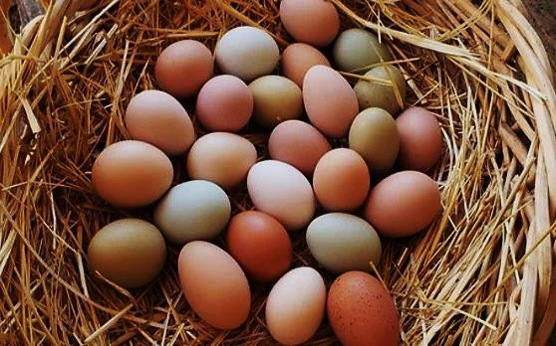

**TASK**

* 1. Your parents have tasked you to investigate the recent rampant death of the chicken and report to him for immediate intervention and way forward. Write down the processes you will go through to find the real cause of the chicken death
  2. After realizing the real cause of the rampant death suggest the most suitable solutions and recommendations to such a tragedy.
  3. What conclusions can you draw from such a scenario regarding the knowledge of temperature measurement you have attained at school.

**SCENARIO**

### ACTIVITY OF INTEGRATION

Our investigation into personal thermometers has found you can't always trust the number on the screen. Being able to identify when you or your child is having a fever is important. It can help you decide whether or not to see a doctor, and inform how you manage an illness. A fever is usually defined as an elevated body temperature of **38°C** or higher. (Normal body temperature is generally **36–37°C**). Since there can be as little as **1°C** difference between a healthy temperature and a fever, getting an accurate reading is important. But how do you know that your thermometer is giving you an accurate temperature reading?

**SUPPORT MATERIAL**

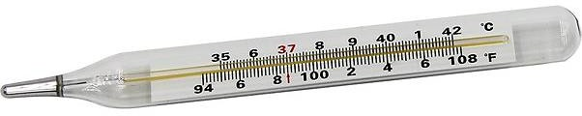

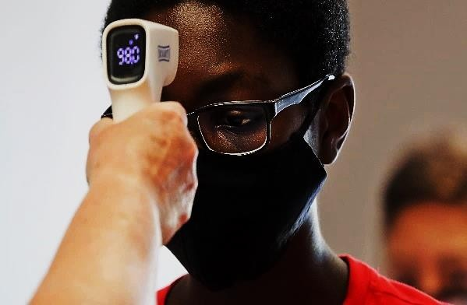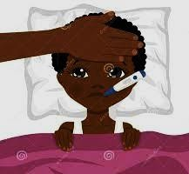

**TASK**

1. Write down the ***guidelines*** you should follow in order to know whether your thermometer is giving accurate results or not.
2. Name the different types of thermometers shown in the above pictures
3. Of the three types of thermometers shown above, which one would you recommend as the ***best***

type for use shown in the pictures above. **Why** is it the best?

1. Define the ***range*** of the thermometer shown above and convert the above range of thermometer reading shown in the picture to the ***standard*** unit of measuring temperature.

**SCENARIO**

### ACTIVITY OF INTEGRATION

During the external MOCK examinations, you were one of the students who was called to help your teacher to organize the laboratory for the physics practical examinations. Each table was supposed to be allocated a liquid in glass thermometer unfortunately you found out that most of the thermometers defected. They were either broken or not working properly. You wondered whether the students who normally carry out practical are just reckless or they don’t know how to use, handle and care for the delicate instrument.

**SUPPORT MATERIAL**

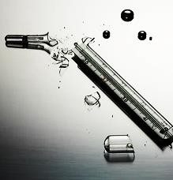

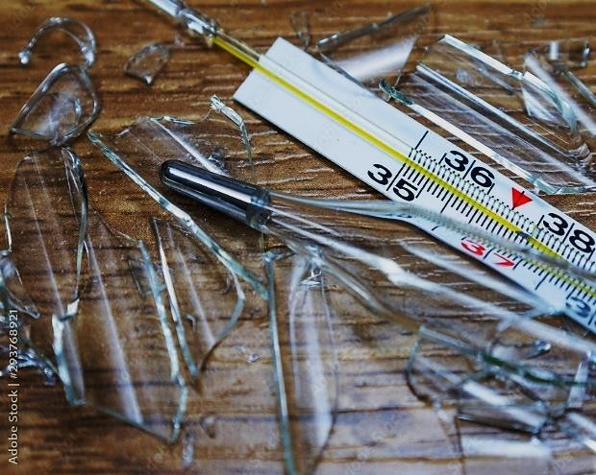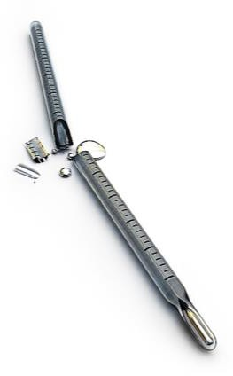

**TASK**

1. As the school academics prefect, you have been called upon to school assembly ground to make a meaningful speech which can stop this vice. You are required to communicate about how to use, handle and care for a thermometer while in carrying out experiments in the laboratory. (You may use illustrations)
2. As you conclude your speech also inform the students of the advantage of proper use, care and handling of the thermometer.
3. As the last part of your speech write down what dangers students risk facing in case they don’t abide by the above guidelines. (What possible harm can come to the student due to misuse of the thermometers)

**SCENARIO**

### ACTIVITY OF INTEGRATION

We all use temperature sensors in our daily lives, be it in the form of thermometers, domestic water heaters, microwaves. Usually, Home appliances such as kettles, toasters, flat irons, will all contain temperature sensors.

Your brother deals in home electronic appliances shown in the figure below and does not have enough scientific knowledge regarding these appliances. He is looking for an expert to help him while explaining to customers how these appliances work. Will you be happy to be his advisor?

**SUPPORT MATERIAL**

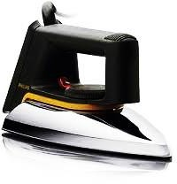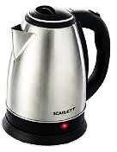

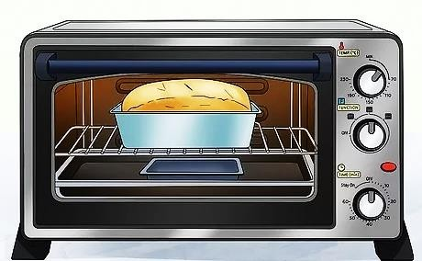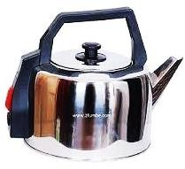

**TASK**

1. Explain to the customer the significance of the red knob in each of the home appliances shown above.
2. Explain briefly how each of the above appliances use knowledge of temperature measurement to operate.
3. What Recommendations would you give the customer who wants to buy electrical appliances which use temperature measurement to operate besides the above displayed.
4. Explain to the customer the effect in case the temperature control knob gets damaged.

## Chapter 6 Heat Transfer

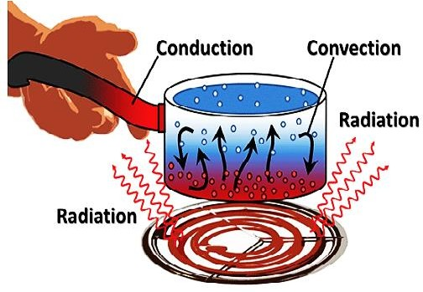

**KEY LEARNING OUTCOME**

*By the end of this chapter, you should be able to:*

* +  understand how heat energy is transferred and the rate at which heat transfer takes place.
  + understand what is happening at particle level of conduction, convection and radiation.



* + understand that greenhouse effect and global warming are related to heat transfer on the earth’s surface.

**INTRODUCTION**

The sun is about 150 million kilometres away from the earth but you can feel its heat. when you put a cold metal teaspoon into your hot cup of tea, the teaspoon handle warms up after a while? Have you ever wondered how this warmth "moved" from the hot tea to the cold teaspoon handle? Why do we feel warm when we are cooking or ironing, or when we sit or stand near a fire or in sunshine?

Heat energy always flows from a hotter body to a colder one due to temperature difference. In this chapter, you will learn how heat is transferred from one place/body to another and how heat transfer is useful in everyday life.

**WORKSHEET (SHORT ANSWER QUESTIONS)**

1. 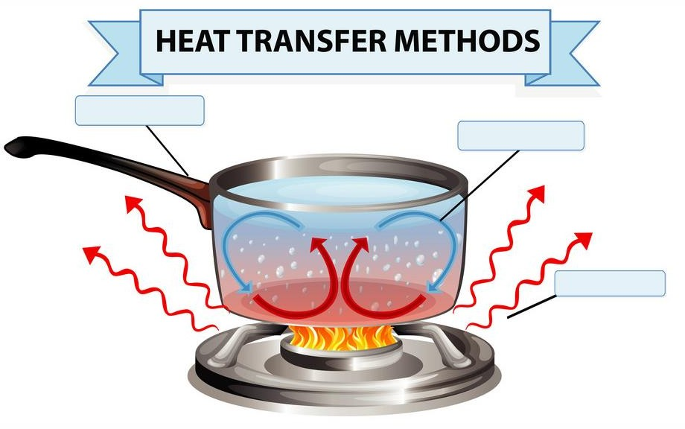a) Identify and label the heat transfer methods in the figure below

b) briefly explain each of the three heat transfer methods giving real life example in each case.

…………………………………………………………………………………………………..

…………………………………………………………………………………………………..

…………………………………………………………………………………………………..

…………………………………………………………………………………………………

…………………………………………………………………………………………………

…..………………………………………………………………………………………………

…..………………………………………………………………………………………………

…..………………………………………………………………………………………………

1. study the figure below and identify and label the different heat transfer modes exhibited.

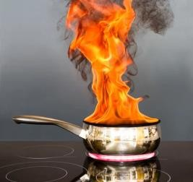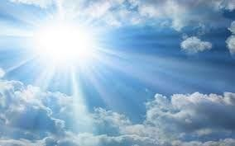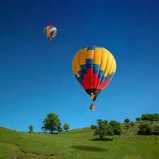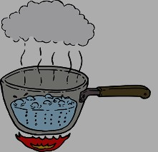

1. A person prefers to sit by a fire during the cold winter months. Which of the heat transfer types gives him the most heat?

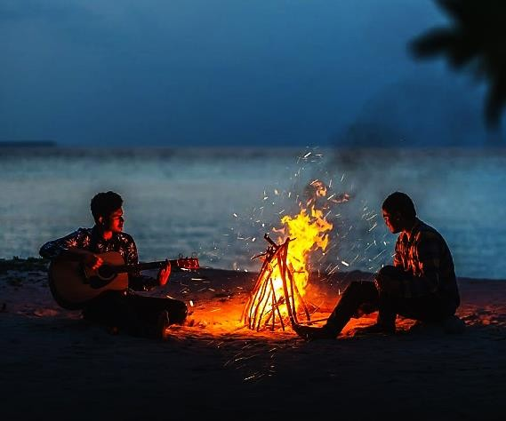State and explain the process through which

travels to warm the person at the fire place during winter months.

……………………………………….…………

……………………………………………………

………………………….………………………

……………………………………………………

…………….……………………………………

……………………..……………………………

…………………………………………………....

1. 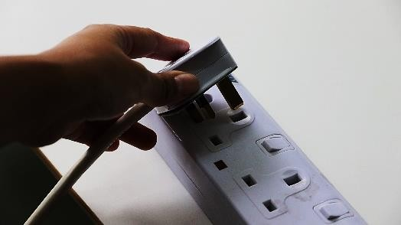Your refrigerator is located a bit too far away from the nearest electrical power point so you use your **10 m** extension lead to connect the appliance. You leave the extension lead wound up in a coil. After four hours, you notice that the extension lead is very warm, but the appliance wire is not. Explain your observations

…………………………………………………………………………………………

…………………………………………………………………………………………

…………………………………………………………………………………………

…………………………………………………………………………………………

…………………………………………………………………………………………

…………………………………………………………………………………………

…

1. 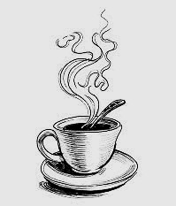A spoon is hot after leaving it in a cup that has hot tea. This is an example of heat transfer by a process called:

*Explain using particle theory of matter the heat transfer process through the spoon from the hot water*……………………………………………………………………………………...

……………………………………………………………………………………………………

……………………………………………………………………………………………………

……………………………………………………………………………………………………

……………………………………………………………………………………………………

……………………………………………………………………………………………………

……………………………………………………………………………………………………

…………………………………………………………………………………………………..

1. When heat is transferred from one particle of a hot body to another by actual motion of heated particles, it is referred to as heat transfer by:
2. When heat is transferred from a hot body to a cold body in a straight line, without affecting the intervening medium, it is referred as heat transfer by:
3. When heat is transferred by molecular collision, it is referred to as heat transfer by

………………………………………………………………………………………………..

1. Heat transfer in liquids and gases take place by………………………………………………
2. Metals are good conductors of heat because………………………………………………….

…………………………………………………………………………………………………

…………………………………………………………………………………………………

1. 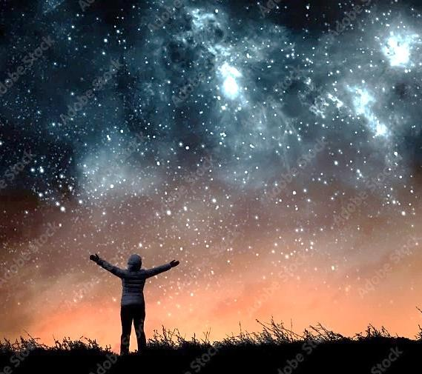A woman standing and watching the stars on a cool, calm night will lose most of her body heat by which mechanism?

*Explain the mechanism through which she loses most of her body heat*

…………………………………………………

…………………………………………………

…………………………………………………

…………………………………………………

…………………………………………………

…………………………………………………

…………………………………………………

………………………………………………….

1. 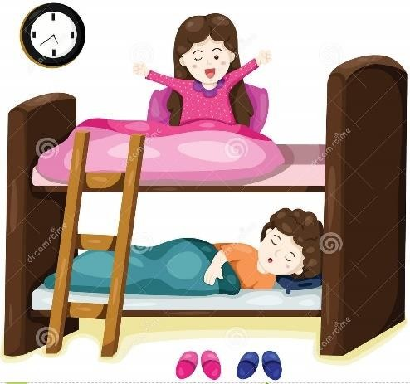You are in the top bunk of a bunk bed and you want to turn the air conditioner on while your friend on the bottom bunk is just fine. You are wondering how and why
   1. *State the reason why your friend is fine and you are not*

……………………………………………………..

* 1. *explain the whole scenario*

………………………………………………………

………………………………………………………

………………………………………………………

………………………………………………………

………………………………………………………

1. The cause of weather systems on earth is
2. . A huge rock at the state park gets so hot during the day that you can’t sit on it. Briefly explain how and why

…………………………………………………………………………………………………

…………………………………………………………………………………………………

…………………………………………………………………………………………………

…………………………………………………………………………………………………

1. A house burns down. On the house across the street, all of the vinyl siding is twisted and warped by the heat. The heat was transferred across the street by a heat transfer process called .
2. 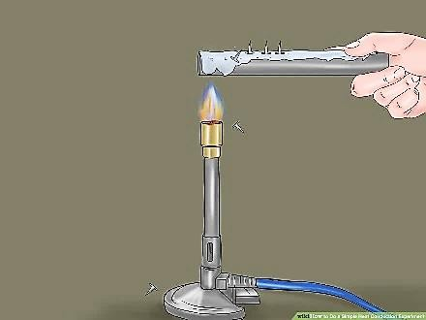One end of a copper rod is placed in a flame of a Bunsen burner. Small pieces of wax placed along the rod melt at progressively larger distance from the flame. Heat is transferred through the rod by

*Explain the process of heat transfer through the copper rod using particle theory of matter.*

…………………………………………………………………………………………………

…………………………………………………………………………………………………

…………………………………………………………………………………………………

…………………………………………………………………………………………………

………………………………………………………………………………………………..

1. In a swimming pool, the water near the surface is slightly warmer while those at the bottom is cooler. Explain why

…………………………………………………………………………………………………

…………………………………………………………………………………………………

…………………………………………………………………………………………………

…………………………………………………………………………………………………

1. Identify the method of heat transfer that takes place in each illustration. Write the method of heat transfer underneath the picture.
2. An object that absorbs energy well also _

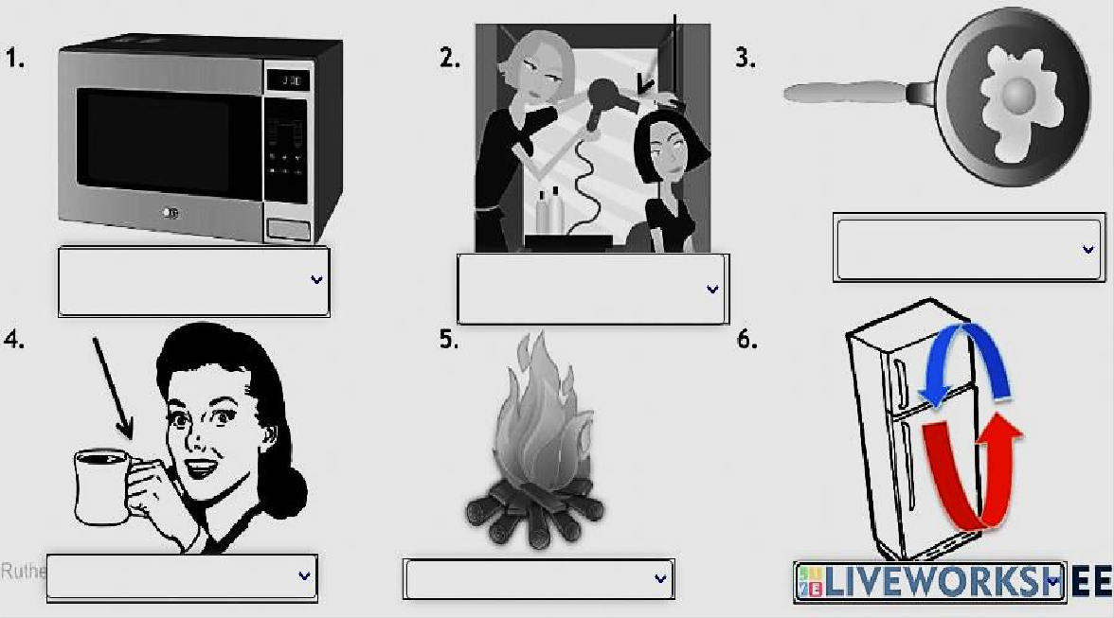

1. Identify the method of heat transfer that takes place in each illustration. Some illustrations may show more than one form of heat transfer.

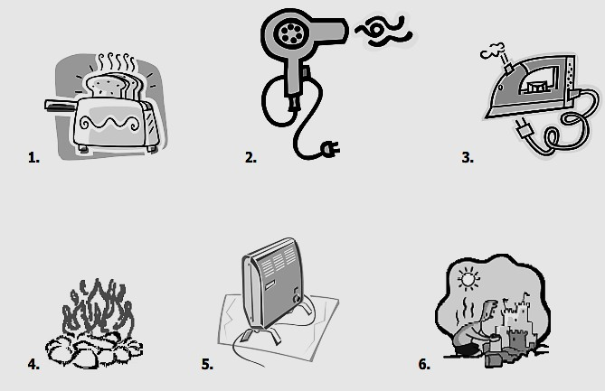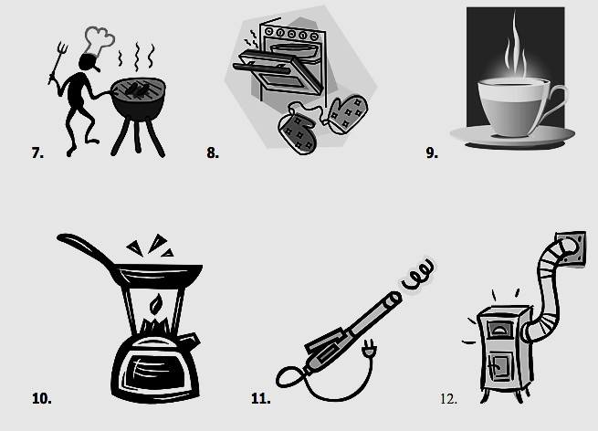

1. In each of the following examples, identify whether heat is being transferred through conduction, convection or radiation. Some may have two possible answers. Choose the answer that best fits the situation.

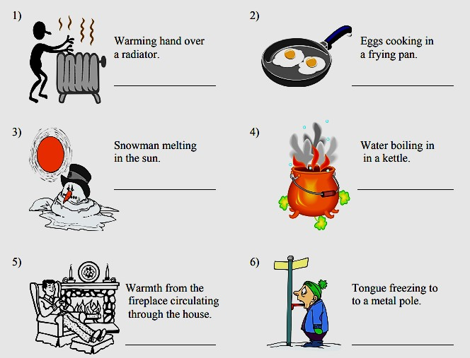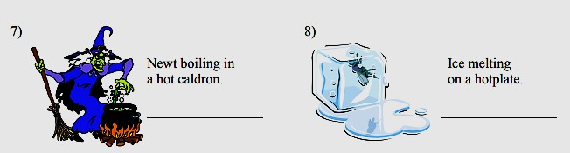

1. In each of the following examples, identify whether heat is being transferred through conduction, convection or radiation. Some may have two possible answers. Choose the answer that best fits the situation.

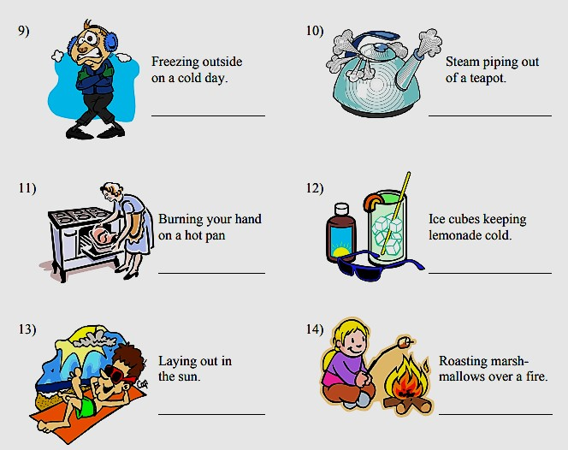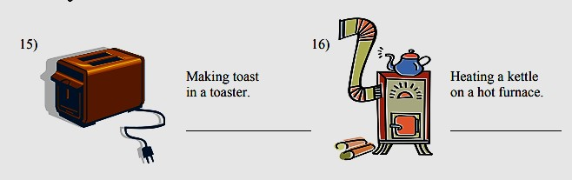

1. Look at this graph showing the conductivity of different materials and write a short paragraph describing it.

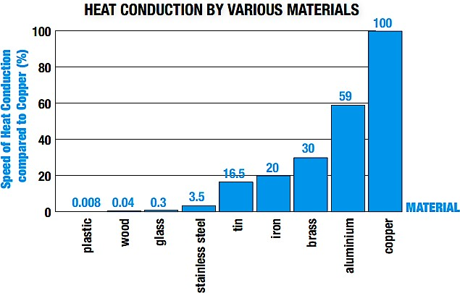

* 1. What is the general description of the graph above?

…………………………………………………………………………………………

…………………………………………………………………………………………

* 1. From the graph name the good conductors of heat.

…………………………………………………………………………………………

…………………………………………………………………………………………

* 1. From the graph name the poor conductors heat.

…………………………………………………………………………………………

…………………………………………………………………………………………

* 1. which materials we use to heat things in the kitchen?

………………………………………………………………………………………….

* 1. which materials we use to protect ourselves from heat?

………………………………………………………………………………………….

1. In this lab you are trying to determine spoon material will cause the butter to melt the fastest. Will it be the wooden spoon? The plastic spoon? Or the metal spoon? This will help us determine which spoon type is better at conducting heat into the butter.

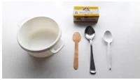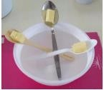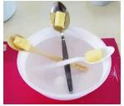

*A bit of butter or margarine is placed into each spoon and then the spoons are placed into the bowl of hot water with the ends with butter sticking out like in the picture.*

1. *Which spoon will melt the butter fastest?*

*………………………………………………………………*

1. *Why did one spoon melt the butter faster than the others?*

*………………………………………………………………*

*………………………………………………………………*

1. *What type of energy transfer is happening in this lab?.......................................................................*
2. *Which type of spoon should you use to eat ice cream?......................................................................*
3. *What conclusion can you draw from the above experiment…………………………………………….*

*……………………………………………………………*

*……………………………………………………………*

1. What are the main methods of heat transfer from the hot core of Earth to its surface? From Earth’s surface to outer space?....................................................................................................

…………………………………………………………………………………………………..

1. Grandma says that it is quicker to bake a potato if you put a nail into it. In fact, she is right. Justify her baking technique in terms of one of the three processes of heat transfer.

…………………………………………………………………………………………………

…………………………………………………………………………………………………

…………………………………………………………………………………………………

1. 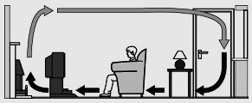Below is an illustration of how air circulates inside any given room.

*State and explain the heat transfer process shown in the picture.*

*……………………………………………*

*……………………………………………*

*……………………………………………*

*……………………………………………*

*……………………………………………*

*……………………………………………*

*……………………………………………*

1. 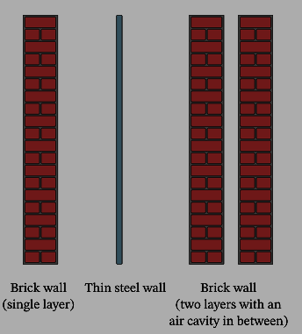The diagram shows three different types of walls that could be built in a house.
   1. *Through which wall would the most heat be lost?*

*……………………………………………………………*

* 1. *Through which wall would the least heat be lost?*

*……………………………………………………………*

* 1. *Explain why the walls would act like that.*

*……………………………………………………………*

*……………………………………………………………*

*……………………………………………………………*

*……………………………………………………………*

*……………………………………………………………*

*……………………………………………………………*

*………………………………………………………………*

1. How does convection help heat your favourite room? Sketch the room. Show where the heat vents are located and label the diagram to show how the room is heated.
2. Why do basements usually feel cooler than the rest of the building?

…………………………………………………………………………………………………

…………………………………………………………………………………………………

…………………………………………………………………………………………………

1. Explain the process of heating soup on the stove. Start with the heat given off by the stove’s element and proceed from there, step by step, until the soup itself is boiling. Use a precise written description and include diagrams to illustrate your explanation.

…………………………………………………………………………………………………

………….………………………………………………………………………………………

…………………………………………………………………………………………………

…………………………………………………………………………………………………

…………………………………………………………………………………………………

…………………………………………………………………………………………………

…………………………………………………………………………………………………

1. What happens to the temperature of the soup when you turn off the stove’s element? Explain why this happens.

…………………………………………………………………………………………………

…………………………………………………………………………………………………

…………………………………………………………………………………………………

1. How is convection used in our day-to-day life?

…………………………………………………………………………………………………

…………………………………………………………………………………………………

1. 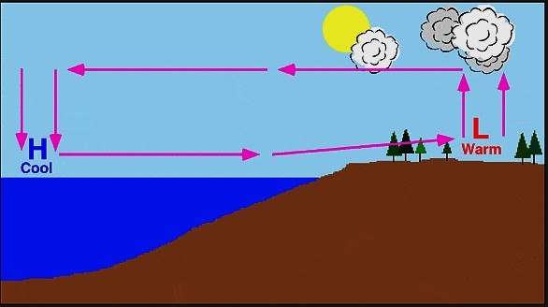The figure below is due to the effect of heat transfer.

*State and explain the heat transfer process shown in the picture*

*……………………………………………………*

*……………………………………………………*

*………………….………………………………*

*……………………………………………………*

*……………………………………………………*

*……………………………………………………*

*……………………………………………………*

1. Warm air over land rising and cool air from the sea taking its place describes which breeze?

…………………………………………………………………………………………………

1. Warm air over the sea rising and cool air from the land taking its place describes which breeze?......................................................................................................................................
2. What type of breeze forms when the land cools faster than the ocean?

………………………………………………………………………………………………..

1. The figure below is due to the effect of heat transfer.

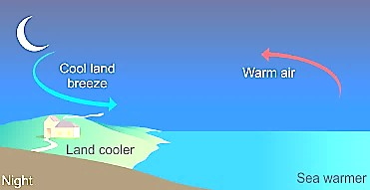*State and explain the heat transfer process shown in the picture*

*……………………………………………………*

*……………………………………………………*

*………………….…………………………………*

*……………………………………………………*

*……………………………………………………*

*……………………………………………………*

*……………………………………………………*

*……………………………………………………*

*……………………………………………………*

1. The best absorbers of radiation waves are…………………………………………………….
2. The best reflectors of radiation heat energy are……………………………………………......
3. The only heat transfer process which takes place by waves is called………………………….
4. When watching a daytime circus in a large, dark-colored tent, you sense significant heat transfer from the tent. Explain why this occurs.

…………………………………………………………………………………………………

…………………………………………………………………………………………………

………………………………………………………………………………………………..

1. Why are cloudy nights generally warmer than clear ones?

…………………………………………………………………………………………………

…………………………………………………………………………………………………

…………………………………………………………………………………………………

1. Why are thermometers that are used in weather stations shielded from the sunshine? What does a thermometer measure if it is shielded from the sunshine and also if it is not?

…………………………………………………………………………………………………

…………………………………………………………………………………………………

………………………………………………………………………………………………..

1. On average, would Earth be warmer or cooler without the atmosphere? Explain your answer

…………………………………………………………………………………………………

…………………………………………………………………………………………………

…………………………………………………………………………………………………

………………………………………………………………………………………………..

1. If you were going to use radiant heat energy from the sun to heat your home, what color or material would you use. Explain your thinking.

…………………………………………………………………………………………………

…………………………………………………………………………………………………

………………………………………………………………………………………………..

1. In an experiment, Philip gathered three coffee cups, identical except for color. He ran hot water from a tap for a minute or two, until it reached its maximum temperature and then filled the cups with hot water and later moved them to a dark, cool room. He placed a thermometer in each one and waited 20 minutes. He then read the thermometer in each cup and compare the temperatures and colors.
   1. 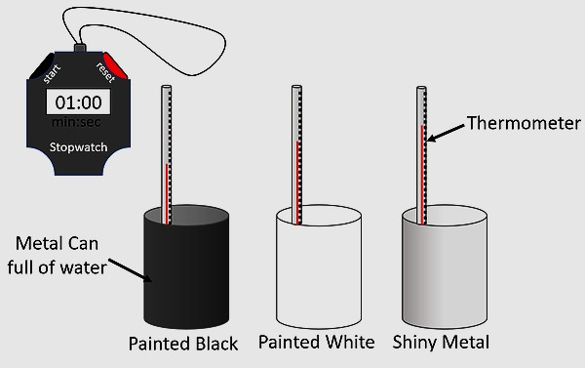*Which cup emitted heat fastest?..............*
   2. *Which cup emitted heat slowest?.............*
   3. *Explain why the cups had different rates of heat emission.*

*………………………………………………*

*………………………………………………*

*………………………………………………*

*………………………………………………*

* 1. *What conclusions can you draw from the above experiment.*

*………………………………………………*

*………………………………………………*

1. During hot summer days, it is advised to wear white or light-colored clothes. Explain why

…………………………………………………………………………………………………

…………………………………………………………………………………………………

1. 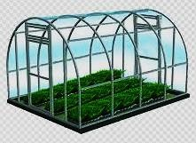In cold areas, a greenhouse is used for the better growth of plants. Plants grow well in the increased temperature of the greenhouse.

*Explain how the plants get enough heat to grow well in the greenhouse shown above*.

………………………………………………………………

…………………………………………………….………

………………………………………………………………

…………………………………………….………………

………………………………………………………………

…………………………………….………………………

………………………………………………………………

1. 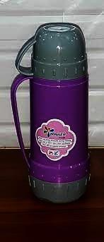Vacuum flasks are designed to keep liquids hot by minimizing heat losses in four possible ways conduction, convection, radiation, and evaporation.

*Draw a well labelled diagram of a vacuum flask and explain how it is able to minimise heat losses through conduction, convection, radiation and evaporation.*

………………………………………………………………………………

…………………………………….………………………………………

…………………………………………………………………………….

………………………………………………………………………………

…………………………………….………………………………………

………………………………………………………………………………

………………………………………………………………………………

…………………………………………….………………………………

………………………………………………………………………………

…….………………………………………………………………………

…………………………………………….………………………………

………………………………………………………………………………

…….………………………………………………………………………

…………………………………………….………………………………

1. 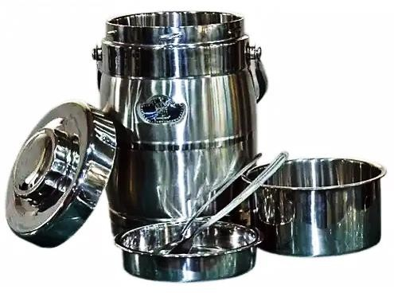Why are teapots, food flasks, and aluminum foils or plates made of shiny surfaces.

………………………………………………………………………………………

…………………………….………………………………………………………

…………………………………………………………….………………………

………………………………………………………………………………………

…….………………………………………………………………………………

……………………………………………………………………………….……

………………………………………………………………………………………

……………………….……………………………………………………………

1. One way to make a fireplace more energy efficient is to have an external air supply for the combustion of its fuel. Another is to have room air circulate around the outside of the fire box and back into the room.

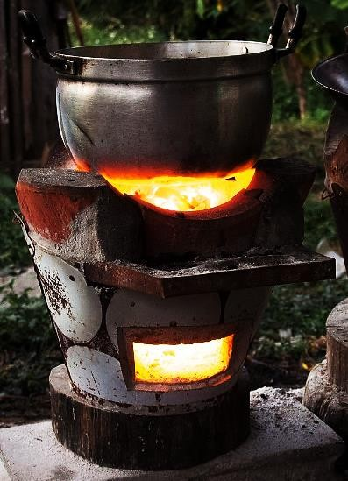*Write down the Detail the methods of heat transfer involved in each. (Use arrows to show air flow)*

*……………………………………………………………………………*

*……………………………………………………………………………*

*……………………………………………………………………………*

*……………………………………………………………………………*

*……………………………………………………………………………*

*……………………………………………………………………………*

*……………………………………………………………………………*

*……………………………………………………………………………*

1. Loose-fitting white clothing covering most of the body is ideal for desert dwellers, both in the hot Sun and during cold evenings.

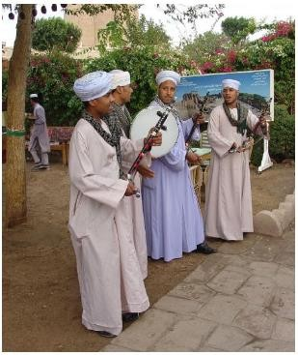*Explain how such clothing is advantageous during both day and night.*

………………………………………………………………………………………………………

…………….………………………………………………………………………………………

…………………………….………………………………………………………………………

…………………………………………….………………………………………………………

………………………………………………………………………………………………………

.……………………………………………………………………………………………………

……………….……………………………………………………………………………………

……………………………….……………………………………………………………………

1. The figure below shows the human activities that affect global warming.

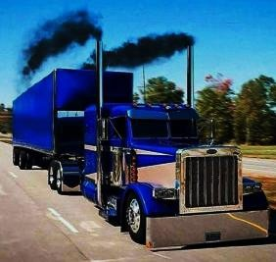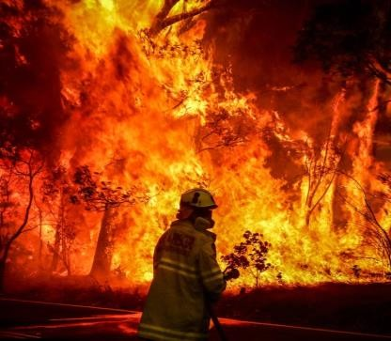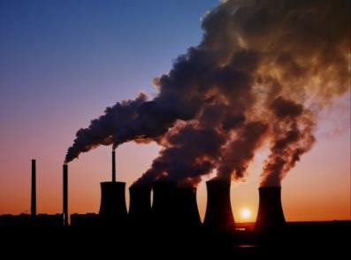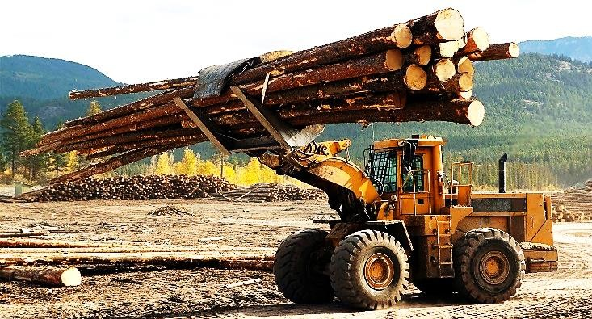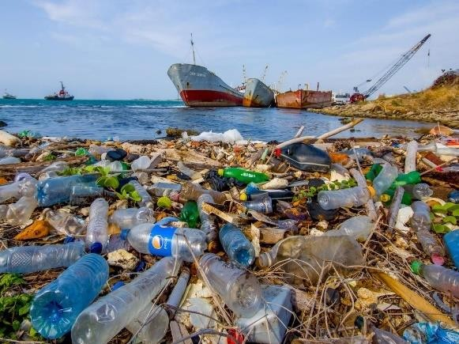

1. Identify and name each of the human activities shown above

…………………………………………………………………………………………………

…………………………………………………………………………………………………

1. Explain briefly how each of the above human activities affect the global warming

…………………………………………………………………………………………………

…………………………………………………………………………………………………

…………………………………………………………………………………………………

…………………………………………………………………………………………………

…………………………………………………………………………………………………

…………………………………………………………………………………………………

…………………………………………………………………………………………………

…………………………………………………………………………………………………

…………………………………………………………………………………………………

…………………………………………………………………………………………………

1. What solutions and recommendations do you think humans can make in order to reverse or slow down the destructive path of rising global warming?

…………………………………………………………………………………………………

…………………………………………………………………………………………………

…………………………………………………………………………………………………

…………………………………………………………………………………………………

…………………………………………………………………………………………………

…………………………………………………………………………………………………

…………………………………………………………………………………………………

…………………………………………………………………………………………………

1. What is the relationship between greenhouse effect and global warming?

…………………………………………………………………………………………………

………………………………………………………………………………………………….

**ACTIVITY OF INTEGRATION**

**SCENARIO**

Your family was recently evicted from their land in central Uganda and your father has decided to relocate to kitgum district in northern part of Uganda. Your parents have acquired a vast piece of land in kitgum districts which normally experiences a long dry season. They would like to construct a family house.

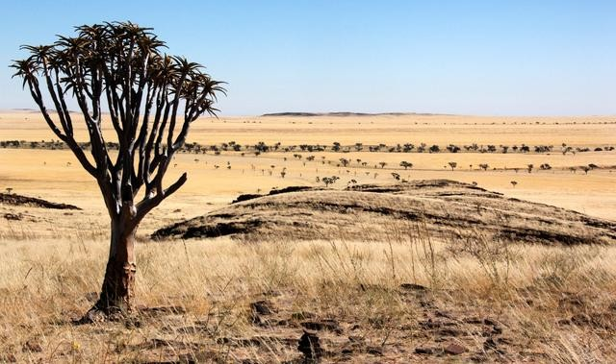**SUPPORT MATERIAL**

**TASK**

1. As a result of your knowledge of physics, advise them on the materials to use, the shape and the house, clearly explaining your responses.
2. Advice your parents on the best types of clothes that you will need to buy to fit in the new environment with ease.

### ACTIVITY OF INTEGRATION

**SCENARIO**

At your home you have been having a challenge of having your meals at very late hours, the maid claims that it’s not her problem that food takes longer than expected to get ready. Your parents have had to fire the previous maids because of the same issue. The maid claims that the kitchen is in bad conditions and the cooking stove might also have some issues.

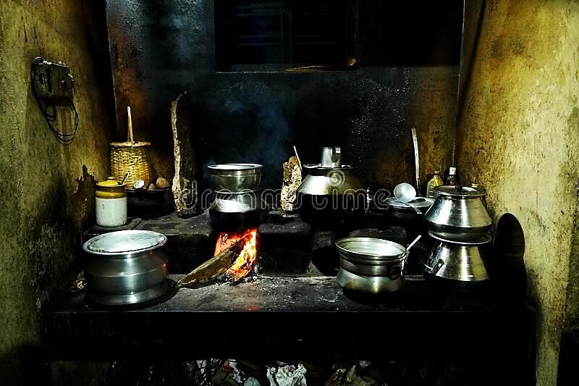**SUPPORT MATERIAL**

**TASK**

1. How will you help the maid fix the kitchen and stove problems so that the meals can get served ready in time? (Include illustrations of the few modifications you will make so that the kitchen and the stove can work efficiently)
2. What extra advice will you give to the maid concerning heat transfer to help her cook at a faster rate next time?

**SCENARIO**

### ACTIVITY OF INTEGRATION

Recently at your home you bought a vacuum flask to use for keeping hot water for use every morning as you go to school but unfortunately the following morning when you woke up you found out that the water was cold instead. What could be the problem with the vacuum flask? Is it spoilt in just one day? Or is it you who doesn’t know how to use it?

**SUPPORT MATERIAL**

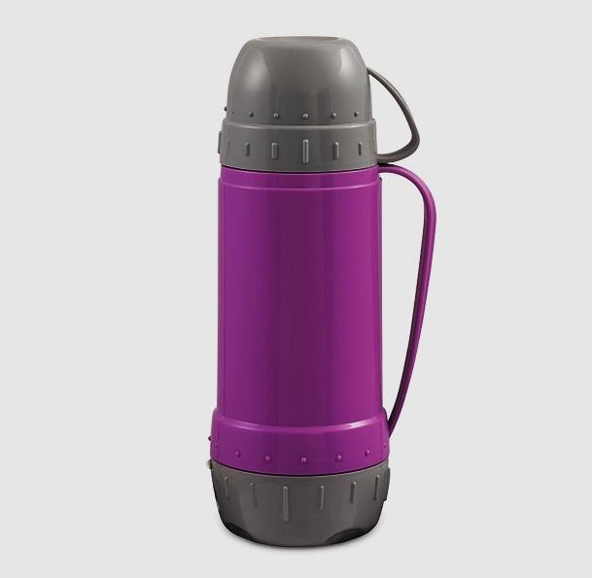

**TASK**

1. Find out what could be the possible causes of the vacuum flask failure to keep hot water hot for a longer time period. (Include a well labelled illustration).
2. How a normal vacuum flask operates? (How does it minimise heat losses?)
3. How come there is no perfect vacuum flask? Explain why

**SCENARIO**

### ACTIVITY OF INTEGRATION

Global warming may be the chief and most complicated environmental problem to potentially affect our planet. The climate has been warming fast since the Industrial Revolution, because human activities are altering the composition of our atmosphere.

All of energy on Earth comes from the sun in form of solar radiation. This energy is then radiated back into space. However, the greenhouse gases work to trap some outgoing heat, warming the planet and its inhabitants. The problem at hand, however, is the continued increase in the concentration of these “greenhouse gases”, such as carbon dioxide, methane, and nitrous oxide. As the amount of these chemicals in our atmosphere increases, they act as a blanket and retain more and more heat inside the atmospheric level, making the planet warmer.

Much of today’s **CO2** is produced by burning fossil fuels, which are used for running cars, and powering factories, but some very powerful greenhouse gases like hydrofluorocarbons (HFC’s) are produced only in industrial processes.

Most environmentalists are concerned that global warming is a potential danger for life on earth. A changing climate is leading to more occurrences of extreme events such as droughts and floods and storms, which have a negative impact on crop growth and yields and health risks.

**SUPPORT MATERIAL**

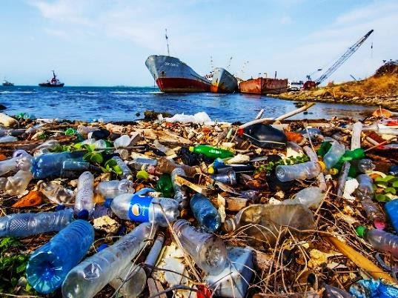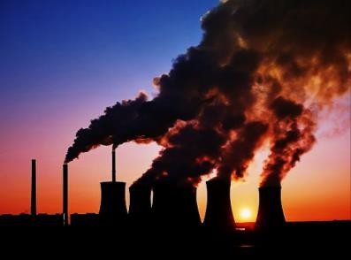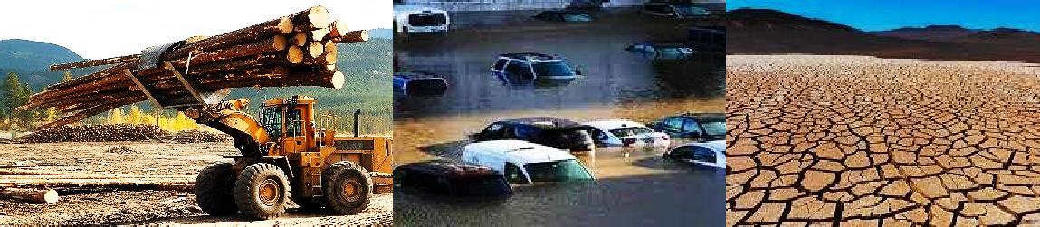

**TASK**

You have been appointed as the in charge of National Environmental and Management Authority (NEMA). What actions will you take in order to slow the increasing destruction of the environment which is responsible for increasing global warming.

## Chapter 7

Expansion Of Solids, Liquids and Gases

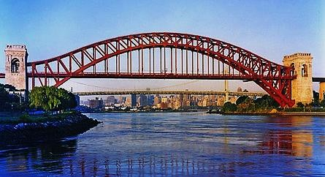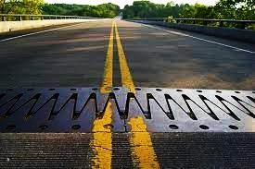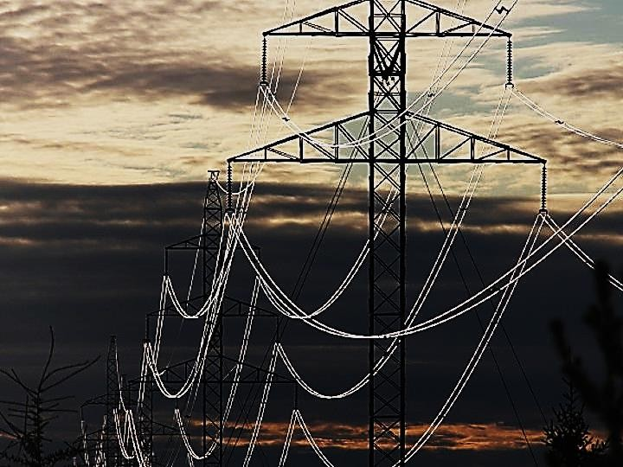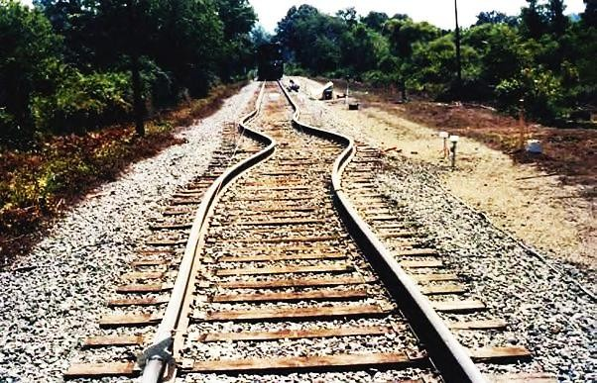

#### KEY LEARNING OUTCOME

*By the end of this chapter, you should be able to:*

*  Understand that substances expand on heating, and recognize some applications of expansion.
*  Understand the effects and consequences of changes in heat on volume and density of water.
*  Appreciate the anomalous expansion of water between 0o C and 4o C and its implications.

#### INTRODUCTION

In thermal expansion, atoms move slightly further apart than usual as the temperature rises. This effect is not limited to metals or even solids, and not every substance responds the same way to a temperature increase.

A nice trick I used to do when I was growing up, and could not find one of my brothers to help me, was to run hot water over the metal lid of a glass jar that I was unable to open. The metal would expand more rapidly than the glass, making the lid easy to twist and pop off. I no longer use this trick I discovered it was more efficient to use a heavy dull metal knife and tap around the lid to get it to loosen - but it was quite handy for a while.

Thermal expansion is the tendency of matter to change in volume in response to a change in temperature. An example of this is the buckling of railroad track, all states of matter expand when heated and contract when cooled. Gases expand most when heated compared to solids and liquids**.**

#### WORKSHEET (SHORT ANSWER REVISION QUESTIONS)

1. State what happens to a solid when it is heated……………………………………………
2. State what happens to hot substance on cooling……………………………………………
3. State what happens to the molecular vibrations of solids when the temperature increases.

……………………………………………………………………………………………

1. 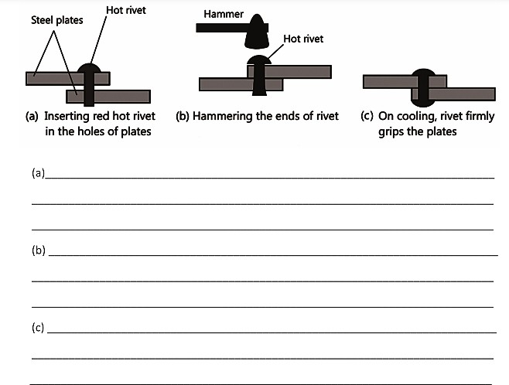Look at the pictures below and explain it
2. **EFFECTS OF EXPANSION AND CONTRACTION OF SOLIDS IN EVERYDAY LIFE**

(Expansion gaps in railway tracks, concrete roads and expansion of bridges)

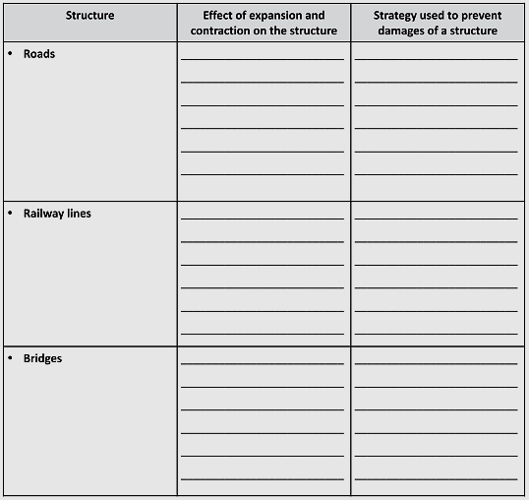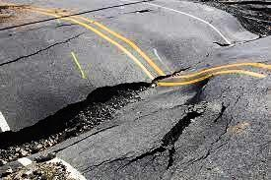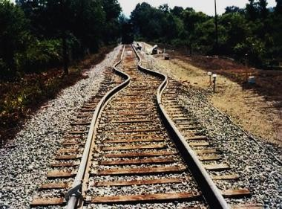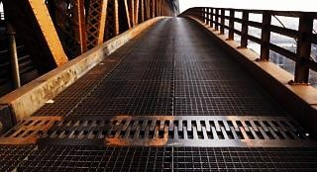

1. Transmission cables Wires or telephone cables are normally not pulled tightly during installation but are loosely held or have loops at various intervals over long distances.

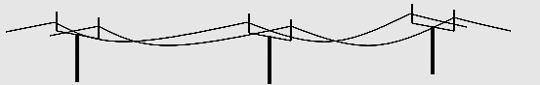

Explain why……………………………………………………………………………………….

………………………………………………………………………………………………………

………………………………………………………………………………………………………

………………………………………………………………………………………………………

1. 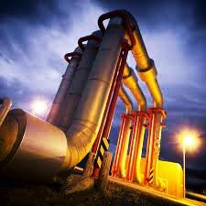Pipes carrying steam from boilers are fitted with various expansion loops and joints. is it really necessary that oil companies make this allowance when constructing fuel pipelines.
   1. Explain why the pipes are coiled to form various loops and joints………………………………………………………...

………………………………………………………………

………………………………………………………………

………………………………………………………………

* 1. The plumber has installed straight pipelines, without any bend in a house situated in the cooler region. State what will happen?...........................................................................

………………………………………………………………

………………………………………………………………

1. Expansion of solids can be illustrated using a metal ball with a ring as shown below.

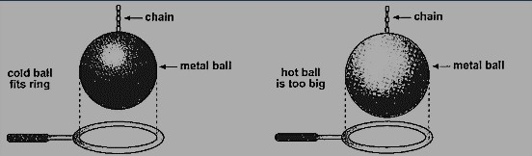

* 1. What is the best title for the above experiment?

………………………………………………………………………………........................

* 1. State what is observed in the above shown experiment.

……………………………………………………………………………….......................

* 1. Use particle theory of matter to explain the above observation

………………………………………………………………………………………………

………………………………………………………………………………………………

………………………………………………………………………………………………

………………………………………………………………………………………………

………………………………………………………………………………………………

* 1. What conclusions can you draw from the above experiments shown above?

………………………………………………………………………………………………

………………………………………………………………………………………………

1. The figure below consists of a metal strip made of two metals such as copper and iron bounded tightly together (bimetallic strip). Study the behaviour of the bi-metallic strip when heated (before and after heating) and answer the questions that follow.

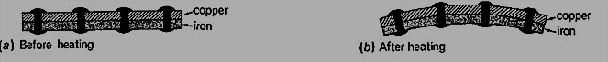

(a) State what observed on heating the bi-metallic strip.

……………………………………………………………………………………………….

(b) Which of the two joined metals expands more?.....................................................................

1. What is the advantage of joining two metals together as compare to using just a single metal?

………………………………………………………………………………………………..

1. Name any three devices which apply the bi-metallic strip in their day-to-day operation.

…………………………………………………………………………………………………

…………………………………………………………………………………………………

1. Using a well labelled diagram, explain the operation of any device mentioned in (d) above

…………………………………………………………………………………………………

…………………………………………………………………………………………………

…………………………………………………………………………………………………

…………………………………………………………………………………………………

…………………………………………………………………………………………………

…………………………………………………………………………………………………

…………………………………………………………………………………………………

…………………………………………………………………………………………………

…………………………………………………………………………………………………

…………………………………………………………………………………………………

1. Steel bridges These are constructed in such a way that one end is rested on rollers and the other end is normally fixed.

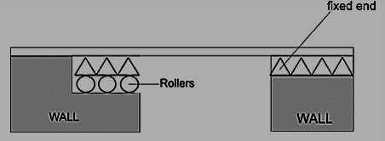

Explain why bridges are built in that way? How does this help the bridge last for generations?

…………………………………………………………………………………………………

…………………………………………………………………………………………………

…………………………………………………………………………………………………

…………………………………………………………………………………………………

1. This activity is used to measure a heated liquid and see how different liquids behave when they are heated
   1. 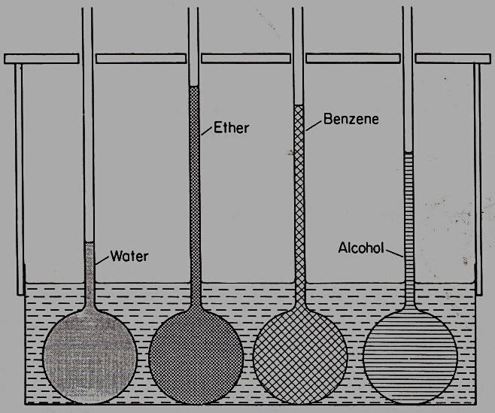*Name the suitable tittle for the above experiment.*

*…………………………………………………..*

* 1. *Which liquid had the most thermal expansion?*

*…………………………………………………*

* 1. *Which liquid had the least thermal expansion?*

*………………………………………………….*

* 1. *Which of the above liquid is used in thermometers?......................................................*
  2. *Why is the above liquid used in the thermometer?*

*………………………………………………….*

* 1. *What conclusion can you draw from the above experiment?.........................................................*

*…………………………………………………………*

* 1. Draw the molecules in the four liquids in the boxes below when they are very hot. Label each box with the name of the liquid



* 1. Why does mercury or alcohol respond quickly to a slight change in temperature while water does not?

…………………………………………………………………………………………………

…………………………………………………………………………………………………

1. Liquids expand when heated but water behaves differently over the temperature range of

**0o C** to **4o C** explain how and how is it important to aquatic life.

…………………………………………………………………………………………………

…………………………………………………………………………………………………

…………………………………………………………………………………………………

…………………………………………………………………………………………………

…………………………………………………………………………………………………

1. Have you ever wondered why pellets of ice float on the surface of water? Explain why ice floats on water………………………………………………………………………………...

…………………………………………………………………………………………………

…………………………………………………………………………………………………

1. The temperature of water in a measuring cylinder is lowered from about **20 o C** to **0 o C**. On the axes sketch the graph of the volume against temperature assuming the water does not freeze.

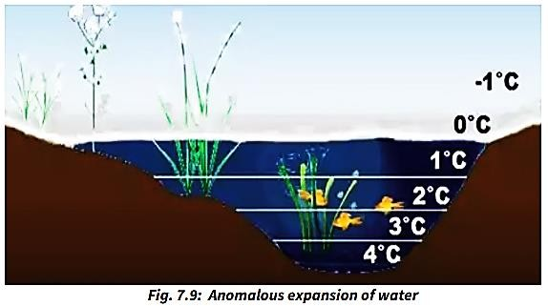

1. In an experiment to investigate the unusual expansion of water, a fixed mass of water at **0 o C** was heated until its temperature reached **20 o C** on the axis same, sketch a graph of density against temperature of the water from **0 o C** to **20 o C.**



1. Explain the how the above two graphs you have drawn in questions 14 and 15 above relate to the anomalous expansion of water.

…………………………………………………………………………………………………

…………………………………………………………………………………………………

…………………………………………………………………………………………………

…………………………………………………………………………………………………

…………………………………………………………………………………………………

…………………………………………………………………………………………………

…………………………………………………………………………………………………

1. Name any advantage two advantages of anomalous expansion of water.

…………………………………………………………………………………………………

………………………………………………………………………………………………….

1. Write down any two disadvantages of anomalous expansion of water

…………………………………………………………………………………………………

…………………………………………………………………………………………………

1. 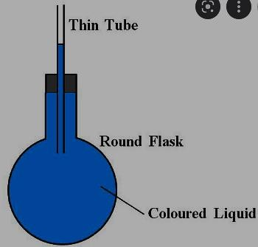Figure 2 shows a round bottomed flask fitted with along capillary tube containing a drop of coloured water. The flask is immersed in ice for some time.
   1. State the observation made

………………………………………………………………

………………………………………………………………

* 1. State the observation made if the ice is replaced by hot water bath instead.

………………………………………………………………

………………………………………………………………

1. Figure 2 shows a round-bottomed flask containing some water. It is heated directly with a very hot flame.

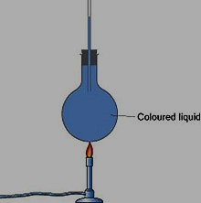Explain why flask is likely to crack especially when the it is closed while heating.

……………………………………………………………

……………………………………………………………

……………………………………………………………

……………………………………………………………

……………………………………………………………

……………………………………………………………

………………………………………………………….

1. 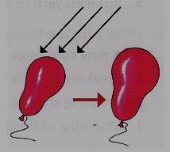If you keep an inflated balloon in the sun for some time, what will happen?
   1. State and explain your observation.

…………………………………………………………

…………………………………………………………

………………………………………………………….

* 1. Explain what would happen if the balloon was put in ice cold place?

…………………………………………………………

…………………………………………………………

………………………………………………………….

1. Explain why balloons burst at the functions during hot weather.

…………………………………………………………………………………………………

…………………………………………………………………………………………………

…………………………………………………………………………………………………

………………………………………………………………………………………………..

1. Most substances expand when they are heated. In the case of gases, the expansion due to heat can be dramatic. A balloon may become several times larger when it is heated. Solids expand so little that it is hard to measure. How about liquids?
2. Gases expand almost 3,000 times more than solids when they are heated over the same amount of temperature. Explain why this happens.

………………………………………………………………………………………………

………………………………………………………………………………………………

………………………………………………………………………………………………

………………………………………………………………………………………………

………………………………………………………………………………………………

………………………………………………………………………………………………

1. What is the order of rate of expansion for solids, liquids and gases? (Which one expands most? Which one is moderate? and which one expands least?)

………………………………………………………………………………………………

………………………………………………………………………………………………

1. 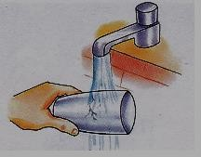If we hold a very hot glass tumbler under cold water, it cracks.
   1. Explain why the glass cracks.

…………………………………………………………

…………………………………………………………

…………………………………………………………

…………………………………………………………

…………………………………………………………

…………………………………………………………

1. If an inflated balloon is tied at the mouth of a bottle and the bottle is placed in ice-cold water as shown in the picture below.
   1. 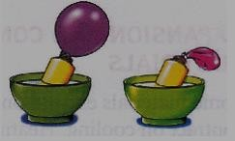State and explain what happens to the balloon

……………………………………………………

……………………………………………………

……………………………………………………

……………………………………………………

……………………………………………………

1. Give a reason why a concrete beam reinforced with steel does not crack when subjected to changes in temperature.

…………………………………………………………………………………………………

…………………………………………………………………………………………………

…………………………………………………………………………………………………

…………………………………………………………………………………………………

…………………………………………………………………………………………………

**ACTIVITY OF INTEGRATION**

**SCENARIO**

During every rainy season in Uganda, most of the remote areas and villages in Uganda face a problem of floods which in most cases destroy the infrastructures such as houses, roads and bridges to mention but a few. Most of these infrastructures in remote areas are always poorly constructed due to inadequate knowledge regarding construction skills, knowledge of forces, expansion and contraction and others. Recently many of the bridges connecting different villages were destroyed by the floods and the community members have organized a meeting to solve this problem of weak bridges which cannot withstand extreme weather conditions. Will they be able to solve this problem permanently?

**SUPPORT MATERIAL**

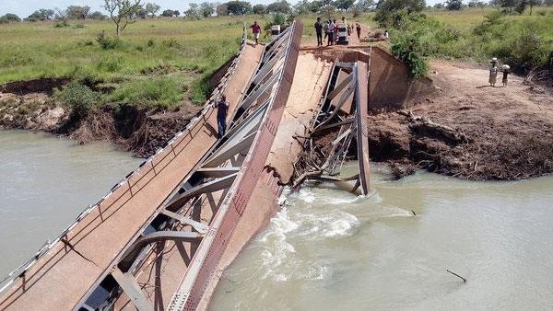

**TASK**

1. You are one of the people who has attended this meeting, what materials will you advise them to use for constructing a long-lasting bridge for this community which can withstand all weather changes.
2. Explain to the community members how the bridge needs to be built so that it can last for generations by (include sketch of how the bridge will look when it is finished)

**ACTIVITY OF INTEGRATION**

**SCENARIO**

One of your friends works at the parking yard in a certain hotel which is in a very hot part of northern Uganda in kitgum district. You visited him one day and discovered that the parking yard is an open place with no shelter from the extreme harsh hot weather conditions. He then informed you that the main problem he faces at his work place is that most customers who visit the hotel always quarrel with him over flat tyres (tire blowouts) at the time of their departure.

**SUPPORT MATERIAL**

**TASK**

1. Help your friend understand the cause of such a phenomenon. Explain to your friend why the tyres are flat (brownout)?
2. What recommendations or advice would you offer to your friend to ensure such scenarios don’t repeat itself again?
3. What conclusions can you draw from such a scenario (what is the relationship between heat and matter)?

**SCENARIO**

### ACTIVITY OF INTEGRATION

You live in a middle-income home where your father hired a maid to take care of most of the roles and responsibilities at home such as cooking and washing dirty laundry. She always does her work perfect but recently you have discovered that you have been buying a new charcoal stove “**sigiri**” each and every month in order to replace the broken ones. This bothers your parents so much to the extent that they almost wanted to fire her for failure to handle the ‘**sigiri**” well. She has been given the last warning or else she risks loosing her only job. During every after preparing a meal, the maid always pours cold water on the charcoal stove “**sigiri**” to cool it.

**SUPPORT MATERIAL**

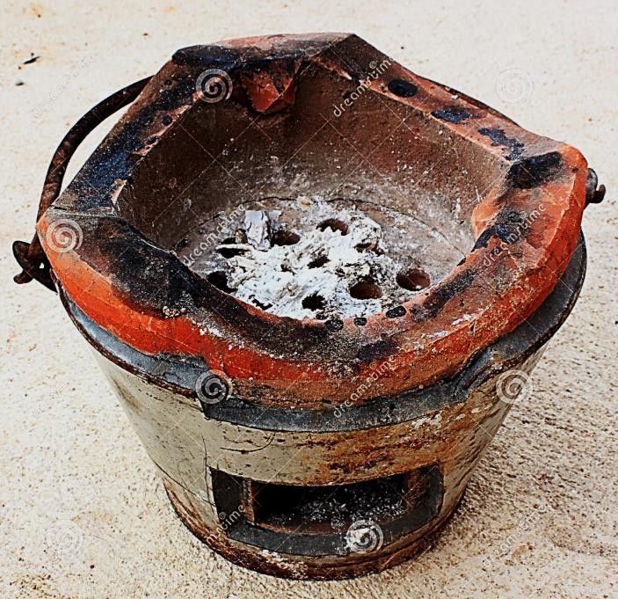

**TASK**

As a physics student, what advice will you give her so that she can retain her job? Write down the guidelines she should follow to ensure that the “**sigiri**” can last for long. Explain to her the real reason why the sigiri breaks very frequently than usual.

**SCENARIO**

### ACTIVITY OF INTEGRATION

The electric flat iron is used in many homes to iron clothes today. there are mainly two common types of flat irons; The **local type** which uses charcoal and the **electric type**. At your home there are both the traditional local iron box and the electric flat iron. Recently the electric flat iron has begun to show some faults. It gets uncontrollably too hot all the time and so far, it has burnt three of your brother’s clothes in one week. As a result, all your family members at home have stopped relying on the electric flat iron and nowadays you all use the local one. Everyone at home is wondering, what could be the problem? Can it be solved or you just need to throw it away? Is it cheap to just throw it away or it can be fixed at a cheaper cost?

**SUPPORT MATERIAL**

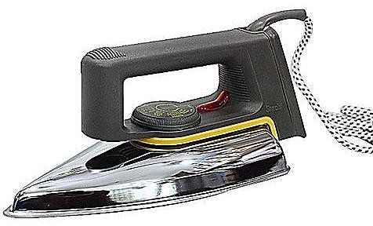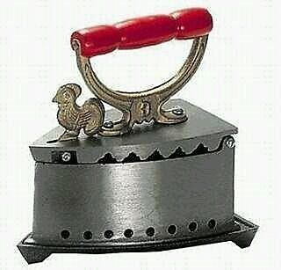

**TASK**

1. At the family meeting you were called upon to present your view about what should be done to the electric flat iron. What you will you say? Explain to them how an electric flat iron operates and let them know what could be the main cause of the problem of overheating (include illustrations)
2. What possible recommendations are you offering to solve this problem
3. Explain to your siblings which of the two iron types of iron boxes you think is better and why you think so.

## Chapter 8

NATURE OF LIGHT;

## Reflection At Plane Surfaces.

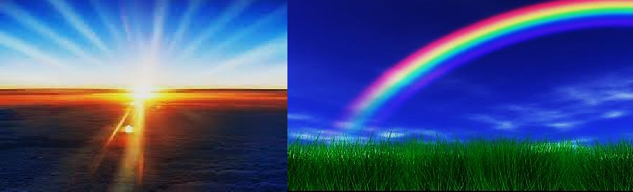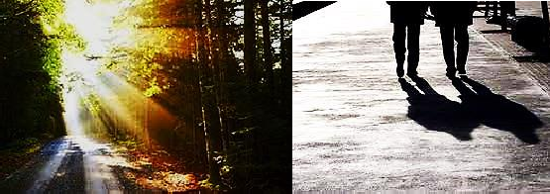

**KEY LEARNING OUTCOMES**

*By the end of this chapter, you should be able to:*

* + identify illuminated and light source objects in everyday life.



* + understand how shadows are formed.
  + understand how the reflection of light from plane surfaces occurs, and how we can make use of this.

#### INTRODUCTION

What can happen if there was no light at all? Can you see in the dark? Or maybe can our eyes get used to darkness? Do we really need light? And how about green plants, how much longer can they survive without light at all?

We all need light every day to see objects around us and to see ourselves. We get most of our light from the sun. Imagine what life would be like if there was only darkness for a full week! In this chapter, you will explore how light travels and the applications related to the propagation of light

#### WORKSHEET (SHORT ANSWER QUESTIONS)

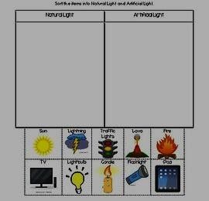

1.

**Natural light**

**Artificial light**

**sun**

**lava**

**fire**

**TV**

**Bulb**

**Candle Torch**

**iPod**

**lightning**

**Traffic lights**

***Sort the items into natural and artificial sources of light***

1. The figure below shows some of the sources of light. You are required to identify, name and classify if the type of light source in the picture (use space beneath each picture).

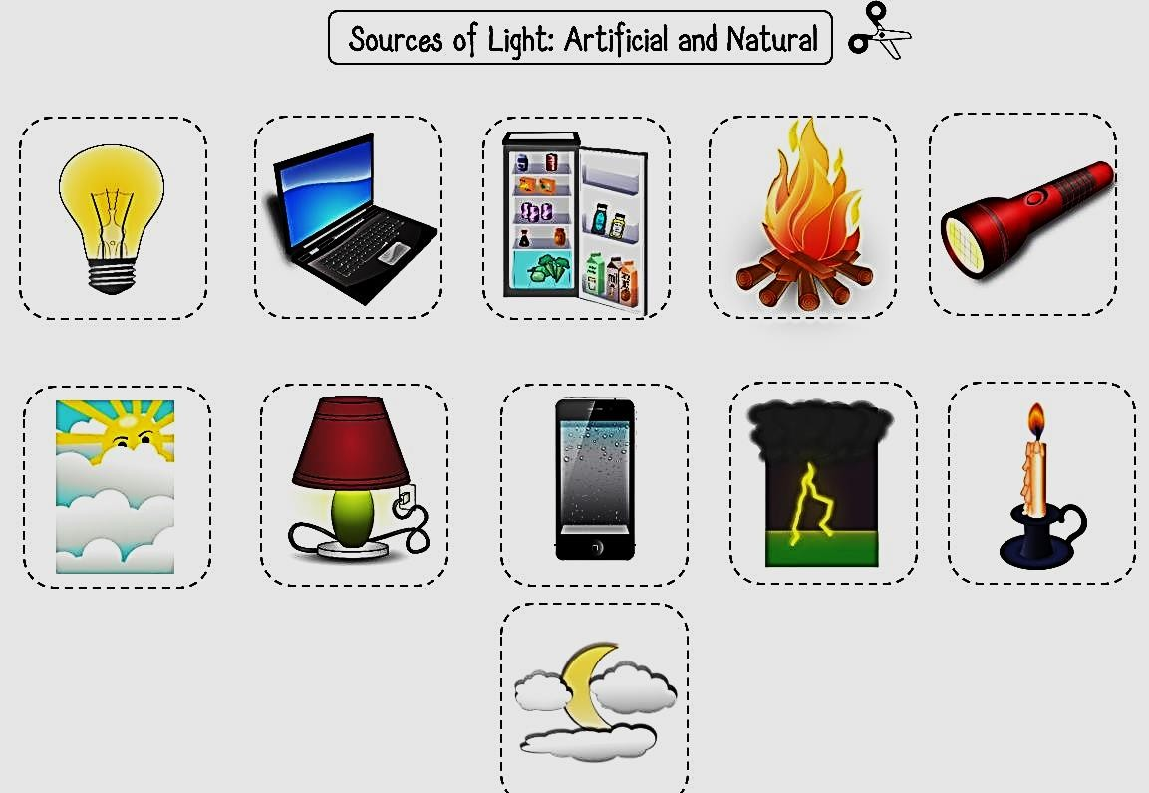

1. 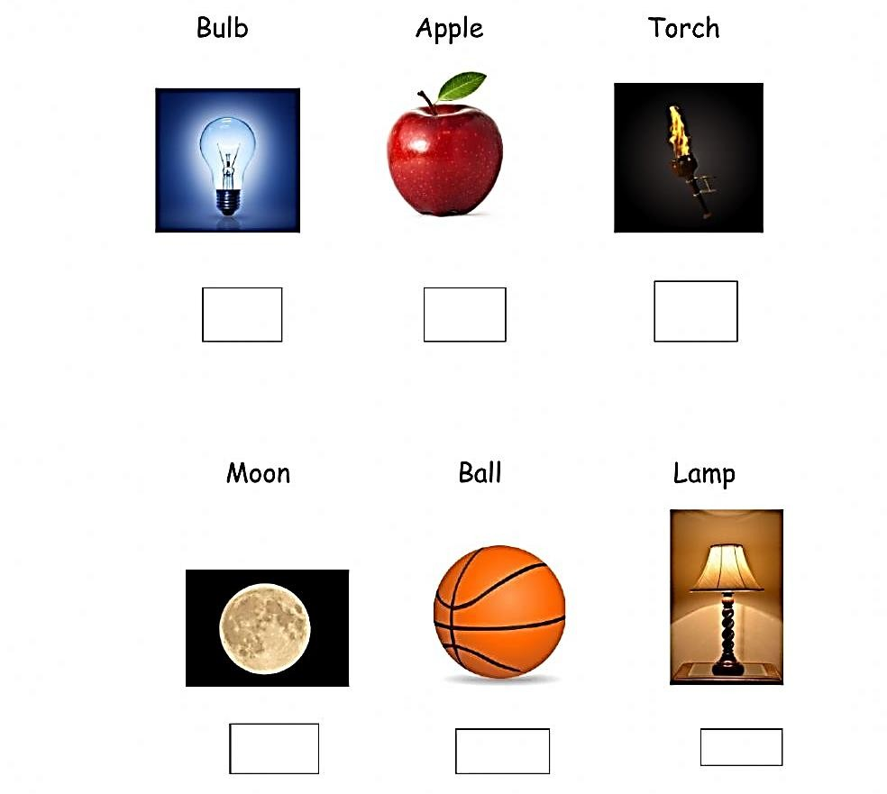Look at the object. Does it give off light? Write yes or no. if no write what it does to light.
2. Make two columns in your book. Label one source of light and the other not a source of light. Identify which of the following are light sources. Cut out and stick the pictures into the correct columns in your book

**Diamond The Sun CD**

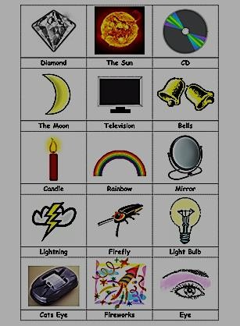

**The moon Television bells**

**Candle Rainbow**

**mirror**

**Lightning**

**Fire fly**

**Light bulb**

**Cats eye**

5.

**Fire works**

**Eye**

1. There are 2 types of reflections. Which one describes that light reflects off all points at the same angle because of a smooth surface……………………………………………………
   1. Draw an illustration of the two types of reflections
2. An object that is allows ALL the light to pass through
3. An object that is doesn’t allow any light to pass through
4. An object that is allows some of the light to pass through
5. Give any one example of each of the above materials for transmission of light mentioned in question 7, 8 and 9 above.

…………………………………………………………………………………………………

…………………………………………………………………………………………………

…………………………………………………………………………………………………

1. What term do we normally use in light to refer to “The bouncing back of a ray of light, sound, or heat.” ……………………………………………………………………………………………………
2. A wave that can travel through empty space of matter is called………………………………

…………………………………………………………………………………………………

1. Normally, light travels in a straight path called a……………………………………………..
2. Explain what would happen to our Earth without the sun?

…………………………………………………………………………………………………

…………………………………………………………………………………………………

…………………………………………………………………………………………………

…………………………………………………………………………………………………

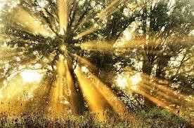………………………………………………………………………………………………….

Use the light terms (rays, beams) to explain what is happening in the picture.

…………………………………………………

…………………………………………………

…………………………………………………

…………………………………………………

…………………………………………………

…………………………………………………

15. How does light travel/move?....................................................................................................

1. List five uses of light.

…………………………………………………………………………………………………

…………………………………………………………………………………………………

…………………………………………………………………………………………………

…………………………………………………………………………………………………

…………………………………………………………………………………………………

1. What happens when light hits an object?

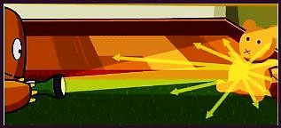What happens when light hits an object?

………………………………………………………………

……….………………………………………………………

……………….………………………………………………

……………………….………………………………………

……………………………………………………………….

1. 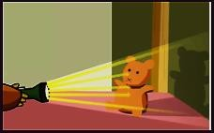How Are Shadows Formed?

How Are Shadows Formed?

……………………………………………………………………….………………

……………………………………………………….………………………………

……………………………………….………………………………………………

…………………………………………………………………………………………

…………………………………………………………………………………………

1. Objects that produce their own light are called………………………………………………
2. Name any three examples of such objects in question 19 above

……………………………………………………………………………………………….

1. Objects that only reflect light from other natural sources of light are called

……………………………………………………………………………………………….

1. Name any three examples of such objects in question 21 above

………………………………………………………………………………………………

1. 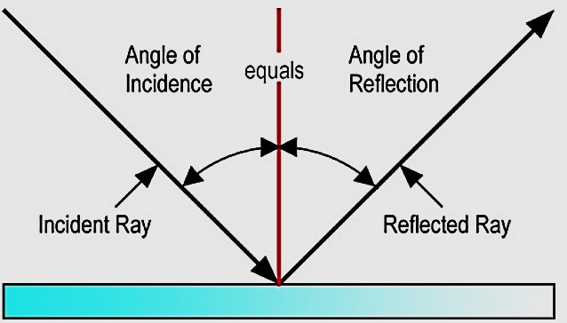Study the figure and state the laws of reflection of light

First law

……………………………………………………………

……………………………………………………………

……………………………………………………………

Second law

……………………………………………………………

……………………………………………………………

……………………………………………………………

……………………………………………………………

1. When a parallel beam of incident light is reflected as a parallel beam in one direction, this type of reflection is known as……………………………………………………………….
2. We see the image of our face when we look into the mirror. It is due to……………………

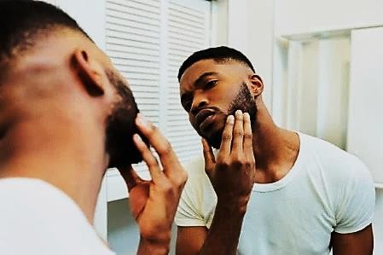……………………………………………………………………………………………….

* 1. Describe the nature of the image formed by plane mirrors.

…………………………………………………………………………………………………

…………………………………………………………………………………………………

…………………………………………………………………………………………………

………………………………………………………………………………………………..

* 1. 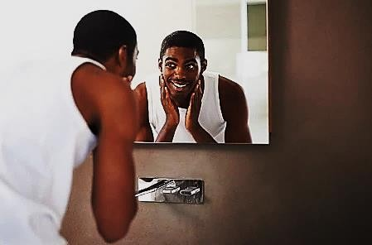Use a ray diagram to show how a plane mirror forms an image of an object placed Infront of it.
  2. What are the real-life applications of plane mirrors?

……………………………………………………………

……………………………………………………………

……………………………………………………………

……………………………………………………………

1. A ray of light falls on the plane mirror and reflects perpendicular to incident ray at the point of incidence. find the angle of incidence and the angle of reflection

…………………………………………………………………………………………………

…………………………………………………………………………………………………

…………………………………………………………………………………………………

………………………………………………………………………………………………….

1. A vertical object placed on a bench is observed to have three shadows of different sharpness, in different directions. Explain this observation. Using illustrations

…………………………………………………………………………………………………

…………………………………………………………………………………………………

…………………………………………………………………………………………………

…………………………………………………………………………………………………

…………………………………………………………………………………………………

…………………………………………………………………………………………………

…………………………………………………………………………………………………

…………………………………………………………………………………………………

…………………………………………………………………………………………………

…………………………………………………………………………………………………

1. 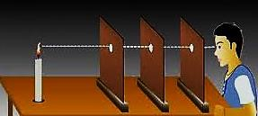In a certain experiment to investigate nature of light, the following set up was arranged
   1. What property of light is he investigating?

…………………………………………..

* 1. State what would happen when one of the cardboards is displaced slightly.

……………………………………………

* 1. Describe the procedures followed when carrying out the above experiment

………………………………………………………………………………………………

………………………………………………………………………………………………

………………………………………………………………………………………………

………………………………………………………………………………………………

………………………………………………………………………………………………

………………………………………………………………………………………………

* 1. What conclusion can you draw from the above investigation?

……………………………………………………………………………………………

1. Using a well labelled diagram describe the formation of images by a pin hole camera.

…………………………………………………………………………………………………

…………………………………………………………………………………………………

…………………………………………………………………………………………………

…………………………………………………………………………………………………

…………………………………………………………………………………………………

…………………………………………………………………………………………………

…………………………………………………………………………………………………

1. An object 2 m tall is observed using a pinhole camera. The height of the image is found to be 2 cm. If the distance of the object from the pinhole is 10 m, find the distance between the pinhole and the image.

…………………………………………………………………………………………………

…………………………………………………………………………………………………

…………………………………………………………………………………………………

…………………………………………………………………………………………………

1. An object is placed 16 cm away from a plane mirror. If the object is moved 4 cm towards the mirror, what will be the distance between the object and its image?

…………………………………………………………………………………………………

…………………………………………………………………………………………………

1. What would happen if there was no reflection? Explain your answer

…………………………………………………………………………………………………

…………………………………………………………………………………………………

…………………………………………………………………………………………………

…………………………………………………………………………………………………

1. When mirrors are inclined to each other, a number of images may be formed. The picture below shows images of a candle placed between two plane mirrors inclined at **90o** to each other.
   1. 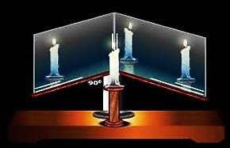How many images are formed?

……………………………………………

* 1. How many images would be formed if the mirrors were inclined at **60o** to each other?

……………………………………………

……………………………………………

……………………………………………

* 1. How many images would be formed if the mirrors were inclined at **30o** to each other?

……………………………………………

……………………………………………

……………………………………………

1. 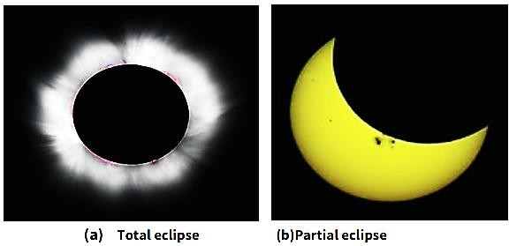Eclipse is a natural occurrence of shadows as shown below.
2. What is the difference between total and partial eclipse

…………………………………………………………………………………………………

…………………………………………………………………………………………………

…………………………………………………………………………………………………

1. Using illustrations, explain the differences between solar eclipse and lunar eclipse.

……………………………….…………………………………………………………………

…………………………………………………………………………………………………

…………………………………………………………………………………………………

…………………………………………………………………………………………………

…………………………………………………………………………………………………

…………………………………………………………………………………………………

…………………………………………………………………………………………………

…………………………………………………………………………………………………

…………………………………………………………………………………………………

#### EXTRA WORK

*A student investigates how the surface of an object affects the radiation it emits.*

*The image below shows the equipment he uses:*

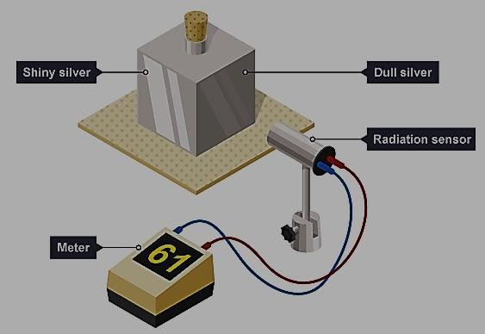

*The cube has four different surfaces. He fills the cube with boiling water so that the temperature of each surface is the same. He uses the radiation sensor to measure the radiation emitted from each surface.*

*His readings are shown in the table below.*

1. *Draw a line from each surface colour to its correct meter reading. One has been done for you.*
2. *Give a reason why the radiation sensor*

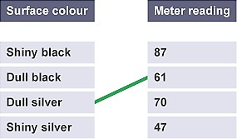*gives a different reading for each surface.*

***…………………………………………………………***

***…………………………………………………………***

***…………………………………………………………***

***…………………………………………………………***

***…………………………………………………………***

**SCENARIO**

**ACTIVITY OF INTEGRATION**

##### A long time ago solar eclipses were considered as a message from the gods since the people in that age dwelt so much in the spiritual realm than the scientific world. But with the development of science and technology eclipses can now easily be explained scientifically instead of spiritually. Whenever eclipses occur many people gather out in open places to watch the beautiful view of the heavenly bodies as they align themselves in a beautiful display.

However, in most remote areas of Uganda some people still observe the eclipse directly using naked eyes not aware of the risk they are exposing their eyes to in the long run. The science club of your school has taken an initiative to always once in a while go out into the community and teach the community members about scientific facts. This year you are expected to go out during the day an eclipse is expected to occur to. You are expected to organize for the presentation about eclipses.

**SUPPORT MATERIAL**

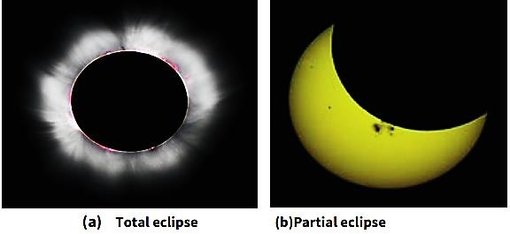

**TASK**

As a student of physics and science club at the school, you are required to organize for the presentation about eclipses that you will use to address the community members on the day the eclipse is expected to occur. Conclude your presentation by recommending the best safe ways to watch an eclipse. (You may include ray diagram illustrations).

**SCENARIO**

**ACTIVITY OF INTEGRATION**

##### Your uncle operates a retail shop in a very busy trading Centre and sometimes having very many customers at the same time can be very challenging to handle since he is alone operating the shop. Like in, most shops in Uganda, the refrigerator is always put outside the shop besides the door where you can’t see it directly when you are seated inside. This proves challenging to handle since some customers come and pick soft drinks from the refrigerator and leave without paying. He can’t see the customers who pick the drinks since the refrigerator is outside the shop besides the door. Your uncle has been complaining about the same scenario and he can’t change the position of the refrigerator since there is no other free space big enough to put it.

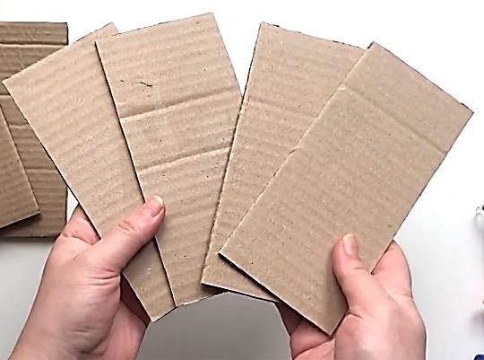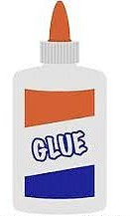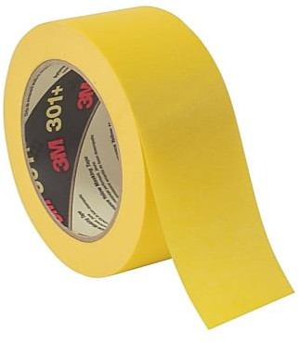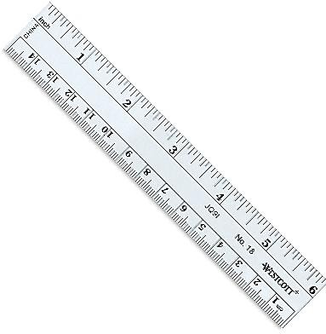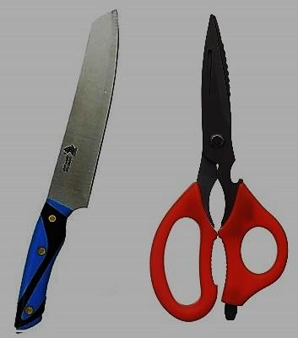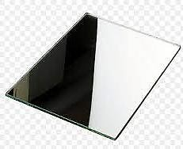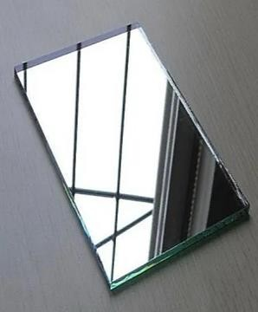

**SUPPORT MATERIAL**

**Masking tape**

**Pen/pencil**

**cardboard**

**Glue**

**Plane mirror 1**

**cutter**

**Plane mirror 2**

**TASK**

**ruler**

As Physics students, help your uncle to solve this problem by designing a device which your uncle will use to see the customers who pick soft drinks from the refrigerator behind the door. (Include illustrations)